ECONOMIC AND MANAGEMENT SCIENCES
GRADE 9
TERM 2

Entrepreneurship – SECTORS OF THE ECONOMY:
Learners should achieve the following outcomes, as per CAPS:
- The primary sector, the secondary sector, the tertiary sector;
- Types of businesses found in the three sectors;
- The interrelationship of the three sectors;
- Sustainable use of resources in the three sectors;
- The role of the three sectors in the economy;
- Types of skills required in each sector.

INTRODUCTION:
The economy is separated in three sectors due to their stages in the process of production. They are the primary sector, the secondary sector and the tertiary sector.
Definitions of the different sectors:
Primary sector | Secondary sector | Tertiary sector
Forms the first level of the economy and include all businesses involved in the extraction of natural resources and the production of goods in the farming, forestry, fisheries and mining sectors. | Forms the second level of the economy and include all businesses involved in the transformation of raw materials into finished goods by making use of the materials from the primary sector. | Forms the third level of the economy and include all businesses involved in rendering services and the sales of finished goods that were obtained from the secondary sector.

Types of businesses found in the three sectors:
Primary sector | Secondary sector | Tertiary sector
Businesses are mostly located in rural areas. | Businesses are mostly located just outside of cities. | Businesses are mostly located far away from the natural environment.
e.g. mining, forestry, fisheries, farming, extraction of oil and gas, hunting and gathering, etc. | e.g. industries, such as factories, construction, plants, etc. | e.g. retail businesses, schools, banks, hospitals, restaurants, transport services, hair salons, etc. .

Interrelationship of the three sectors:
All three sectors depend on one another, because each sector supply a product or service which the other sectors need.
Primary sector | Secondary sector | Tertiary sector
The raw materials produced in the primary sector are used as inputs in the secondary sector. | The secondary sector needs the raw materials from the primary sector to be used as inputs in the production process. | The tertiary sector acts as a link between the other two sectors.
Development in the secondary sector depends on the level of development in the primary sector. | The secondary sector is depending on the retail businesses in the tertiary sector to sell their finished goods. | Without the tertiary sector there would not have been a market for finished goods produced in the secondary sector.
Industries in the primary sector need the services of banks, storage facilities, insurance companies, transport companies, etc. who are all coming from the tertiary sector. | Industries in the secondary sector need the services of banks, insurance companies, transport companies, electricians, etc. who are all coming from the tertiary sector. | The other two sectors depend on the services rendered in the tertiary sector, such as insurance, legal services, financial services, etc.

Sustainable use of resources in the three sectors:
The 3 R’s:
- Recycle – should not be discarded after use, but rather sent to recyclers or factories that will use it again in the production of other products.
- Reuse – other uses should be found for products to ensure optimal utilization. E.g. to reuse empty ice cream containers by storing washing pegs in it.
- Reduce – The use of harmful products should be limited to ensure that the environment is not polluted any further. It can also refer to the fact that we should reduce the use of resources in the production of goods.
- Most resources are not renewable, which means that it cannot be reproduced or imitated, e.g. water and coal.
- Resources must be used sparingly in order to ensure that it will still be available for future generations.

The role of the three sectors in the economy:
Primary sector | Secondary sector | Tertiary sector
The primary sector employs the largest share of people in undeveloped countries due to the high levels of unskilled people. | As the population grows, the secondary sector also grows to satisfy increasing needs. More employment opportunities become available. | The tertiary sector put more goods and services and money in the economy than the other two sectors.
The primary sector plays a vital role in the economic growth of undeveloped or under developed countries. | The secondary sector plays a vital role in the economic growth of developing countries. | The economic importance of services in SA is increasing.
As technology improves, the risk arises that workers will lose their jobs and be replaced with machinery. | As technology improves, the risk arises that workers will lose their jobs and be replaced with machinery. | The tertiary sector is the largest sector in developed countries and employs the largest number of people.
Types of skills required in each sector:
Primary sector | Secondary sector | Tertiary sector
Workers in the primary sector usually perform physical labour, like farm workers who do not require high levels of skill.  Less workers need higher levels of skill such as a farm manager.  Nowadays more machinery is used, which means that workers should be semi-skilled or at least have a certain extent of training. | Workers in the secondary sector usually perform routine activities, e.g. factory workers who need a certain extent of training to operate machinery.  Skilled workers are also needed in the secondary sector, e.g. plumbers, electricians, etc. | A lot of opportunities for skilled workers exist in the tertiary sector, due to the fact that critical and creative thinking abilities are required.  E.g. marketers, doctors, teachers, lawyers, etc.  However, there are opportunities for unskilled workers as well, such as general workers, cleaners, etc.
Mostly unskilled labourers. | Mostly semi-skilled workers. | Mostly skilled workers.

ECONOMIC AND MANAGEMENT SCIENCES
GRADE 9
TERM 2

Entrepreneurship – SECTORS OF THE ECONOMY:

Activity 1:
Definitions – Primary, Secondary and Tertiary sectors; Types of businesses in each sector
  - Complete the table below by defining the three economic sectors.
Primary sector | Secondary sector | Tertiary sector

  - Give three examples of different businesses in each of the three economic sectors.
Primary sector | Secondary sector | Tertiary sector

Activity 2:
Types of businesses in each sector; Interrelationship of the three sectors; Types of skills required in each sector
2.1. Study the diagram below and answer the following questions.
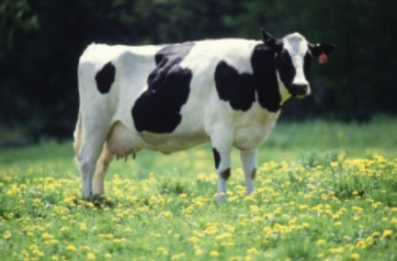 |  | 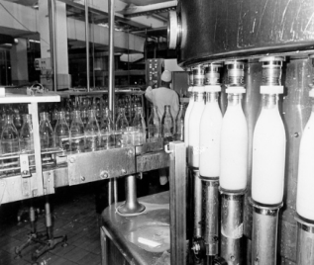
Picture A Picture B Picture C
2.1.1. Identify which sector is represented by each of the pictures above.
Picture A: ______________________________________________________
Picture B: ______________________________________________________
Picture C: ______________________________________________________
2.1.2. Explain the interrelationship of the three sectors by using the production process of milk (from the diagram) to demonstrate your knowledge.
______________________________________________________________
______________________________________________________________
______________________________________________________________
______________________________________________________________
______________________________________________________________
2.1.3. Indicate the type of skills needed the most in each of the three economic sectors. Briefly motivate your answer.
Primary sector | Secondary sector | Tertiary sector

Activity 3: Sustainable use of resources in the three sectors
3.1. Recommend three ways in which resources can be used on a sustainable and environmentally friendly way in the three sectors.
___________________________________________________________________
___________________________________________________________________
___________________________________________________________________
___________________________________________________________________
___________________________________________________________________
___________________________________________________________________

Activity 4: Role of the three sectors of the economy
4.1. Briefly explain the role of the three economic sectors.
Primary sector | Secondary sector | Tertiary sector

