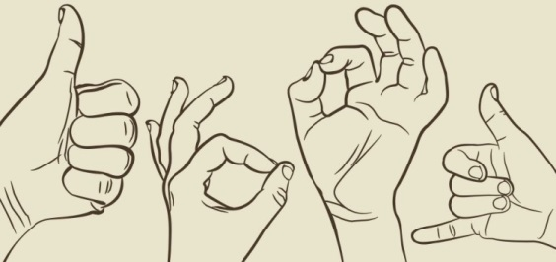
SUMMARY

1. Use the information below to write a summary on the science of talking with your hands.
2. You must write a fluent paragraph, using your own words.
3. Your summary should include SEVEN points and NOT exceed 90 words.
4. You are NOT required to include a title for the summary.
5. Indicate your word count at the end of your summary.

THE FASCINATING SCIENCE BEHIND 'TALKING' WITH YOUR HANDS
If someone has ever made fun of you for making elaborate hand gestures while talking – or you've seen footage of yourself speaking, only to be horrified by your flailing forearms – don't be too concerned. According to psychologists, those gestures are probably helping you express your thoughts more effectively.
'Hand gestures are really a powerful aspect of communication, from both the speaker's and the listener's end,' says Dr Carol Kinsey Goman, body language expert. Last year, a study analysing human gestures found that the most popular, prolific speakers used an average of 465 hand gestures, which is nearly twice as many as the least popular speakers used. Other research has found that people who 'talk' with their hands tend to be viewed as warm, agreeable and energetic, while those who are less animated are seen as logical, cold and analytical.
Gesturing is a healthy and normal aspect of human communication. Hand gestures help us take what's in our mind and make it intelligible to others. 'Gesture is really linked to speech, and gesturing while you talk can really power up your thinking,' Kinsey Goman said. Gesturing can help people form clearer thoughts, speak in tighter sentences and use more declarative language. A brain region known as Broca's area is connected to speech production, but is also active when we wave our hands.
We gather information from others' body language, as well as from their specific words because gestures often underscore the important points someone is making. Furthermore, hand motions can reveal information that may be absent in our speech. Research demonstrates that the movements we make with our hands when we talk constitute a kind of second language, adding information that's absent from our words. Gesture reveals what we know. It also reveals what we don't know.
A child's use of hand gestures early in life can be a sign that she will later develop a strong vocabulary, as well as skills related to sentence structure and storytelling, according to a study published last year in the Journal of Child Language. From cradle to grave, body language is crucial in helping communicate our emotions and motivations to others.
[Adapted from www.huffingtonpost.com]

MEMO
PARAGRAPH
Gestures are effective communication tools and help to express our thoughts clearly. Gestures stimulate cognitive processes; when one uses gestures, one's language use is more concise and expressive. Furthermore, body language facilitates the interpretation of what others consciously or unconsciously convey. Moreover, gesturing shows one's knowledge or lack thereof, thus clarifying messages. Lastly, hand motions reveal facts that are not always verbally communicated and these motions are related to the development of vocabulary, sentence structure and storytelling.
(77 words)
