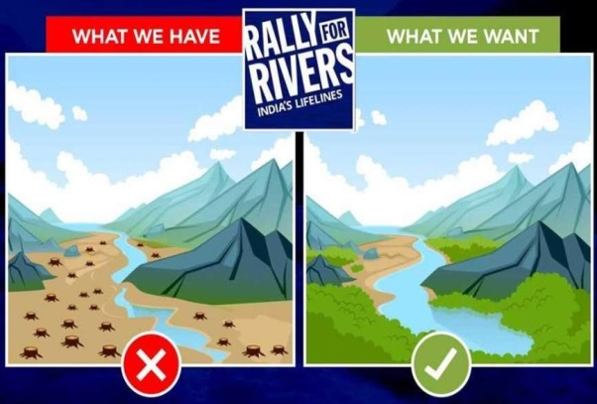
Summary
Saves our rivers
and streams
SAVE OUR RIVERS AND STREAMS
If each South African performed a positive action every day our rivers and streams would benefit. Try to avoid using too many plastic containers. Bottles and bags pollute our waterways and also kill many water animals and birds.
A simple thing like closing the tap while you are brushing your teeth, or taking a shower instead of filling a bath tub with water can make an enormous difference. You can also have a positive impact if you think twice before buying appliances. Do a little research and buy energy-saving appliances which you can then use responsibly. Washing two small loads of clothes in a washing machine uses more water and electricity than washing one big load.
Do not dump dangerous waste. There are safe ways to get rid of hazardous materials like paints, drain cleaners and used motor oil. When people, unthinkingly, pour these materials down the drain they land up in rivers or the ocean, doing harm.
Try not to over-use pesticides, herbicides and fertilisers. The run-off from these products lands in our water resources and poisons our animals and plants living in the water.
Washing a car at home allows dangerous substances like oil and petrol to soak into the groundwater where they kill water life and pollute drinking water. Commercial car washes have ways to process water containing grease and oil.
Cleaning up after your pet can make a difference. Pet waste should not be allowed to land up in water resources as it contains harmful bacteria which kill fish and encourage the growth of harmful algae.
Much rainwater goes to waste as it just runs off roofs. Rainwater tanks can be installed to store water for use in the garden, washing machine or toilet.

MEMO – SUMMARY
Save our rivers and streams

