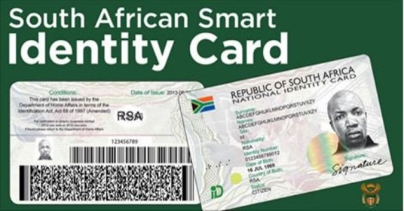
SUMMARY

INSTRUCTIONS
Read the passage below and list SEVEN important points on the new smart identity cards.
1. Your summary must be written as a paragraph.
2. List SEVEN points in full sentences, using not more than 90 words.
4. Write only ONE point per sentence.
5. Use your OWN words as far as possible.
6. Indicate the total number of words you have used in brackets at the end of your summary.

NEW SMART IDENTITY CARDS

The Smart Identity Card replaces the old green South African identity book.
The technologically advanced Smart Identity Card, designed to limit identity fraud, was launched on former president Nelson Mandela's 95th birthday, 18 July 2013. Nelson Mandela's daughter, Zindzi, received the new card on behalf of her father.
The Smart Identity Card is about the size of a credit card and has an embedded microchip that prevents fraud. The card was designed in such a way that it would be difficult to forge. Your personal information is laser-engraved into the identity card. Your photograph is laser-engraved, making it impossible for fraudsters to swop it with another picture, as was the case with the green identity book.
The card also includes detailed fingerprint analysis to identify a person on an electronic system. Each card has a unique identity card number. One-dimensional and two-dimensional barcodes are used to scan the cards. The one-dimensional barcode uses the old technology, while the two-dimensional barcode uses the newer scanner technology.
Your card is read using portable verification machines with which the police are issued. This makes it easy to identify cards that have been tampered with. Institutions that require your identity details have to buy the necessary scanning machines. This means that they know with whom they are dealing.
The Department of Home Affairs says the old identity books are being phased out over a period of time. To avoid a rush for the new cards, citizens are being invited to apply in stages.

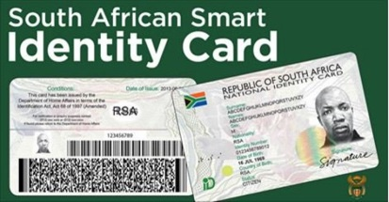
MEMO
NEW SMART IDENTITY CARDS
