GRADE: 9

SUBJECT: MATHEMATICS

TERM 2

FORMAL ASSESSMENT TASK (FAT)

Name:________________________________________________________

Class: _____________________ Date: ____________________________

School: ____________________ Educator: _______________________

FAT | ACTIVITY/FORM | Learner’s point | Learner %
2.1 | TEST
TOTAL

MATHEMATICS GRADE 9 FORMAL ASSESSMENT TASK (FAT):
TEST
Total: 50 Marks Time: 1 Hour
Instructions:
- Answer all the questions.
- Write your name and date.
- No calculators allowed.
- Show calculations as requested.
- The marks allocated are an indication of the number of steps per calculation.
- Check your answers.
- Round off all answers to the 2nd decimal place

VRAAG 1 |  |  | QUESTION 1
Gegee: AB = BC ; BC ll DE ; $\hat{C_{1}}=x+15°$  - Bepaal (met redes) die groottes van:  - $x$  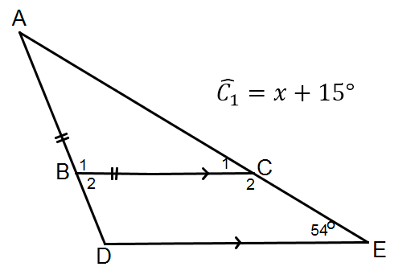  - $\hat{D}$ |  |  | Given: AB = BC ; BC ll DE ; $\hat{C_{1}}=x+15°$  - Determine (with reasons) the sizes of:  - $x$ (2)  1.1.2 $\hat{D}$ (4)
1.2 | Gegee / Given: SO = 8 cm ; NO = 12 cm ;  $S\hat{N}P$ = 27$°$

1.2.1  1.2.2  1.2.3 | Watter tipe vierhoek is SNAP?  Gee redes vir jou antwoord.  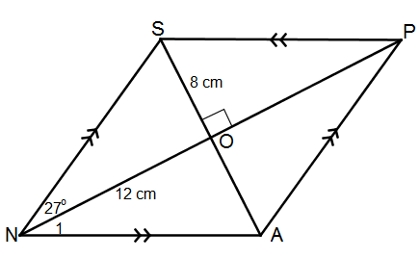  Bepaal die grootte van $\hat{N_{1}}$.  Gee redes vir jou antwoord.  Bepaal die grootte van $N\hat{S}O$.  Gee redes vir jou antwoord. | 1.2.1  1.2.2  1.2.3 | What type of quadrilateral is SNAP?  Give reasons for your answer.  Determine the size of $\hat{N_{1}}$.  Give reasons for your answer.  Determine the size of $N\hat{S}O$.  Give reasons for your answer. (2) [12] | (2)  (2)
VRAAG 2 |  | QUESTION 2
2.1. | Gebruik die stelling van Pythagoras en bewys of die volgende reghoekige driehoeke is. |  | Use the theorem of Pythagoras to prove whether the following triangles are right angled triangles.
2.1. | AB = 5  BC = 4  CA = 3 | 2.1. | AB = 5  BC = 4  CA = 3 | (2)
2.2. | Gebruik die stelling van Pythagoras om x te bereken. Rond af tot twee desimale posisies, waar nodig. | 2.2. | Use the theorem of Pythagoras to calculate x. Round off to two decimal places where necessary.
 | 2.2.1.  x  8 cm  5 cm  B  A  C |  |  | (3)
2.3 Look at the sketch below. Bestudeer die skets
A
B
C
F
E
D

2.3.1 Name a pair of parallel line segments. 2.3.1 Noem ‘n paar paralelle lyn segmente (2)
2.3.2 Name two pairs of perpendicular line segments. 2.3.2 Noem twee pare loodregte lyne (2)
AB and EF EF and BF, AB and BF [9]

VRAAG 3 QUESTION 3
3.1 Sê of die volgende stellings 3.1 Say if the following statements
WAAR of VALS is: are TRUE or FALSE:

3.1.1 Gelykvormige driehoeke is 3.1.1 Similar triangles are
altyd kongruent. always congruent. (1)

3.1.2 Alle gelyksydige driehoeke is 3.1.2 All equilateral triangles are
gelykvormig aan mekaar. similar to one another. (1)

3.1.3 Twee gelyke sye en enige 3.1.3 Two equal sides and any
ooreenstemmende hoek is altyd corresponding angle are always
genoeg rede om kongruensie in enough to prove congruency in
twee driehoeke te bewys. two triangles. (1)
3.2 3.2
Sê of die volgende pare driehoeke Say if the following triangles are
kongruent is of nie. congruent or not.
Indien wel, noem die kongruente driehoeke If so, name the congruent triangles and
met die toepaslike rede vir kongruensie. give the applicable reason for congruency.
Indien die driehoeke nie kongruent is nie, If the triangles are not congruent,
verduidelik hoekom. explain why.
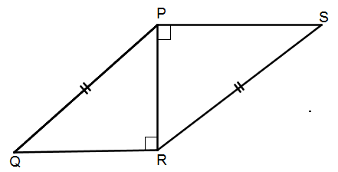
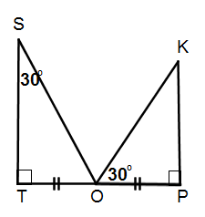
3.2.1 3.2.2

(4)
3.3 ABCD is ‘n parallelogram. 3.3 ABCD is a parallelogram
Bewys dat $∆DAE ≡ ∆CBF$. Prove that $∆DAE ≡ ∆CBF$.

(6)
3.4 Gegee: / Given: $A\hat{B}C=A\hat{C}B$ ; $BD = CE$.
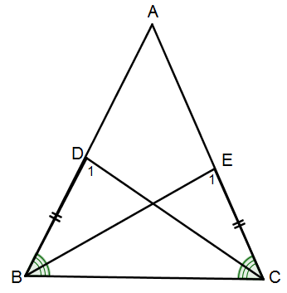
Bewys dat / Prove that: $\hat{D_{1}}= \hat{E_{1}}$

(4) [17]

VRAAG 4 QUESTION 4
4.1 Sê of die volgende driehoeke 4.1 Say whether the following triangles
gelykvormig is of nie. Gee ‘n rede are similar or not. Give a reason for
vir jou antwoord. your answer.
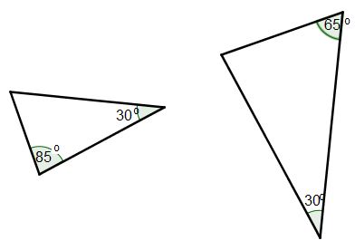

(2)

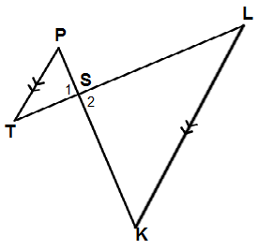
4.2 Bewys dat $∆PTS$lll $∆KLS$ 4.2 Prove that $∆PTS$lll $∆KLS$

(4)
[6]
VRAAG 5
Konstrueer die volgende skets akkuraat deur eers ‘n rowwe plan te teken: - jy mag net
‘n liniaal en passer gebruik – los alle konstruksielyne.

‘n Wildplaas is in die vorm van ‘n driehoek,$∆ABC$.
Sy AB is 16 km lank en sy BC is 10 km lank. $A\hat{B}C is 60˚.$
Gebruik die skaal 1cm : 1km om die skets te konstrueer.

Gebruik BC as die horisontale basis.
Meet AC en dui dit aan op die skets.Dui die hoekpunte aan deur A, B en C.

QUESTION 5

Construct the following map accurately by first drawing a rough plan: - you may
only use a ruler and compass – leave all construction arcs.

A Game Farm has a shape of a triangle, $∆ABC$ .
Side AB is 16 km long and side BC is 10 km long. $A\hat{B}C is 60˚.$
Use a scale of 1cm : 1km to construct the map.

Use BC as the horizontal base
Measure AC and fill it in on your map. Label the vertices A,B and C [6]
TOTAAL / TOTAL: [50]

