Life Orientation

Grade 12

Term 2

Democracy & Human Rights

1. | Define the term responsible citizenship
2. | What is the Bill of rights?
3. | Define the term “Discrimination
4. | How would you deal with discrimination?
5. | Define the term “Human rights Violations

Operation Underground railroad (O.U.R.) paves the way for permanent eradication of child sex trafficking through:
- Coordinated rescue
- Recovery planning

In the past six years of existence, O.U.R. has rescued 3,300 victims and assisted in the arrests of more than 2,000 traffickers around the world. The partners we are empowering have collectively helped rescue the lives of more than 10,000 survivors who were enslaved, exploited or at risk.

Read the following article and answer the questions

21 SURVIVORS RESCUED IN SEX TRAFFICKING RAID
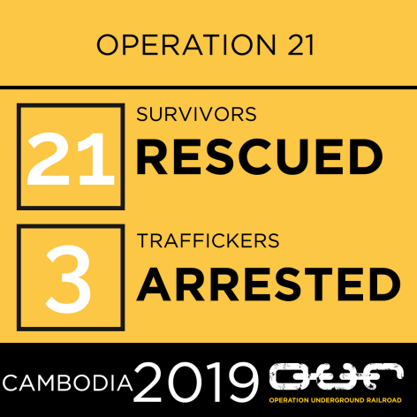
Oct 11, 2019 | agapewebsite.org

In one of our largest operations, local police officers and AIM SWAT rescued a total of 21 victims, including 6 minors, from a high-end massage parlour in Phnom Penh on September 16th. This is our largest sex trafficking raid to date and the beginning of FREEDOM for these women and girls.

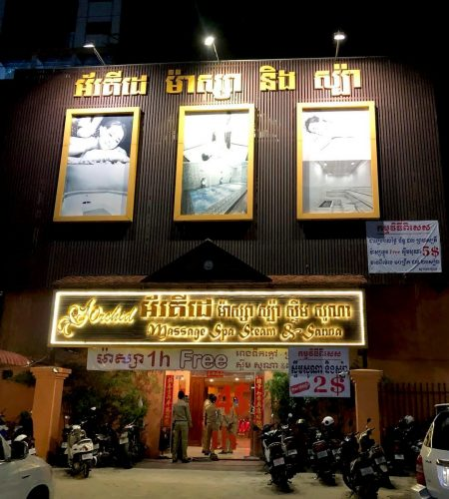
The raid followed a covert surveillance operation that was launched after officers received information that minors were being sold for sex or sexual services to customers.

The 21 survivors were rescued during the raid and 3 suspected traffickers were detained.

The massage parlour was officially closed down by local authorities after evidence inside the parlour was secured.

The 3 suspects were then arrested and will await trial from prison for child sex trafficking-related offenses.

We are now looking after all 6 minor girls and 5 of the adult women at our Restoration Home, while the other 10 women have been transferred to partner shelters for aftercare services.

The AIM Legal Team will represent all 21 victims throughout the forthcoming court process.

Rescue is where freedom starts for these women and children. We are truly grateful for the incredible support of our partners who make these raids possible and enable us to rescue girls and stop traffickers from ever hurting them again.

TOGETHER, WE WILL BRING AN END TO TRAFFICKING.

Questions
6. | Identify which human rights were violated in this article (there’s more than one)
7. | What impact do you think these violations will have on the victims?
8. | What does (O.U.R.) stand for?
9. | How does the (O.U.R.) help these victims?
10. | How can you help?
11. | Give 10 other human rights violations

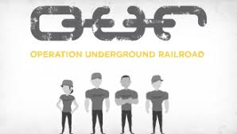

The role of the media

12. | What is freedom of expression
13. | What is the “job” of the media?
14. | Define the term “fake news”?
15. | What impact could fake news have on companies and individuals?
Ideologies, believes and world views on recreation and physical activity across culture & genders

16. | How do Ideologies, believes and world views on recreation and physical activity affect participation in sport?
17. | Define the term “culture”?
18. | Do you think that in Sports today there is still discrimination? Give a reason for your answer

Social and environmental responsibility

19. | What responsibilities does the government have
20. | Define the term “Laws”?
21. | Give 2 examples of Laws that promote safe and healthy living
22. | Define the term “by-laws”?

Personal mission statement for life
23. | What is a mission statement
24. | Define the term “values”?
25. | Give 10 examples of values
26. | Define the term “belief system”?
27. | Define the term “religion”?
28. | What does religion mean to you?

Personal mission statement for life
29. | Name and discuss 4 different religions
Impact of vision
30. | How does your vision on actions and behavior impact your life? Name and explain 5

