SUMMARY
GRADE 9 - PRACTICE

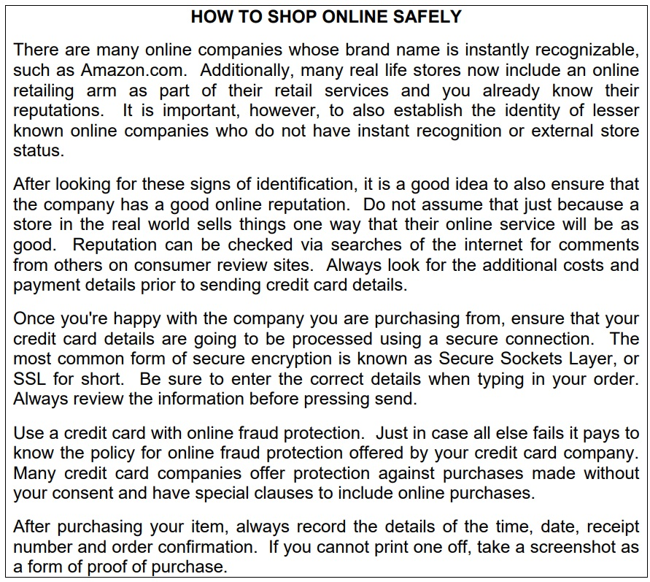

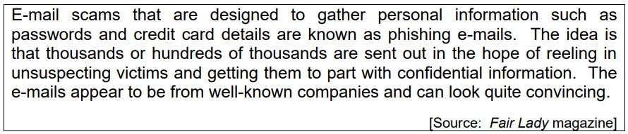

MEMO

HOW TO SHOP ONLINE SAFELY

1. Verify the identity of online companies you want to use.
2. Do not assume that an online company is as reliable as its real world equivalent.
3. Check comments and reviews from other users.
4, Check all details before you press the send button.
5. Make sure that your credit card has online fraud protection.
6. Keep a detailed record of all your purchases.
7. Be on the alert for phishing/fraud.

