CAPS LESSON PREPARATION

SUBJECT: PHYSICAL SCIENCE GRADE: 12
KNOWLEDGE AREA: MECHANICS
SECTION/S: VERTICAL PROJECTILE MOTION
DURATION: 30. Minutes / periods
LESSON OBJECTIVES | At the end of the lesson learners should know the following:  - Define the terms free fall and projectile  - Describe the motion of a free-falling object that is  - Dropped / released from some height above the ground  - Thrown vertically downwards  - Thrown vertically upwards and caught at the point of projection  - Thrown vertically upwards from a certain height and reach the ground below the point of projection.  - Use equations of motion to determine position, velocity and displacement of a projectile at any point in time.

PRE-KNOWLEDGE | Grade 10  - Vectors and scalars.  - Describing uniform linear motion – constant velocity and constant acceleration.  - Graphs of motion.  - Equations of motions.  Grade 11  - Newton’s second law of motion.

PRESENTATION
- Define free fall as a type of motion in which gravitational force is the only force acting on an object.

Ignore the effects of air friction

- Define a projectile as an object upon which the only force acting is the force of gravity

A free body diagram of a free-falling object – 1 MARK

Fg

- An object is dropped / released from a height of height of 29,4 m above the ground. Ignore air friction.

Unpacking the scenario:
- The object starts from rest: v_{i} = 0 m.s⁻¹
- Ignore air friction: Gravitational force (not gravity) is the only force acting on the object – the object is in free fall

A free body diagram of a free-falling object – 1 MARK

Fg
- Since gravity is the only force acting on the object: F_{g} is the F_{net} acting on the object.
- According to Newton 2nd law of motion (Grade 11): the object accelerates uniformly in the direction of F_{g}. The object moves faster and faster downwards.
- Constant acceleration of 9,8 m.s⁻² downwards (magnitude and direction). The velocity of the object changes by 9,8 m.s⁻¹ for every second (constant acceleration)
- From grade 10

Time (s) | 0 | 1 | 2 | 3
Velocity (m.s⁻¹) | 0 | 9,8 | 19,6 | 29,4

- v vs t graph is a straight-line graph starting at the origin with a constant gradient (acceleration)
- a vs t graph will be represented by a straight horizontal line (constant acceleration) a = 9,8 m.s⁻²

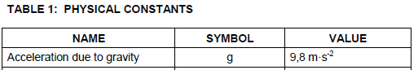

Important points to note

For an object in free fall:
- Only the force of gravity acts on the object.
- The object has a constant acceleration of g = 9,8 m.s⁻² downwards

- For an object thrown vertically downwards when air friction is ignored:
- We consider the motion from the moment it leaves the hand – thus from the point only gravitational force acts on the object (free fall)
- v_{i} is not equal to zero, however, the object’s velocity still changes by the same magnitude per second – constant acceleration.

- For an object thrown vertically upwards when air friction is ignored:
- We still consider the motion of the object from the instant it leaves the thrower’s hand – thus only gravitational force acts on object (free fall)
- The object moves slower and slower until it comes to rest (constant acceleration) - Grade 10
- As the object slows down while moving upwards, it is actually accelerating in the direction of the gravitational force (downwards) - constant acceleration.

Language usage

- How long: implies time (∆t)
- How fast: implies speed (scalar) or velocity (vector)
- How high: refers to distance or displacement (∆y) between any two points in motion.
- Dropped: implies the object is released from rest, vi = 0 m.s⁻¹
- Thrown: implies that the object is given a non-zero initial velocity (upwards or downwards)

Examinable scenarios

- A ball dropped from height “h”
- A ball thrown vertically downward from height “h”
- A ball thrown vertically upwards at a certain non-zero initial velocity
- A ball dropped from a moving object (relative initial velocity)
- Bouncing ball

Worked example

A ball is thrown vertically upwards with a speed of 15 m.s⁻¹ from the edge of a balcony and strikes the ground 6 seconds later. Ignore air friction.

1.1 define the term free fall. (2)
Basic recall type of question: all or nothing 2/2 or 0/2
Pay attention to the key words and must be used in the correct scientific context.

1.2 Calculate

1.2.1 how high above the balcony the ball travels. (3)

Choose sign convention i.e. which motion is taken as positive
Take upwards as positive: a = - 9,8 m.s⁻² and vi = 15 m.s⁻¹, take note that the initial velocity and acceleration are in opposite directions.
Consider motion from the point of projection to the highest position whose time we do not know: v_{f} = 0 m.s⁻¹
Identify the relevant equation of motion and substitute correctly
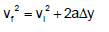
0² = 15² + 2(- 9,8)∆y

∆y = 11,48 m

A calculation problem that carries 3 MARKS is usually a simple routine calculation – fromula, substitution and answer. Be on the lookout !!!

1.2.2 the velocity of the ball when it strikes the ground. (3)

Consider the motion from the point of projection (initial position) until the ball strikes the ground (final position)
a = - 9,8 m.s⁻² and vi = 15 m.s⁻¹

∆t = 6 s

Identify the relevant equation of motion and substitute correctly

v_{f} = 15 + (- 9,8)(6)

v_{f} = - 43,8 m.s⁻¹

v_{f} = 43,8 m.s⁻¹ downwards (magnitude and direction)

1.2.3 the height of the balcony
Consider the motion from the point of projection (initial position) until the ball strikes the ground (final position)
The change of position (∆y) of the ball is essentially the height of the balcony.
a = - 9,8 m.s⁻² and vi = 15 m.s⁻¹

∆t = 6 s

Identify the relevant equation of motion and substitute correctly:

∆y = 15(6) + 0,5(- 9,8)(6)²

∆y = - 86,4 m

Therefore, the height of the balcony is 86,4 m
(Always interpret the answer)

Problem-solving Approach

- Draw the trajectory followed by the projectile (if necessary)
- Put critical points in your trajectory, i.e. Point of launch, Maximum height, point symmetrical to the point of launch and the ground
- Choose sign convention i.e. which motion is taken as positive
- When applying equations of motion, always consider motion between any two points (initial and final) and take direction into account.
- Refer to the data sheet. Copy the relevant equation and subsequently isolate the unknown, without attempting to initially change the subject of the formula.

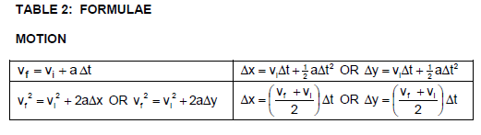

LEARNER ACTIVITY

Multiple choice

Question 1

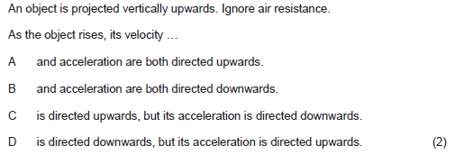
Question 2
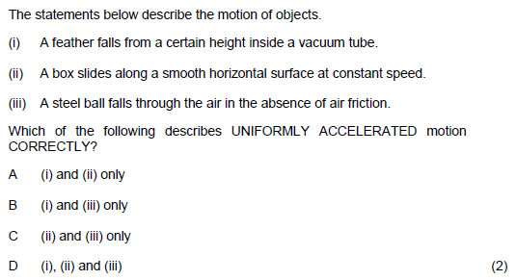

Question 3

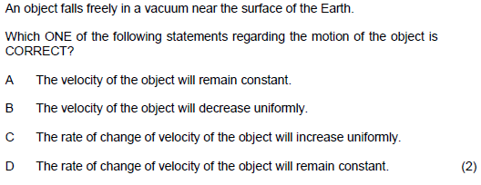

Question 3
