Practical work
Grade 10
Life Sciences

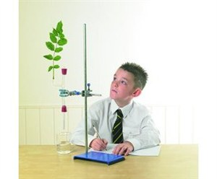

Session 2
Strand: Life processes in plants and animals
Index
1 | The effect of temperature, wind and humidity on the transpiration rate | 3
2 | Water uptake through the roots | 9
3 | Water movement through xylem | 12
4 | Dissection of a mammal heart | 14
5 | The effect of exercise on pulse rate | 20
6 | Laboratory organisation | 24

- The effect of temperature, wind and humidity on the transpiration rate
Aim: To investigate the effect of temperature, wind and humidity on the rate of transpiration.
Apparatus:
- potometer (or similar apparatus)
- leafy twig
- heater
- rubber tubing
- capillary tubing
- beaker
- fan
- stopwatch
- paper towel
- black marker
- transparent plastic bag
Method:
- Attach the cut end of the leafy twig to the capillary tubing by a short length of rubber tubing. Cut the stem and join it to the tube under water.
- Clamp the capillary tube to a stand with the bottom end in a beaker of water as shown in the diagram. Make sure no air bubble gets into the system.
- Make two marks A and B on the capillary tube 10 cm apart.
- Lift the capillary tube out of the beaker, touch the end of it with some paper towel, and then put it back. An air bubble will have been introduced into the capillary tube.
- Wait until the bubble reaches point B.
- Time how long it takes for the air bubble to travel from point B to A on the capillary tube.
- When the air bubble has passed on the second mark push it back out of the capillary tube into the beaker of water by squeezing the rubber tubing.
- Repeat the investigation with the other environmental factor.
Precautions:
- Cut the leafy twig under water to prevent blockage of the xylem.
- Seal all joints to prevent entrance of air.
- For the best results the end shoot can be cut at an angle.

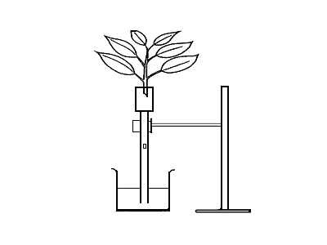
rubber tube

capillary tube

beaker of water

air bubble

Apparatus used to measure rate of transpiration
under various environmental conditions
o
marker A
marker B
HIGH TEMPERATURE
- Place a heater at a suitable distance from the twig. Switch on the heater. Wait for about 15 minutes
- Record your observation in the table provided.
HIGH HUMIDITY
- Spray the inside of a transparent plastic bag with water. Place a plastic bag over the leafy twig. Tie the bag around the base of the twig. Wait for 15 minutes.
- Record your observation in the table provided.
WIND
- Place a fan at a suitable distance from the twig. Switch on the fan. Wait for about 15 minutes
- Record your observation in the table provided.

Observations:
Table of Results
 | Time taken for the bubble to move from first to second mark (s)
Condition | Reading 1 | Reading 2 | Average
Wind
Humidity
Temperature

Discussion:
- Why was the twig cut under water? -------------------------------------------------------------------------------------------------------------------------------------------------------------------------

- List two precautions you would observe when conducting this experiment.----------------------------------------------------------------------------------------------------------------------------------------------------------------------------------------------------------------------------------

- What conditions should prevail for a high rate of transpiration to occur? -------------------------------------------------------------------------------------------------------------------------------------------------------------------------------------------------------------------------------------------------------------------------------------------------------------------------------------------------

- Use the data to draw a bar graph comparing the rates of transpiration under different conditions.

Conclusion:
--------------------------------------------------------------------------------------------------------------------------------------------------------------------------------------------------------------------------------------------------------------------------------------------------------------------------------------------------------------------------------------------------------------------------------------------------------------------

Alternative experimental settings
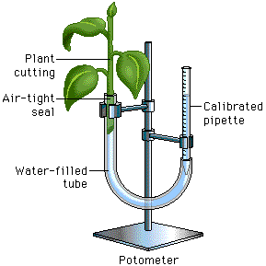
Example 1
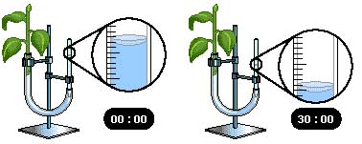
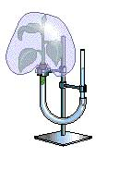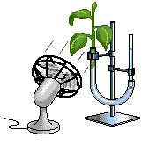
Humidity Wind

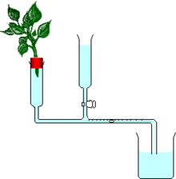
Example 2

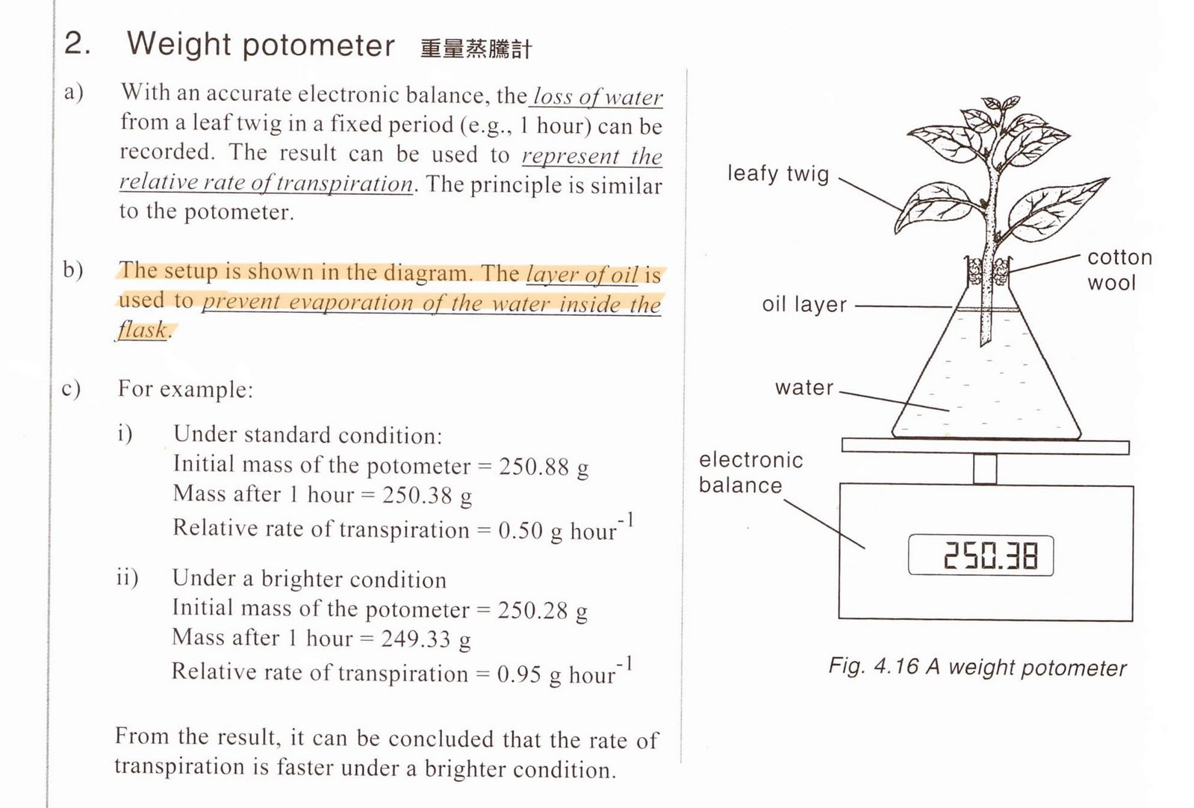
Example 3

- Water uptake through the roots
ACTIVITY 1

CAPILLARITY

Aim: To investigate the spontaneous movement of water through tubes with different diameters.

Apparatus:
- 100 ml beaker.
- 3 capillary tubes of different diameters.
- Water.
- Ink (red/blue/black).
Method:
- Half fill the beaker with water.
- Add sufficient ink to dye the water and make it clearly visible.
- Observe the level of water.
- Place three capillary tubes of different diameters in the beaker.
- Observe the level of water in each capillary tube.
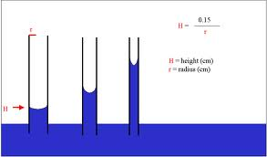

Observation: Draw the capillary tubes and indicate level of water in each.

Conclusion: Liquids have a natural tendency to move up tubes with narrow diameters (fine pores)
ACTIVITY 2

ROOT PRESSURE

Aim: To investigate whether roots exert a pushing force strong enough to cause water to move up the stems of plants.

Apparatus:

- Potted plant
- Retort stand
- Glass tube
- Pliers
- Rubber tubing
- Wire
- Knife
- Rubber stand

Method:

- Carefully cut the stem of a well watered plant about 4-5 cm above the soil level.
- Attach rubber tubing to the stump that remains.
- Tie the rubber tubing tightly to the glass tubing and the stump using pliers and
wire.
- Clamp the glass tubing in the place using a retort stand.
- Add a little water through the open end of the glass tube.
- Add one or two drops of oil or paraffin over the water in the tube.
- Mark the level of water and oil/paraffin.
- Continue to water the cut potted plant two to three times a day.
- Observe what happens to the level of the water in the glass tube.

Precautions:
- Use a sharp knife to cut the stem to ensure that xylem cells are not damaged.
- Add oil/paraffin over the water in the tube to prevent evaporation of water.
- The potted plant must be well water prior to the experiment to
- The rubber tube must be airtight to

Results/Observation:

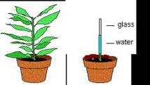

After a day or two, the level of water rises in the glass tube.

Discussion:

Transpiration takes place through the stomata of mainly the leaves, and to some extend through, the stems. Since there were no leaves, transpiration could not have occurred and be responsible for the rise in water in the glass tube. The glass tube was not a capillary tube i.e. the bore is large not narrow to cause rise in water level in the tube. Therefore, the rise in water level in the glass tube could only be due to root pressure.

Conclusion:

Root pressure is responsible for the upward movement in the plant

- Water movement through xylem
Aim: To demonstrate the path way of water through a plant
Apparatus / Materials:
- two stalks of celery or white roses or white flowers such as arum lilies or daisies or carnations or impatiens
- clear drinking glass or glass beaker (250ml)
- water
- 15ml food colouring (preferably red or blue)
- a sharp knife or blade

Method:
- Pour 200ml water into the glass and add 15ml food colouring.
- Cut 1 cm from the end of flower stem using a knife or blade. Preferably keep the stalk under water while cutting.
- Immediately place the flower into the glass of coloured water.
- Place the glass in the direct sunlight and leave for 24 hrs or a few days
- Notice the colour change to the white petals.
- Use a razor blade or knife to cut a thin cross section. Make a wet mount and look at it under a light microscope.
Results/Observations:
- Cut the stem again near the end and use a hand lens to observe the cut surface
  - Do you notice any of the stain inside the plant?
__________________________
  - If so, where is it?
_____________________________________________________________

- Draw simple cross section diagrams to show the positions of the stained tissue from the stem as you observe it under the microscope. Indicate which parts appear stained in your diagram.

- Name the tissue that is stained.
________________________________

- Explain two ways in which the tissue stained is adapted for its function.
_________________________________________________________________

_________________________________________________________________

_________________________________________________________________

- Why must the stem be cut under water?
_________________________________________________________________

Conclusion:

_______________________________________________________________________

_______________________________________________________________________

_______________________________________________________________________

- Dissection of a mammal heart
Aim: To observe the parts of a sheep heart
Apparatus/Materials:
- Fresh sheep’s heart specimen from a local butcher
- Dissecting needles
- Forceps or tweezers
- Sharp scalpel or knife
- Pair of sharp scissors
- Needle or metal probe
- Dissecting tray or dissecting board to cut on
- Label flags or tags
- Pins

Method:
- Obtain a fresh specimen of a sheep heart
- Put on safety glasses or goggles, gloves, and lab apron
- Place the heart in a dissecting tray or board
External anatomy

- Study Figures 1 and 2 and familiarize yourself with the mammalian heart structures.

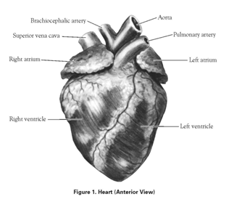
Aorta
Brachiocephalic artery

Pulmonary artery
Superior vena cava

Left atrium
Right atrium

Right ventricle
Left ventricle

Figure 1: Heart (Anterior View)

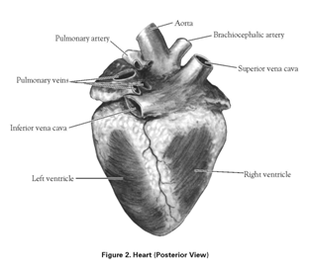
Aorta
Brachiocephalic artery
Pulmonary artery

Superior vena cava
Pulmonary veins

Inferior vena cava

Right ventricle
Left ventricle

Figure 2: Heart (Posterior View)

- Notice the fat that covers the upper part of the heart and blood vessels. Remove as much of this fat as possible, using forceps to either pick or scrape it away. Work carefully and do not damage any of the heart structures as you remove the fat.
- The fat is light colored, soft, and without structure. Heart muscle is dark and fibrous. The walls of blood vessels are thin, tough, and usually smooth on the inside. Make an effort to distinguish between these 3 tissue types.
- Once you remove the fat, locate the structures shown in Figures 1 and 2. In some cases, the blood vessels may be cut so close to the heart that little more than holes remain to show where they once attached.
Internal anatomy

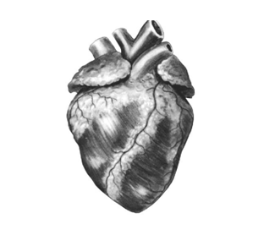
- The hearts anterior must face you

Figure 3

- Cut open the left atrium and locate the bicuspid valve between the left atrium and ventricle.
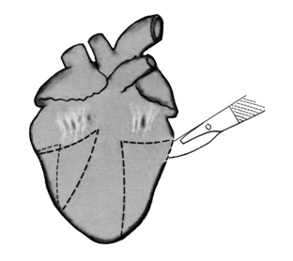
- Beginning at a point below the middle of the left ventricle, make an incision through the left ventricle wall as shown in the figure below. Remove the lower-front portion of the wall.

Figure 4

- Look through the hole you have produced and locate the chordae tendineae and the papillary muscles as shown in Figure 5.
- Trim away the front and side of the left ventricular wall, leaving part of the papillary muscles and all of the bicuspid valve in place. Make an incision to the side of the bicuspid valve as shown at A in Figure 5.
- Spread the left side of the heart and identify the structures labeled in Figure 5
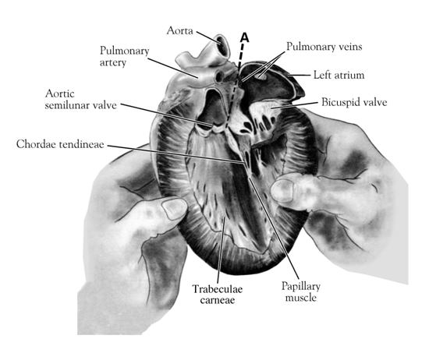
Aorta
Figure 5
Pulmonary veins
Left atrium
Bicuspid valve
Pulmonary artery
Aortic semi lunar valve
Chordae tendineae
Papillary muscle
Trabeculae carneae
- The right side is dissected similarly; begin by opening the top of the right atrium and locating the tricuspid valve between the right atrium and ventricle.
- Remove the lower-front portion of the ventricular wall just as you removed that of the left ventricle.
- Cut high across the front of the heart to locate the pulmonary semi lunar valves.
- Identify the structures labeled in Figure 6.
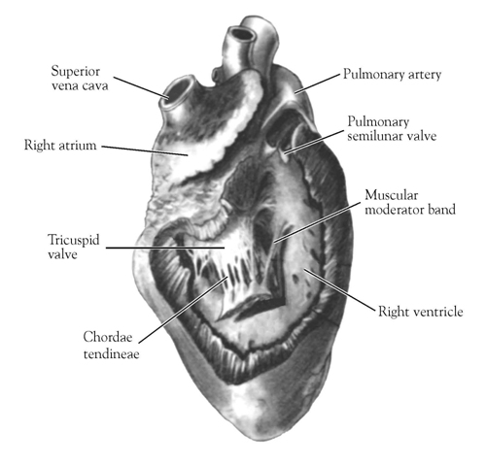
Pulmonary artery
Pulmonary semi -lunar valve
Muscular moderator band
Superior vena cava
Right atrium
Tricuspid valve
- Observe the thick septum that divides the right and left sides of the heart
Figure 6
Right ventricle
Pulmonary artery
Chordae tendineae
- Use forceps or tweezers to pull part of the membrane, called the pericardium, away from the heart muscle.
- Identify the two atria and feel the thickness of their walls.
- Squeeze the left and right ventricles and describe what you feel.
- Identify the blood vessels to and from the heart. Find the vena cava, large veins that enter the right atrium, blood vessels
- Push a dissecting needle or probe down these vessels to help you find out from which part of the heart they are coming
- Compare the wall thickness of the pulmonary artery and aorta with those of vena cava and pulmonary vein.
- Use the label tags or label flags to identify the different blood vessels, chambers, valves, muscles on the label flags
Precautions:
Learners should wear safety glasses or goggles, gloves, and lab aprons when dissecting. They should dissect on the dissection tray at all times to contain the specimen and any excess fluids. Promote proper hygiene practices before, during, and after the lab.
Results/Observation:
Answer the following questions:
- With what is the heart covered and what is the function of this structure?
----------------------------------------------------------------------------------------------------------------------
- Which large artery can you observe on the outer surface of the heart and what is the function of it?
----------------------------------------------------------------------------------------------------------------------
- Identify the atriums and ventricles externally and internally. Make note of their differences
 | Atrium | Ventricle
Colour
Muscular walls
Size

- Explain why the ventricles have much thicker walls than the atriums?
----------------------------------------------------------------------------------------------------------------------
- Explain why the left ventricles feels much firmer that the right ventricle.
----------------------------------------------------------------------------------------------------------------------
- Suggest why the arteries leaving the heart have thicker walls than the veins that enter the heart
----------------------------------------------------------------------------------------------------------------------
- Which blood vessels enter at the:
Left atrium -------------------------------------------------------------------------------------------
Right atrium -------------------------------------------------------------------------------------------
- Which arteries leave the:
Left ventricle -------------------------------------------------------------------------------------------
Right ventricle -----------------------------------------------------------------------------------------
- Identify the valves inside the heart. Identify the valves found:
Between the left atrium and left ventricle -----------------------------------------------------
Between the right atrium and left ventricle ----------------------------------------------------
Inside the aorta ---------------------------------------------------------------------------------------
- Why are valves necessary for the heart to function correctly?
----------------------------------------------------------------------------------------------------------------------
11. Draw a simple labelled diagram to show the internal structure of the sheep’s heart.
Use arrows to show the direction of flow of blood

- The effect of exercise on pulse rate
The effect of exercise on the heart rate
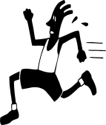
Aim: To investigate the influence of exercise on the heart rate of a person.
Apparatus:
- Stopwatch (Cell phone may also be used).
- Pen and paper
Method:
- Work in pairs.
- Measure both persons’ heart rates and record it in the table at rest position.
- The first person (Person A) runs on the same place for 30 seconds (lift knees up high when running).
- When finished running, person B takes person A’s pulse and record it in the table.
- Person B runs on the same place for 30 seconds.
- When finished running, person A takes person B’s pulse and record it in the table.
- Person A runs on the same place for 60s and person B measure and records his/her pulse rate after he/she finished running.
- Repeat step 7 but with person B doing the running and person A doing the measuring and recording.
- Person A runs 90s on the same spot and person B measures his/her pulse and record it.
- Repeat step 9 but with person B doing the running and person A doing the measuring and recording.

Tip: How to measure a person’s pulse rate:
Place your index and middle finger on the inside of the wrist. Count the number of beats you feel for a minute.
This is the pulse rate, measured in beats per minute.

Results:
Duration of exercise (seconds) | Heart rate of person A (beats per minute) | Heart rate of person B (beats per minute)
Rest
30s
60s
90s

Discussion:
Interpretation:

- Name the dependant variable.
___________________________________________________________

- Name the independent variable.
___________________________________________________________

- What variables did you keep constant?
__________________________________________________________

- What relationship exists between the dependant and independent variable?
___________________________________________________________
- How could you increase the reliability of the experiment?
______________________________________________________________________
______________________________________________________________________
- Why is exercise recommended?
______________________________________________________________________________________________________________________________________

- Name some diseases which are the result of people not exercising and overeating?
______________________________________________________________________________________________________________________________________

Conclusion:
______________________________________________________________________________________________________________________________________________________________________________________________________________________________________________________________________________________________________________________________________________________________________________________________________________________________________________________________________________________________________________________________________________________________________________________________

Memorandum The effect of exercise on the heart rate
Discussion:
Line graph showing the relationship between the duration of exercise and heart rate

Time (seconds)
Heart rate
(beats per minute)

- Heart rate.
- Duration of exercise.
- Type of exercise, same person doing three sets of exercise (person A does three sets and person B does three sets.)
- The longer the duration of the exercise the higher the heart rate becomes. The two variables are directly proportional to each other.
- Do more sets of the exercise by increasing the time with 30 s with each set. Use more people. Do different kinds of exercises and compare the results.
- It keeps the body fit and healthy. It exercises the heart muscles which also keeps the heart healthy. It prevents fat depositing in the arteries which causes illnesses.
- Diabetes type 2, Cholesterol, artereo-sclerosis
Conclusion:
The child should discuss the relationship between the two variables, what went wrong, how the experiment could be improved and what effect the exercise has on the heart rate (maybe talk about health issues.)

- Laboratory organisation
- Laboratory organization
- Equipment and chemicals are stored in a systematic, orderly and a neat manner.
- Equipment and chemicals borrowed from a preparation room or storage area is
returned to the assigned place.
- Teaching and storage rooms are uncluttered with no equipment protruding over
benches, no dangling wires and no equipment stored on the floor.
- Bench tops are always clean. Any spillage is wiped up immediately.
- Reagent bottles are clearly labelled and filled regularly.
- Sinks are clean and not blocked with waste.
- Separate waste bins are used for broken glass (which must be wrapped) for paper, for cloth and for solid chemical residues.
- Water outlets, gas turrets on the benches, power outlets and electrical switches are in good working order.
- The laboratory and storeroom doors are locked when not occupied.
- Supervision of students
Supervision of students must be continuous and vigilant so that unauthorized or inappropriate behaviour does not lead to accidents resulting in physical injury, fires or other dangers. Teachers must choose a set of laboratory rules to be prominently displayed and with copies given to students. Students must know the rules and understand them.
Teachers must pay particular attention to the following rules:
1. Students do not enter any laboratory or storeroom unless a teacher is present.
2. Students do not eat or drink in the laboratory or storeroom.
3. Students do not taste chemicals.
4. Students must behave in a careful and businesslike manner.
5. Students are safely seated and not crowded, with fellow students, chemicals and glassware not within "elbow width".
- Experimental procedures
1. Read the label on reagent bottles twice to avoid errors.
2. Always follow exactly the instructions for chemical experiments.
3. Do not substitute another chemical for chemicals specified in the experiment instructions.
4. Always add a solid to a liquid reagent to achieve better control of gases that form in the reaction.
5. Do not let students do unauthorized experiments. Some chemicals are safe by themselves, but they may form explosive mixtures when mixed with oxidizing agents, e.g. sulfur, sucrose (cane sugar) and powdered zinc..
- Biological hazards and use of live animals
- Students and the local community may be upset if they think animals suffer during experiments, e.g. fish and frogs.
2. Human saliva, human cheek cells, human whole blood from a hospital source, and human teeth scrapings may transmit diseases. The use of body fluids for secondary school experiments is not favoured nowadays so many laboratory experiments are now being done with artificial solutions. Do not take blood samples from staff or students.
3. Studies of living mosquitoes may risk transmission of malaria and other diseases.
4. Most animals can inflict bites so handle them with great care. Animal bites may transmit infections and animals may carry human parasites.
5. Treat dissection material as if it is contaminated. Dissecting instruments must be sterilized before use.
6. Vermin and the insects are attracted to animal food. Mouldy and decaying animal food and animal wastes may be health hazards because of the presence of bacteria and other micro-organisms.
7. The teacher must answer the following questions about using live animals:
7.1 Is it essential for live animals to be kept?
7.2 Have alternatives to animal experiments been investigated?
7.3 Has the number of animals been kept to a minimum?
7.4 Will the animals be housed under appropriate conditions?
7.5 Who will take responsibility for feeding and caring for animals during holiday periods?
- Equipment safety
Test-tubes, glassware and microscope slides
1. Never look down a test-tube and never point the open end of a test-tube at a student while a reaction occurs. Hold the test-tube up to the light and look from the side. Put the test-tube in a test-tube rack before putting chemicals in it. When heating substances in test-tubes, move the test-tube back and forth across the flame. Heat substances in wide test-tubes or boiling tubes.
2. When transferring materials from one container to another, hold the containers at arms length. Check glassware for cracks before use. Put broken glass metal pieces and unused chemicals in a specially marked container and bury them.
3. Microscope slides and cover slips are easily broken. Do not leave broken pieces on the desk. After each class where microscopes are used, wipe the benches with a damp cloth to remove broken glass, especially broken cover slips.

- Safety signs
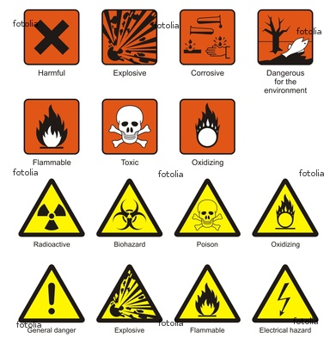
Harmful Explosive Corrosive

Dangerous for
the environment
Flammable Toxic Oxidizing
Radioactive Biohazard Poison Oxidizing

General danger Explosive Flammable Electrical hazard

