MATHEMATICAL LITERACY

GRADE 10
Investigation 1

2019

SCHOOL BASED ASSESSMENT TASK

TOPIC: Finance and Data handling

MARKS: 50

WEIGHTED MARK: 10

SUGGESTED TIME: 60 Minutes

INSTRUCTIONS AND INFORMATION

1. | Answer ALL the questions.
2. | Number the answers correctly according to the numbering system used in this question paper.
3. | You may use an approved calculator (non-programmable and non-graphical), unless stated otherwise.
4. | Show ALL calculations clearly.
5. | Write neatly and legibly.

QUESTION 1

1.1 | Twenty-five - year old Jane has a 3-month old baby. She is eligible for the monthly child grant from the state, because she is unemployed.  In this task you need to find out more about the child grant and draw up a budget for Jane based on the money available to her. Assume that Jane has only one child.  If you have access to the Internet, go to http://www.sassa.gov.za/ INTRODUCTION - TO SOCIAL -ASSISTANT-642aspx.  Alternatively, you may phone toll free 0800 60 10 1  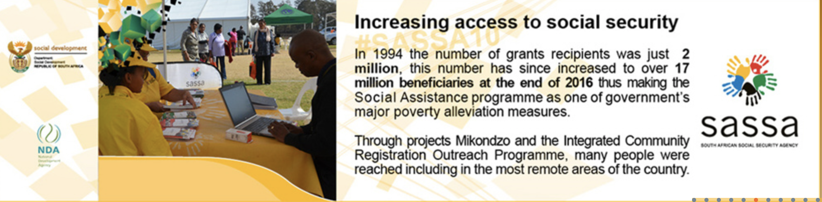

 | 1.1.1 | How do you get information about the child grant? |  | (2)

 | 1.1.2 | Define child grant |  | (2)

 | 1.1.3 | How much money is a child grant? |  | (2)

 | 1.1.4 | Who is eligible to receive a child grant? |  | (2)

 | 1.1.5 | How does the money get paid out to the recipients? |  | (2)

1.2 | Interview Jane to find out what she needs to buy every month for the baby.

 | 1.2.1 | Develop a questionnaire (minimum 5 questions) that you are going to use and hand it in with your investigation. |  | (5)

 | 1.2.2 | Draw up a list of items (things she needs for the baby on a monthly basis) based on the information from the interview. |  | (5)

1.3 | Visit any two shops to get comparative prices of the items in Q1.2.2 and present your information in a suitable table OR provide evidence from the shop.  The following table may be used.  # Item Prices @ Shop A Prices @ Shop B  1  2  3  4  5  … |  | (10)

1.4 | Draw up a monthly budget for Jane. Your budget must be reasonable in terms of Jane’s income from the grant. You might have to leave off certain items after careful consideration. |  | (10)

1.5 | Provide five financial advices to Jane explaining why it is necessary to leave out certain items and guide her on alternative ways to obtain those items or how to cope without those items. |  | (10)

[50]

