MATHEMATICAL LITERACY

GRADE 10
Assignment 2

2019

SCHOOL BASED ASSESSMENT TASK

TOPIC: Basic Skills, Measurement and Finance

MARKS: 50

WEIGHTED MARK: 10

SUGGESTED TIME: 60 Minutes

INSTRUCTIONS AND INFORMATION

1. | This question paper consists of TWO questions. Answer ALL the questions.
2. | Use the ANNEXURE to answer QUESTION 1.2
3. | Number the answers correctly according to the numbering system used in this question paper.
4. | Start EACH question on a NEW page.
5. | You may use an approved calculator (non-programmable and non-graphical), unless stated otherwise.
6. | Show ALL calculations clearly.
7. | Round off ALL final answers appropriately according to the context, unless stated otherwise.
8. | Indicate units of measurement, where applicable.
9. | Maps and diagrams are NOT necessarily drawn to scale, unless stated otherwise.
10. | Write neatly and legibly.
QUESTION 1

1.1 | A bank charges 12% simple interest p.a. on cash loans to its clients. Tito has asked for a R10 000 loan amount and has promised to repay the loan over 4 years.

 | 1.1.1 | Define the term interest in the given context. |  | (2)

 | 1.1.2 | Re-write 12% as a common fraction in simple form. |  | (2)

 | 1.1.3 | Convert 4 years to months. |  | (2)

 | 1.1.4 | Calculate the interest which Tito should pay for the loan. |  | (4)

 | 1.1.5 | Calculate the total amount Tito must pay back after 4 years. |  | (2)

 | 1.1.6 | Give ONE reason why people loan money from banks. |  | (2)

1.2 | Banks can charge clients/customers fees for services rendered.  Study XYZ Bank tariff table on the ANNEXURE to answer the questions that follow.

 | 1.2.1 | Write down the monthly fee for a Gold account. |  | (2)

 | 1.2.2 | Calculate the bank charges if a client wants to send a cash amount of R450,00 to a friend at an ATM without using a card. |  | (3)

 | 1.2.3 | Calculate the total bank charges for the month (Excluding the Monthly account fee) if the following transactions was made:  - R500 cash withdrawal from Branch counter  - R200 External debit order  - R 5 600 XYZ Bank ATM cash deposit |  | (8)

[27]

QUESTION 2

2.1 | Cell 5 Network has increased their 2015 tariffs for the monthly subscription on the 100 Always-call-U charges of their contract phones. The fixed monthly contract rate will be R100 with free 100 minutes and then thereafter a call charge will be 50 cents per minute (or part of a minute).  100 Always-call-U  250  200  150  Amount A (rands)  100  50  0  0  100  200  Time t (minutes)  300  400

Use the information above to answer the questions that follow.

 | 2.1.1 | Copy and complete the table:  Time, t (minutes) 0 50 100 150 200 250 300  Call charges 0 0 0 25 50 D E  Amount, A (rand) A 100 B 125 150 C 200 |  | (5)

 | 2.1.2 | Explain why the graph is plotted in a horizontal pattern from 0 to 100 minutes. |  | (2)

 | 2.1.3 | If a person makes 37 calls of approximately 3 min each.  Calculate the total cost of these calls using, the table or the graph above. |  | (4)

 | 2.1.4 | Is this graph above an example of direct or indirect proportion? |  | (2)

2.2 | A grade 10 class is going to bake muffins.  The recipe that they are going to use requires the following ingredients  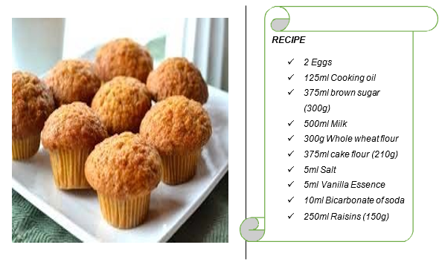

 | 2.2.1 | Convert 375 ml to litres. |  | (2)

 | 2.2.2 | How many eggs will be needed to bake 156 muffins? |  | (3)

 | 2.2.3 | The students need to make 504 muffins, using muffin trays that hold 6 muffins per tray. They plan to put 4 trays at a time into a oven. Each oven takes 20 minutes to bake. How long will they take to make 504 muffins if they will be using 4 ovens? |  | (5)

[23]

ANNEXURE A

QUESTION 1.2
XYZ BANK’s tariff table
Transaction type
Monthly Fees
Monthly account fee | R22 (Current Account)  R30 (Silver, Gold, Platinum)
Deposits
Cash deposit: Branch counter | R4,85 + 1,15% of deposit value
Cash deposit: XYZBANK ATM | R1,10 per R100 (or part thereof)
Cash Withdrawals
Branch Counter | R27,00 + R1,15/R100 (max R500)
XYZBANK ATM | R3,85 + R1,10/R100
Account payments
- XYZBANK ATM  - Branch counter | R3,75 + R0,75/R100 R33,00
Debit and stop orders
- Internal  - External stop order  - External debit order | R5,20  R3,75 + R0,75/R100 (max R15,00) R3,75 + R0,75/R100 (max R25,00)
Electronic Funds transfer
- XYZBANK ATM  - Branch counter | R3,15 R33,00
CASH SEND (XYZBANK ATM) | R6,90 + R1,05/R100

