MATHEMATICAL LITERACY

GRADE 10
Assignment 1

2019

SCHOOL BASED ASSESSMENT TASK

TOPIC: Basic Skills

MARKS: 50

WEIGHTED MARK: 10

SUGGESTED TIME: 60 Minutes

INSTRUCTIONS AND INFORMATION

1. | This question paper consists of TWO questions. Answer ALL the questions.
2. | Use the ANNEXURE to answer QUESTION 2
3. | Number the answers correctly according to the numbering system used in this question paper.
4. | Start EACH question on a NEW page.
5. | You may use an approved calculator (non-programmable and non-graphical), unless stated otherwise.
6. | Show ALL calculations clearly.
7. | Round off ALL final answers appropriately according to the context, unless stated otherwise.
8. | Indicate units of measurement, where applicable.
9. | Maps and diagrams are NOT necessarily drawn to scale, unless stated otherwise.
10. | Write neatly and legibly.
QUESTION 1

1.1 | Study the lotto information below and answer the questions that follow.  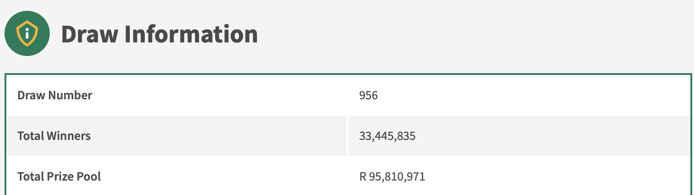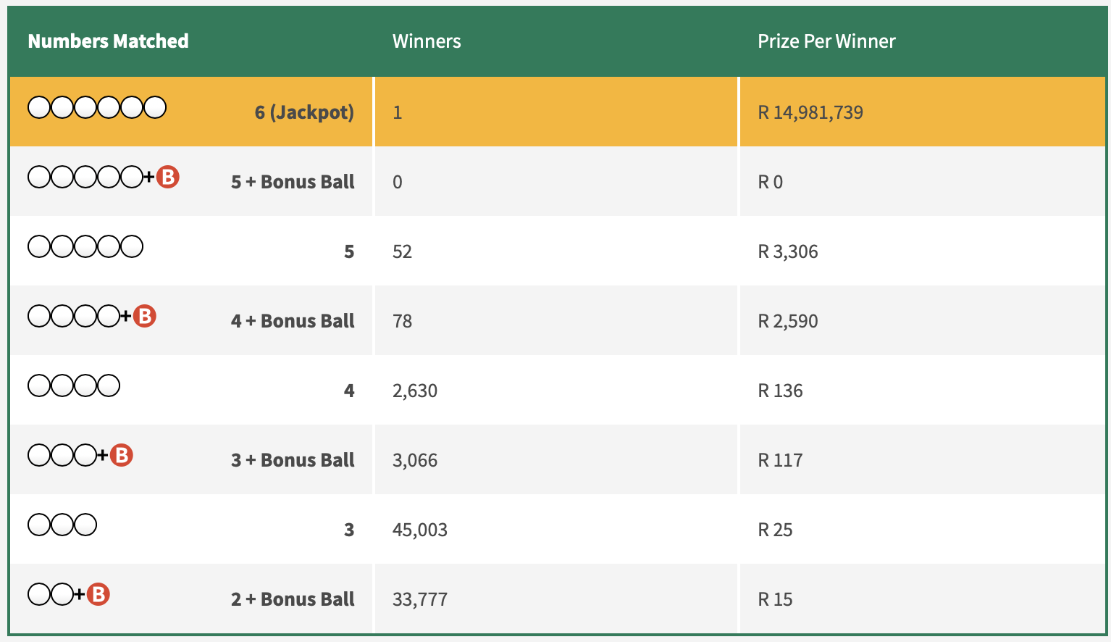

 | 1.1.1 | Write the total number of winners in the correct South African number format. |  | (2)

 | 1.1.2 | Write the Total Prize Pool’s number in words. |  | (2)

 | 1.1.3 | Round the Draw Number to the nearest 5. |  | (2)

 | 1.1.4 | Round the Total Prize Pool to the nearest 50 000. |  | (2)

 | 1.1.5 | Calculate the total prize money that was paid out by the national Lottery for 4+Bonusball numbers matched. |  | (4)

 | 1.1.6 | Give ONE reason why people play the National Lottery. |  | (2)

1.2 | Look at the receipts, collected by the Marufane family, then answer the questions that follow.  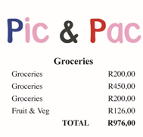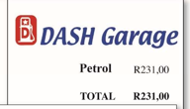

 | 1.2.1 | Write the total car insurance to the total petrol as a ratio. |  | (2)

 | 1.2.2 | Divide the total amount spend of fruit and veg in the ratio of 2:3. |  | (5)

 | 1.2.3 | The Marufune family’s Rent will increase by 7,5%. Calculate the new rent amount, after the increase. |  | (3)

 | 1.2.4 | Round ‘Pic & Pac’ total to the nearest R100. |  | (2)

 | 1.2.5 | Decrease the “General motor vehicle cover” with 15%. |  | (3)
 |  |  |  | [29]

QUESTION 2

2.1 | A petrol tanker arrived at John’s home to refill the storage tank at their farm.  A graph depicting how long it takes to empty the petrol tanker is shown:  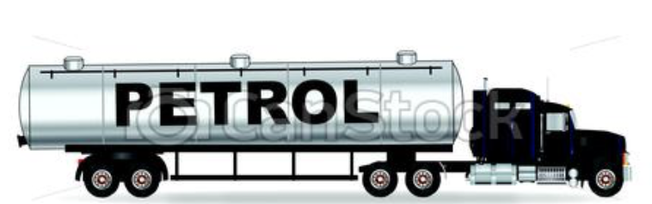  Emptying the tanker  1600  1400  1200  1000  800  600  400  200  0  0  10  20  30  40  Time (min)  50  60  70  80

 | 2.1.1 | Is the above graph an example of direct or indirect proportion?  Give a reason for your answer. |  | (4)

 | 2.1.2 | Determine the maximum volume of petrol in the tanker. |  | (2)

 | 2.1.3 | Determine the volume of the petrol that was left in the tanker after 45 minutes. |  | (2)

 | 2.1.4 | Describe the general trend of this graph. |  | (2)

2.2 | The relationship between John’s Dad’s petrol cost and people in the car when he travels to work in a car is shown below. He spends R50 when he travels alone. His father approached John for advice on saving on travel. John used the following table:  Number of people in car (n) 1 2 3 4 5  Dad's petrol cost in Rand (C) 50 25 16.67 12.5 10

 | 2.2.1 | Describe this relationship in words. |  | (2)

 | 2.2.2 | Draw a graph on a suitable set of axes on the ANNEXURE |  | (5)

 | 2.2.3 | The decision to include a 5th person is not advisable for his dad’s condition.  Give TWO reasons for your answer. |  | (4)

[21]

ANNEXURE

QUESTION 2.2.2
60
50
40
30
20
10
0
0
1
2
3
Number of people in car
4
5
6

