GRADE 10 SKILLS BOOKLET

GRAPHS

Graphs are a way of recording the relationship between two things / factors that can change in picture form. These factors that change in relation to each other are called variables.
Graphs are therefore a way of recording large amounts of information in a simple form that can easily be understood. Graphs make it easier to interpret trends.

Depending on the information we want to record, we can use different types of graphs. The most common graph is the (jagged) line graph; we will also deal with bar graphs, histograms and pie graphs.

Before we start, we need to learn the terminology linked to graphs. The following terms are common to most graphs:

Axis (pl. axes): The vertical axis is the y-axis
The horizontal axis is the x-axis

Origin: The point where the x- and y-axis cross meet.
THERE MUST BE A ZERO AT THE ORIGIN.

Independent variable: always goes on the x-axis.
This is the variable that we can control / change so that we can see what happens.

Dependent variable: always goes on the y-axis.
This is the variable that depends on the independent variable i.e. it changes as we change the independent variable / the variable that is measured.

Scale: This is the way we determine how to plot the information on the graph and we have to take readings from the graph and carefully consider it before we start the graph. We need to make sure that our scale covers all the figures that we have to plot. The scale starts at 0 and must be kept constant e.g. 5, 10, 15, 20 or 10, 20, 30 etc. The scale must also be clearly marked on the axes.

Heading: All graphs must have a heading that includes the information on both axes i.e. both variables. The question will guide you to write the heading. The heading must say what type of graph it is. The heading must not have the units. The heading must be underlined.

Labels: Each axis must be correctly labelled – always include units (if there are any)

Plotting points: Plot the points and clearly mark them on the graph with a dot.
Use a ruler to join the plotted points.

1. JAGGED-LINE GRAPHS:

Line graphs are used when we compare two different number values.

  - Draw two graphs on the same set of axes showing the changes in heart rate of two boys, John and Thabo, as they run over a certain distance.

Distance run (m) | John’s heart rate  (beats per minute) | Thabo’s heart rate  (beats per minute)
0 | 60 | 70
100 | 75 | 80
200 | 85 | 90
400 | 100 | 110
800 | 120 | 115
1500 | 120 | 130

  - What is the relationship between exercise (running further and further) and heart rate
(heart beats per minute)?
_______________________________________________________________________________
_______________________________________________________________________________

  - Translate the information in the table into a line graph on the same set of axes. It gives the % male and female cigarette smokers aged 16 and over from 1972 until 1982.

Year | Percentage cigarette smokers
Year | Males aged 16 & over | Females aged 16 & over
1972 | 52 | 41
1974 | 51 | 41
1976 | 46 | 38
1978 | 45 | 37
1980 | 42 | 37
1982 | 38 | 33

What trend can you infer from the two graphs:
- about smoking in general and
- comparing smoking in males and smoking in females?
________________________________________________________________________________________________________________________________________________________________________________________________________________________________________________

2. BAR GRAPHS / CHARTS:

Bar graphs are used when one of the variables is given in numbers.
Remember:

- bar graphs have separate bars like the bars in a prison
- bars are always the same size (width) – measure and draw with a ruler
- spaces between the bars are always the same size
- do not draw bars against the y-axis
- scale must be clearly marked and the number written next to the mark
- it is strongly advised that a key be used. eg. A, B, C or 1, 2, 3.
- Do not write in the bars.

2.1. Translate the information in the table below showing the number of learners in a class of
35 who like different types of sports, into a bar graph.

Types of sports | Number of learners  who like the sport
Soccer | 8
Rugby | 5
Basketball | 6
Netball | 10
Volleyball | 2
Cricket | 4

2.2. Which sport is liked the least? ____________________________
2.3. Which sport is liked the most? ____________________________
3. HISTOGRAMS:

Histograms are used when information is presented in continuous groups. These are similar
to bar graphs BUT THERE ARE NO SPACES BETWEEN THE BARS.

Remember:

- bars are always the same size (width) – measure and draw with a ruler
- draw bars against the y-axis
- scale must be clearly marked and the number written next to the mark
- it is strongly advised that a key be used. eg. A, B, C or 1, 2, 3.
- Do not write in the bars.

3.1. Translate the following information showing the rainfall (mm) per month for Tshwane in
2004 into a histogram.

Month of the year | Rainfall ( mm)
January | 200
February | 350
March | 210
April | 100
May | 50
June | 10
July | 0
August | 0
September | 10
October | 150
November | 200
December | 280

4. PIE GRAPHS / CHARTS:

How to draw a pie chart:

1. Add the numbers to get a total.
2. Convert to %.
3. Convert % to degrees.

Example.

Convert the following table to a pie chart.

Different food types | No. of portions
Lipids | 10
Proteins | 20
carbohydrates | 40

Step 1 – Add number of portions together to get a total
10 + 20 + 40 = 70

Step 2 – Convert each food type to %.

Lipids –10 X 100 = 14%
70 1

Proteins – 20 X 100 = 29%
70 1

Carbohydrates – 40 X 100 = 57%
70 1

14 + 29 + 57 = 100%

Make sure you round off correctly till you get 100% then proceed to next step.

Step 3 - Convert the % to degrees by multiplying by 3, 6 OR 360/100.

Lipids - 14 % X 3,6 = 50 degrees

Proteins – 29 % X 3,6 = 105 degrees

Carbohydrates – 57 X 3,6 = 205 degrees

50 + 105 + 205 = 360

Add all degrees and once you have 360 degrees then you may proceed to draw the circle.

Remember to use a key for the pie chart.
Do not write any numbers in the pie chart.

4.1. Draw a pie chart above to show the proportion of carbon, hydrogen and oxygen in a
carbohydrate. The proportion of C:H:O is 1:2:1.

4.2. Translate the information showing the number of learners who like different
type of fruits into a pie graph.

Types of fruits | No. of learners who like  the fruits
Kiwi | 10
Apples | 5
Pears | 15
Oranges | 10

SCIENTIFIC DIAGRAMS:
Remember:
- Diagrams must be drawn with a pencil.
- Draw sharp, clear and solid lines.
- No shading or colour.
- Diagrams must be 10 lines big or a third of the page big.
- Labels should be printed in lowercase unless a structure is the name of a person e.g. Golgi apparatus.
- Labels must be one below each other.
- Label lines should be drawn with a ruler and should be parallel.
- Heading should include: Drawing of ………… what it is …………. which view i.e. L/S or a C/S ………….. fresh material / seen under a microscope ……………. with magnification e.g. A line diagram of a cross section of a dicot root as seen under a microscope X200. (Section of diagram and magnification must be include only if relevant to diagram)
- Heading must be underlined.
- You may be asked to draw annotated diagrams. These are diagrams with labels and functions or labels and descriptions of the structures.

Study the micrograph below. Draw a C/S of this nucleus on the next page. DO NOT TRACE THE DRAWING!! Label it.
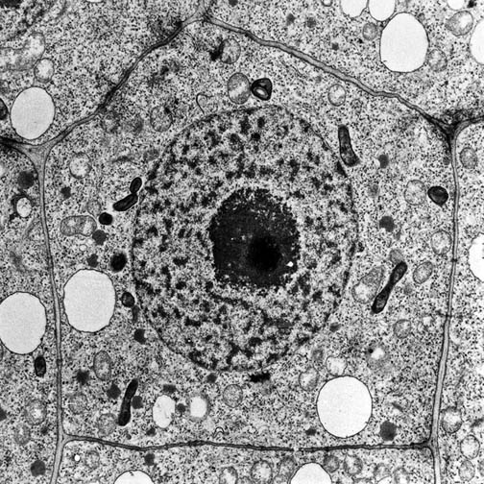

TABLES

- A table must have a heading which includes the variables that are in the table
.ie. A table of ….
- The heading must be underlined.
- A table must have columns and rows. (horizontal and vertical lines)
- Each column must have a heading and units. (if applicable).
- Table must have a frame or border (drawn in pencil and with a ruler)
Tabulate the differences between a plant and an animal cell in the space below.

ESSAYS:

Remember:
- An essay is a series of paragraphs with facts managed correctly and in an order.
- There is NO introduction and conclusion.
- Write in third person. ( Do not use I and me in the essay)
- The use of scientific terminology, ability to select relevant information and link it to the theme of the essay is tested.
- No diagrams or flow charts may be included in the essay.
- Facts must be organized in a logical way.
- Stick to the topic and do not give irrelevant information.
- Do not write more than 1 and half pages.
The cell is the basic structure of life. Discuss the statement by referring to the structure and function of the nucleus and the mitochondria.
……………………………………………………………………………………………………………………………………………………………………………………………………………………………………………………………………………………………………………………………………………………………………………………………………………………………………………………………………………………………………………………………………………………………………………………………………………………………………………………………………………………………………………………………………………………………………………………………………………………………………………………………………………………………………………………………………………………………………………………………………………………………………………………………………………………………………………………………………………………………………………………………………………………………………………………………………………………………………………………………………………………………………………………………………………………………………………………………………………………………………………………………………………………………………………………………………………………………………………………………………………………………………………………………………………………………………………………………………………………………………………………………………………………………………………………………………………………………………………………………………………………………………………………………………………………………………………………………………………………………………………………………………………………………………………………………………………………………………………………………………………………………………………………………………………………………………………………………………………………………………………………………………………………………………………………………………………………………………………………………………………………………………………………………………………………………………………………………………………………………………………………………………………………………………………………………………………………………………………………………………………………………………………………………………………………………………

An essay is only for 17 marks so should not be more than one a half pages.

Include paragraphs which flow form one idea to the next idea.

The 3 marks for synthesis is for:

Relevance – only answer what is asked in the topic. NO extra information.

Logical sequence- One idea must flow with another and make sure you write a statement and a
reason.

Comprehensive- may be based on marks or the number of correctly linked statements and reasons.

THE SCIENTIFIC METHOD

Steps of the scientific method

Ask a question: The scientific method starts with a question about something that you observe:
How, Why, When, What or Where?

Construct a hypothesis: A hypothesis is an educated guess about the outcome of the experiment:
If ____________________ (I do this) ______, then _____(this) ____will happen.
You must state your hypothesis in a way that you can easily measure or test. Include both the dependent and independent variable and the relationship between the variables in the hypothesis.
Test your hypothesis by doing an experiment: your experiment tests whether your hypothesis is true or false. It is important for your experiment to be a fair test. You conduct a fair test by making sure that you change only one factor at a time while keeping all the other conditions the same.
You should also repeat your experiments several times to make sure that the first results were not just an accident (if possible).

Variables

Independent variable : a variable/factor that you choose to control in the experiment.

Dependent variable: a variable/factor that you measure in an experiment.

Fixed variables: Variables/factors that stay the same throughout the experiment.
Begin with the word same…

Aim
To determine / To investigate …. . The aim must include the 2 variables.

Apparatus
List all apparatus/ chemicals/equipment you will use in the experiment. You may be asked to draw the apparatus as it should be set up.

Method
The method is written in steps and is numbered. It is short and simple and written in third person, as a set of instructions.

Results/Observation
A table is best used to record results. The observation can include what you have seen, heard or smelt. You may be asked to draw a graph in the results.

Discussion
State the results. Discuss the results. Why it happened and what caused it to occur? Was the hypothesis true or false? Was it a fair test? How could you have improved the experiment?

Conclusion
Refer back to aim. It is a short statement.

EXAMPLE OF A SCIENTIFIC WRITE-UP

Investigative question
Do plants on a window sill grow towards light?

Hypothesis
If plants are placed on a window sill, then plants will grow towards light.

Aim
To investigate if plants on a window sill grow towards light.

Dependent variable: growth of a plant

Independent variable: amount of light

Fixed variables: same size pot plant, same amount of water, same amount of soil,
same time intervals, same type of plant, same temperature.

Apparatus
- 2 pot plants (same size and type, same amount of soil and water)
- window sill near light
- dark cupboard
Method
- Collect 2 pot plants.
- Place one pot plant on a window sill.
- Place the other pot plant in a dark cupboard.
- Leave for 2 weeks.
- Record the observations.

Observation

A table of the growth (direction) of 2 pot plants in the dark and on the window sill (different amount of light)

Pot plant in dark | Pot plant on window sill
No change | Entire plant grew towards light

Discussion
The pot plant on the window sill grows towards light. Plants need light for photosynthesis. The hypothesis is supported.
How could you have improved the experiment?

Evaluation
The experiment is not a fair test as I could have used many plants and could have increased the sample group.

Conclusion
Plants on a window sill do grow towards light.

EXERCISE: DESIGNING AN EXPERIMENT USING THE SCIENTIFIC METHOD:

PRACTICE EXERCISE:
Your teacher put forward the hypothesis that males are stronger than females. To test this she takes her class into the playground where they decide to test her hypothesis by finding out who can throw an object the furthest. Study the pictures below showing how they complete the test and what the result shows.
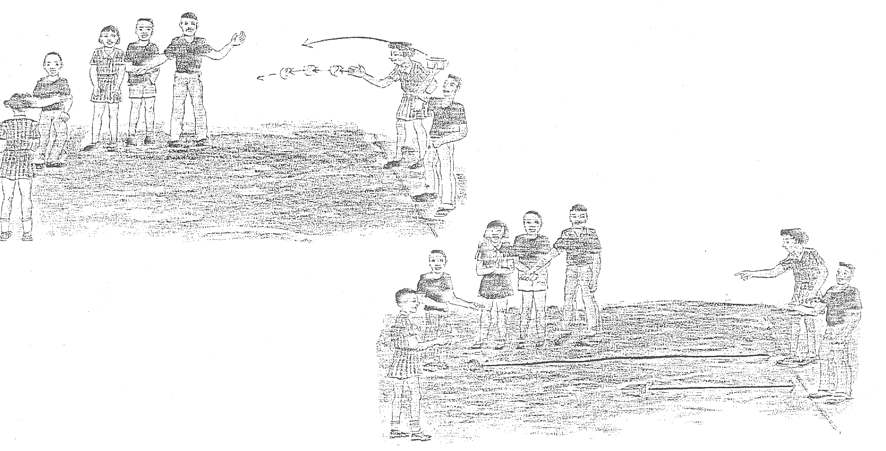

Result: ……………………………………………………………….......................................
Conclusion: ……………………………………………………………...................................
Was the teacher’s hypothesis correct? ………………………………………
Do you agree with the outcome of this experiment? …………………………………………
Give reasons for your answer above: .…………………………..............................................
……………………………………………………………………………………………………………………………………………………………………………………………………
Is this a fair test? ………………………..
How could you change this experiment to make it a fair test?
(Hint: variables)……………………………………………………………………………….
……………………………………………………………………………………………………………………………………………………………………………………………...........
Name the independent variable(s) in this experiment: ……………….....................................
…………………………………………………………………………………………………
Name the dependent variables(s): …………………………………………………................

Write down the experiment to test this hypothesis.
Do this on a separate sheet of paper.

HOMEWORK EXERCISE: DESIGNING AN INVESTIGATION USING SCIENTIFIC METHOD:

Observation: Mrs Ntuli has two different kinds of pots in her kitchen. The food always seems to cook quicker when she uses the aluminium pots than when she uses the enamel pots.

Write a scientific report with the following headings:
- Hypothesis
- Aim
- Apparatus
- Variables
- Method
- Results (including a suitable graph)
- Conclusion
- Evaluation

PLANNING STEPS
4.3. (Nov 2010 Paper 1)

The blood bank wants to carry out an investigation to determine the distribution of blood groups of
1 200 learners in a high school. They decide to use a sample to do their investigation in order to save costs and time. They also want to get a reliable result.

4.3.1. State any FOUR planning steps that the blood bank should put in place to do this investigation,
before they draw blood from the learners, using a syringe. (4)

4.3.2. State THREE precautions that the blood bank should take when drawing blood from the
learners. (3) (7)

Answer

4.3.1.
- Determine sample sizeü
- Determine the venueü
- Take random samplesü
- Arrange necessary equipmentü
- Arrange trained personnel ü
- Inform school of day and time research will take placeü
- Draw up a table to record informationü (4)

4.3.2.
- Personnel should wear glovesü
- Sterilise the learners armsü
- Use new sterile syringes for every learner that is testedü
- Apply pressure to stop the bleedingü
- Monitor the learners after drawing the bloodü (3) (7)

RELIABILITY

- Repeat the investigation.
- Increase the sample size.
VALIDITY

Validity questions how the investigation or experiment or method was carried out. It is important to be sure that all the factors or variables have been controlled except the one variable that is being tested.
To ensure validity the samples must be chosen randomly.

LONG QUESTIONS
ALWAYS REMEMBER TO: WRITE A STATEMENT WITH A REASON!!!!!

CALCULATIONS
- AVERAGES
To calculate the average: Add together the set of quantities and then divide by the number of
quantities that were added.

Example. The average of 2, 4, 6 and 8
2+4+6+8 = 20
20 ÷ 4 = 5 is the average.

- PERCENTAGE INCREASE AND DECREASE
% increase or decrease = difference X 100
first

You must know and write the formula in any problem.

Example 1. Pretoria High School for Girls had 200 girls in 2004. The numbers have

increased to 350.

Calculate the percentage increase of girls in the school.

% increase = difference X 100
first

150 X 100 = 75 % increase
200

Example 2. Nadine weighed 55 kg when she was 16 years old. At 21 years she weighs 49 kg.

What is the percentage decrease in her mass?

% decrease = difference X 100

first

6 X 100 = 11 % decrease
55

Example 3.

Mass of different materials recycled for the years 2004 and 2010

Type of material | Mass (in millions of tons)
Type of material | 2004 | 2010
Paper | 2,5 | 3,0
Glass | 1,0 | 1,7
Plastic | 0,4 | 0,6
Wood | 0,8 | 0,9

    - Calculate the percentage increase in the mass of paper recycled from 2004 to 2010. (2)
Answer

Percentage increase = Difference X 100
First

3,0 – 2,5 X 100 ✓ OR 0,5 X 100
2,5 1 2,5 1
= 20 %✓ (2)

- RATIOS
Simplify the numbers to its simplest form.
Remember the order of the ratio is given in the question.

Example 1 14 boys and 16 girls

7: 8

Example 2 Morgan has 9 cows, 3 dogs and 27 cats on her farm. What is the ratio of
animals in her farm?

3: 1: 9

- TRENDS
As the one variable increases or decreases so too does the other variable increase/ decrease/ no change.

(From T. Isaac study guide)
Year | Total amount of solid waste (millions of tons) | Amount of recyclable material in solid waste (millions of tons)
2003 | 1,49 | 0,78
2004 | 1,59 | 0,82
2005 | 1,80 | 1,20
2006 | 1,93 | 1,30

    - Describe the general trend in the total amount of waste produced and the amount of recyclable materials dumped from 2003 to 2006. (5)
Answer
    - The total amount of solid waste produced increased✓ from 1, 49 to 1, 93 ✓ in 2003 to 2006 and the amount of recyclable material increased ✓ from 0, 78 to 1,30✓ in 2003 to 2006. ✓ (5)

May mention words like increase, decrease, becomes constant or stable.
Describe the increase or decrease by using the words: steady, slow or drastic.
Use the numbers as well to show the increase or decrease.

- RELATIONSHIPS
As the one variable increases or decreases so too does the other variable increase or decrease.

Do not use words such as directly and indirectly proportional.

(From T. Isaac study guide)
Amount of nitrate fertiliser added to crop (kg/hectare) | Yield of grass  (100 kg/hectare)
0 | 8
225 | 14
425 | 18
650 | 20
700 | 20
750 | 19

    - Describe the relationship between the amount of fertiliser added and the yield of grass. (3)
Answer

    - As the amount of nitrate fertiliser increases✓ so too does the yield of grass increase✓ up to a certain point. ✓ (3)

- MAGNIFICATION: Using a microscope

Total magnification = eyepiece magnification X objective lens magnification

= 10 X 40

= 400X

