Gr 11 Geomorphology – questions

1.2 Refer to FIGURE 1.2 showing a landscape found in South Africa. Four options are provided as possible answers to the following questions. Choose the answer and write only the letter (A – D) next to the question number (1.2.1 – 1.2.5) in the ANSWER BOOK, for example 1.2.6 A. (March 2009)
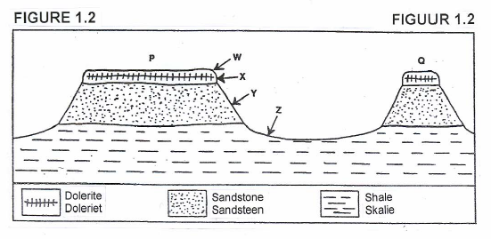
1.2.1 The landscape illustrated in FIGURE 1.2 is associated with … rock.
A massive igneous
B horizontal sedimentary
C tilted igneous
D tilted sedimentary

1.2.2 Landform P is a …
A mesa.
B cuesta.
C butte.
D tor.

1.2.3 Slope element Z is the …
A crest.
B cliff.
C talus.
D pediment.

1.2.4 The landscape is typical of … regions in South Africa.
A humid and hot
B dry and hot
C humid and cold
D dry and cold

1.2.5 The landscape is typical in …
A Mpumalanga.
B KwaZulu-Natal.
C the Northern Cape.
D Gauteng. (5 x 2) (10)

1.6 FIGURE 1.6 illustrates the development of a structural landform associated with massive igneous rock. (March 2009)

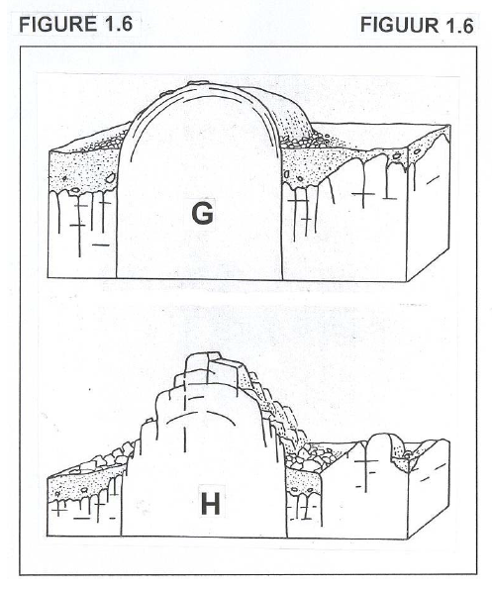
1.6.1 Identify the landforms labelled G and H respectively. (2 x 2) (4)
1.6.2 Name the original underground igneous landform from which landforms G and H originated. (1 x 2) (2)
1.6.3 Briefly explain how landform H develops. (3 x 2) (6)

2.7 Rocks have different types of strata which give rise to unique landforms. Use FIGURE 2.7 to observe some of these landforms and answer the questions that follow. (March 2009)
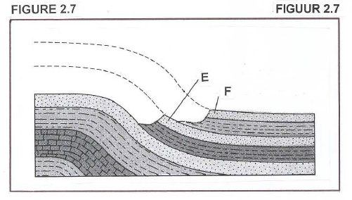
2.7.1 Identify the features (landforms) labelled E and F. (2 x 2) (4)
2.7.2 Give ONE difference between feature (landform) E and F. (1 x 2) (2)
2.7.3 Of what value is this landscape to man? Give TWO reasons. (2 x 2) (4)
[10]

2.2 Refer to FIGURE 2.2 illustrating the four slope elements/forms. Choose the correct term from those given in brackets to make all the statements below TRUE. Write only the term next to the question number (2.2.1 – 2.2.5) in the ANSWER BOOK. (November 2009)
2.2.1 The landform illustrated in FIGURE 2.2 is associated with (tilted/horizontal) sedimentary rock layers.
2.2.2 Slope element W is called the (crest/cliff).
2.2.3 Slope element W consists of (soft/resistant) rock.
2.2.4 The angle at which slope element X develops (remains constant/changes constantly).
2.2.5 Slope element Y gets (wider/narrower) as slope element X retreats.
(5 x 2) (10)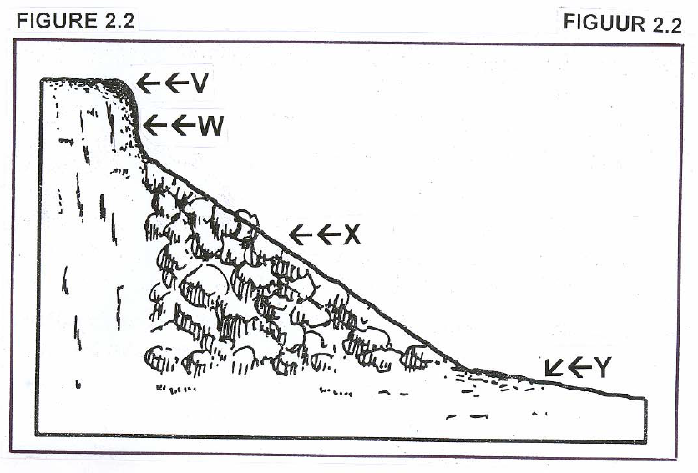

EKHURULENI NORTH 2016 Geography Paper 1 November
FIGURE 1.4
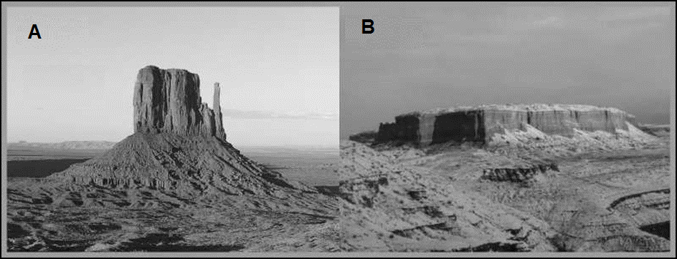
1.4.1 |  | Label Features A and B in FIGURE 1.4. |  | (2x1)(2)
1.4.2 |  | Explain why these features do not decrease in height. |  | (1x2)(2)
1.4.3 |  | Name and explain the process that results in Feature B ending up like Feature A. |  | (2x2)(4)
1.4.4 |  | Where in South Africa will you find these landscapes? |  | (1x2)(2)
1.4.5 |  | Explain what humans would likely use this landscape for? |  | (2x2)(4)

1.6 |  |  | Study the photo of the Magaliesberg and read TEXT 1.6 which describe the Magaliesberg mountain range and answer the questions thereafter.
Magaliesberg is a mountain range extending west and north from Pretoria to just south of Pilansberg. The Magaliesberg Range has a very long geological history. Its quartzite’s, shales and dolomite were deposited as sediments in an inland basin. About 2 billion years ago a massive upwelling of molten magma resulted in what is now known as the Bushveld Igneous Complex. The enormous weight of this intrusion depressed the sediments that lay beneath and tilted the sediments along the edges so that the broken scarps faced outward and upward, and the gentler dip slopes inward.

In 1923, the Hartbeespoort Dam was completed. The Hartbeespoort Dam, surrounded by the Magaliesberg mountain range became a popular holiday and weekend destination for the inhabitants of Johannesburg and Pretoria.
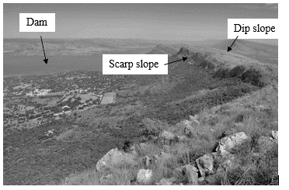
1.6.1 |  |  |  | The Magaliesberg mountain range is made up of sedimentary rock. What is sedimentary rock? |  |  |  |  |  |  | (1x1)(1)
1.6.2 |  |  |  | Name ONE factor that would cause the rock to become inclined. |  |  |  |  |  |  | (1x1)(1)
1.6.3 |  |  |  | Describe the difference between a dip slope and a scarp slope. |  |  |  |  |  |  | (2x1)(2)
1.6.4 |  |  |  | The Magaliesberg Mountains are homoclinal ridges. Explain the difference between homoclinal ridges and hogs back ridges. |  |  |  |  |  |  | (2x2)(4)
1.6.5 |  |  |  | In a short paragraph, describe the significance of cuestas for humans. |  |  |  |  |  |  | (4x2)(8)
 |  |  |  |  |  |  |  | [16]

QUESTION 2
2.1 |  | Examine FIGURE 2.1 A and B and the list of terms given below. Match each term to either FIGURE A or FIGURE B. Write only the number A or B next to the question number. E.g. 2.1.8. A.
FIGURE 2.1 A |  |  |  |  | FIGURE 2.1 B
2.1.1 |  |  |  | Exfoliation |  | 2.1.5 |  | Granite dome
2.1.2 |  |  |  | Core stones |  | 2.1.6 |  | Tor
2.1.3 |  |  |  | Jointed rock |  | 2.1.7 |  | Mechanical weathering
2.1.4 |  |  |  | Chemical weathering |  |  |  | (7x1)( 7)
 |  |  |  |  |  |  |  | [7]

2.3 |  | Study FIGURE 2.3 that illustrates SLOPE ELEMENTS and answer the questions that follow.

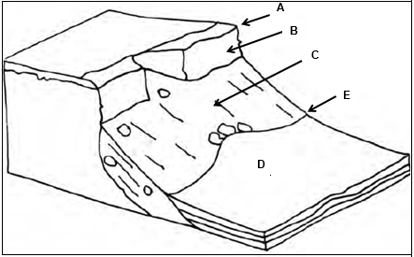
FIGURE 2.3
2.3.1 |  | Define the term scarp retreat. |  | (1x1)(1)
2.3.2 |  | Name point E which indicates a sharp change in gradient. |  | (1x1)(1)
2.3.3 |  | Identify the slope elements A, B, C and D as indicated on FIGURE 2.3. |  | (4x1)(4)
2.3.4 |  | Explain why deposition cannot occur at B. |  | (1x2)(2)
2.3.5 |  | In a short paragraph, describe each slope element (A, B, C and D) in terms of shape and dominant geomorphological process. |  | (4x2)(8)

2.5 |  | Examine FIGURE 2.5 showing an example of mass movement. Answer the questions that follow.

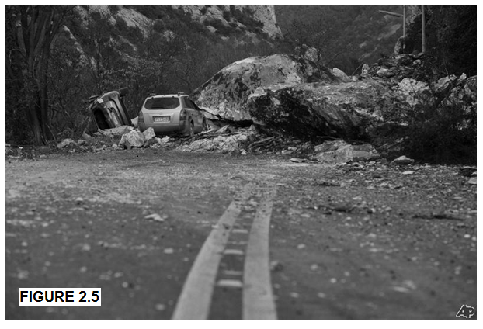

2.5.1 |  | Define the term mass movement. |  | (1x1)(1)
2.5.2 |  | Identify the type of mass movement evident in FIGURE 2.5. |  | (1x1)(1)
2.5.3 |  | Is the type of mass movement depicted in QUESTION 2.5.1 fast or slow? Give a reason for your answer. |  | (2x2)(4)
2.5.4 |  | Describe TWO negative economic impacts that could occur as a result of the type of mass movement evident in FIGURE 2.5. |  | (2x2)(4)
2.5.5 |  | Explain TWO measures that can be taken to prevent the damage shown in FIGURE 2.5. |  | (2x2)(4)
 |  |  |  | [14]

 |  | 2.6 |  |  | Study ARTICLE 2.6 to help you answer the questions below.
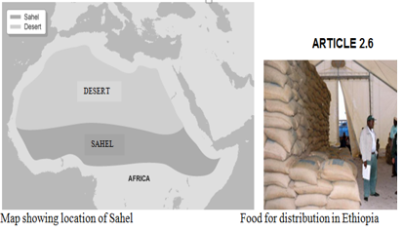

The Sahel region of Africa has been suffering from drought on a regular basis since the early 1980’s. The area naturally experience alternating wet and dry seasons. If the rains fail it can cause drought.
In addition to natural factors, the land is marginal. Human activities such as overgrazing, over cultivation and the collection of firewood can lead to desertification, particularly when combined with drought conditions.
The result is crop failure, soil erosion, famine and hunger: people are then less able to work when their need is greatest. It becomes a vicious circle and can result in many deaths, especially among infants and the elderly. In Niger in 2004, the situation was made worse when a plague of locusts consumed any remaining crops. In these cases, people rely on food aid from the international community.

 | 2.6.1 |  |  |  | Identify the desert of which the Sahel forms the southern border. |  | (1x1)(1)
 | 2.6.2 |  |  |  | Name ONE country that falls within the Sahel region. |  | (1x1)(1)
 | 2.6.3 |  |  |  | Distinguish between the terms drought and desertification. |  | (2x1)(2)
 | 2.6.4 |  |  |  | Name and explain TWO human activities, mentioned in ARTICLE 2.6, which can lead to desertification. |  | (2x2)(4)
 | 2.6.5 |  |  |  | An indirect cause of desertification is the increasing population in sensitive areas. How does this lead to desertification? |  | (1x2)(2)
 | 2.6.6 |  |  |  | Describe TWO ways in which desertification in the Sahel region could be managed by governments. |  | (2x2)(4)  [14]

EKHURULENI NORTH 2016 Geography Paper 1 November

Figure 1.4
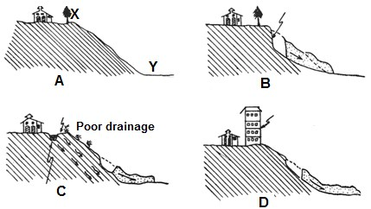
    - Name slope elements/forms X and Y in sketch A. (2x1)(2)

    - Describe the shape of slope X. (1x2)(2)

    - Explain why slope D became unstable. (2x2)(4)

    - Write a paragraph (approximately 8 lines) analysing the impact of
slope instability and methods that could be used to prevent disasters
associated with this instability. (4x2)(8)
[16]

1.6 Study the following picture FIGURE 1.6 before answering the questions.
FIGURE 1.6
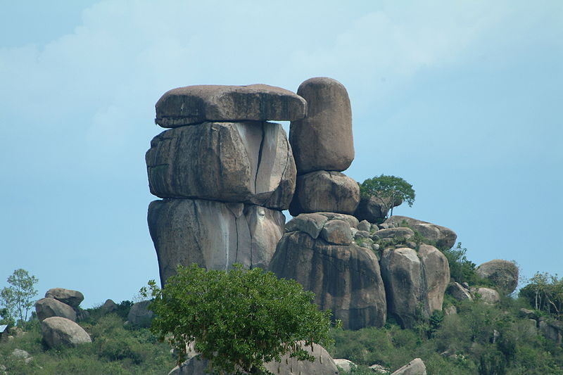

1.6.1 Identify the landform feature in FIGURE 1.6 and define it. (1+1)(2)

1.6.2 State the type of rock associated with the above-mentioned
feature/ phenomena? (1x2)(2)

1.6.3 Identify the process responsible for the formation of the above
feature. (1x2)(2)

1.6.4 Write a short paragraph and explain how the feature in FIGURE 1.6 was formed using the following terms as a guide: batholith, joints, weathering,
core stones. (4x2)(8)

2.2 Refer to FIGURE 2.2 showing a cross-sectional sketch of a structural landform. Two options are given as possible answers to the following questions. Choose the answer and write only the correct answer next to the question number (2.2.1 – 2.2.7) in the ANSWER SHEET, for example 2.2.8.Dome
Figure 2.2
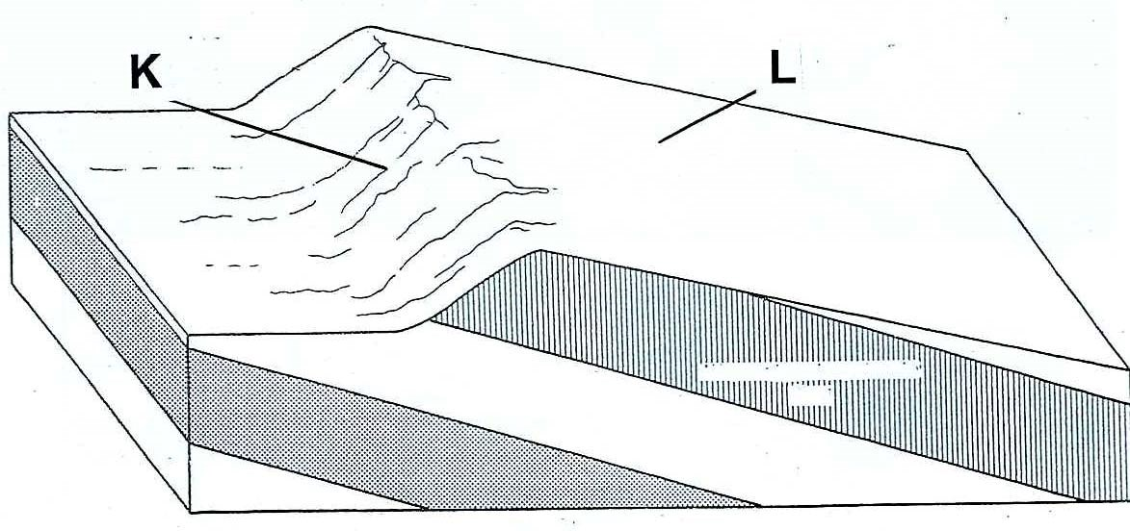
2.2.1 The diagram shows a cross section through a (tor/cuesta).
2.2.2 The structural landform develops from (tilted /horizontal)
sedimentary rock.
2.2.3 Slope K is known as the (scarp/dip) slope.
2.2.4 (Landslides/soil creep) will most likely take place on slope L.
2.2.5 L is the (dip slope / scarp slope)
2.2.6 The distinguishing factor for cuestas and homoclinal ridges is mainly (type of resistant rock / angle of dip slope).
2.2.7 (Dip slope / Scarp slope) of a cuesta is not suitable for human activity.

2.3 Refer to FIGURE 2.3 which shows structural landforms and then answer
the following questions.

FIGURE 2.3
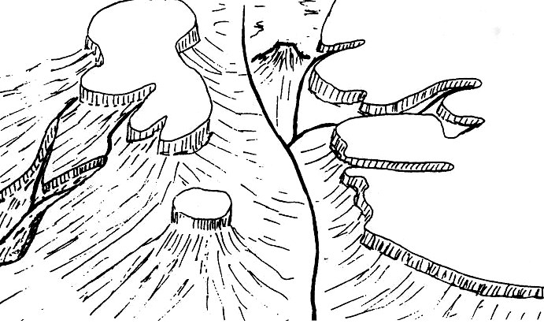

Source:
[

Adapted from

New
G
eneration
G
eography
]

1

4

2
3

A

B

C

D

River

2.3.1 Identify the landforms 2 and 3 respectively. (2x1)(2)

2.3.2 Name the rock strata (layers) represented in the sketch. (1x1)(1)

2.3.3 Where in South Africa will the above landscape typically be found? (1x1)(1)

    - Briefly explain how feature 4 formed from feature 1. (2x2)(4)

    - Write a single paragraph (of approximately 8 lines), discussing how
the landscape illustrated in FIGURE 2.3 can be used by humans.
Also refer to factors that limit the use of this landscape. (4x2)(8)
[16]

  - FIGURE 2.5 illustrates typical slope elements associated with horizontal
strata.
FIGURE 2.5
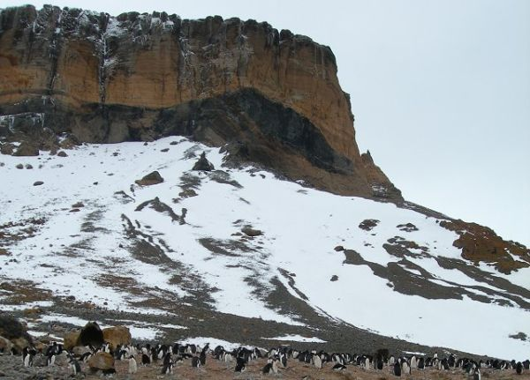
Penguins
Crest
Cliff
D
Talus

    - Describe the shape of the crest. (1x2)(2)

    - Why is the cliff slope so steep? (1x2)(2)

    - Identify TWO ways in which humans can use a cliff. (1x2)(2)

    - Where did the debris fragments on the talus slope
come from? (1x2)(2)

    - Name the slope element labeled D. (1x2)(2)

    - Suggest why vegetation grows better on slope element D
than on the talus slope. (2x2)(4)
[14]

