**Grade 10 Geomorphology : Pass papers**

______________________________________________________________________________

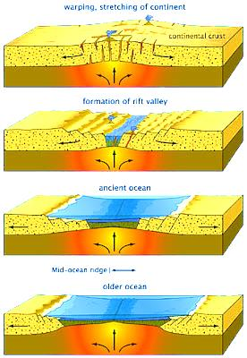

1.6 Refer to **FIGURE 1.6A** illustrating the formation of the ‘Rift valleys’

# and read the extract in FIGURE 1.6B ‘There's a Superplume Under Africa,

# Slowly Splitting the Continent Apart’

# http://bermudatrianglegeography.files.wordpress.com/2013/02/9114d52343c766a7.jpghttp://bermudatrianglegeography.files.wordpress.com/2013/02/9114d52343c766a7.jpg

# There's a Superplume Under Africa, Slowly Splitting the Continent Apart

By Terrell Johnson Published: Aug 6, 2014, 8:24 AM EDT weather.com

“The rift valley is tearing East Africa apart,” , a geochemist at Scripps and one of the study's co-authors. “In another 50 million years, we’ll have another ocean there.”

For many years, scientists have debated what exactly is pushing the tectonic plates underneath the surface apart. The single plate that exists today, the African plate, is slowly dividing into two plates, the Somali plate and the Nubian plate, that will rupture completely in .

As Scientific American magazine points out, geophysicists believed the cause to be what is known as a , a huge area within the Earth's mantle that brings heat up from the planet's core to the crust.

“The rift valley is tearing East Africa apart,” , a geochemist at Scripps and one of the study's co-authors. “In another 50 million years, we’ll have another ocean there.”

For many years, scientists have debated what exactly is pushing the tectonic plates underneath the surface apart. The single plate that exists today, the African plate, is slowly dividing into two plates, the Somali plate and the Nubian plate, that will rupture completely in .

As Scientific American magazine points out, geophysicists believed the cause to be what is known as a , a huge area within the Earth's mantle that brings heat up from the planet's core to the crust.

1. Explain the term *endogenic forces*. (1x2)(2)
2. Explain in detail the formation of lakes along the rift valley by referring to the

steps depicted in FIGURE 1.6A (3x2)(6)

1. Identify the famous African landform mention in the extract of

FIGURE 1.6B. (1x1)(1)

1. Describe these plate boundaries as convergent or divergent. (1x2)(2)
2. Determine if a ‘subduction zone’ would be present with the plate

boundary mention in Question 1.6.4. give a reason to support your answer.

(2x2)(4)

[15]

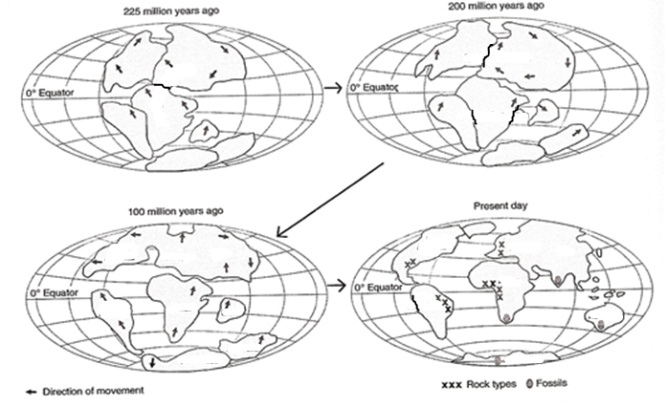

1.2 Refer to **FIGURE 1.2** on ‘Continental Drift’ and answer the following questions.

1. Who is the “father” of the continental drift theory? (1x1)(1)
2. Name the large water mass that existed 250 million years ago. (1x1)(1)
3. Name the large landmass that existed 250 million years ago. (1x1)(1)
4. Name the **TWO** landmasses found in the north and south respectively

when this large landmass split. (2x1)(2)

1. Name any **TWO** of the present-day continents that used to be part of

Gondwanaland. (2x1)(2)

1. Name the present day country that broke away from the southern

continents to join the northern continents of today. (1x1)(1)

[8]

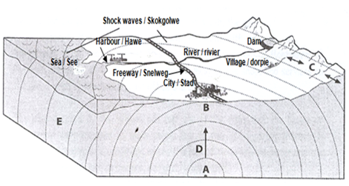----------------------------------------------------------

1.4 Refer to **FIGURE 1.4** showing the structure of a magnitude 7 earthquake.

1. What is an *earthquake*?
2. Label point **A** and **B**.
3. Identify the types of waves at **C** and **D** respectively.
4. Explain why the intensity of the shock waves decreases from B. (1x2)(2)
5. Write a short essay (no longer than 8 lines) in which you discuss the consequences that a magnitude 7 earthquake would have on the city (in the diagram) and it’s surrounding areas. Use specific examples from the diagram to justify your answers. (4x2)(8)

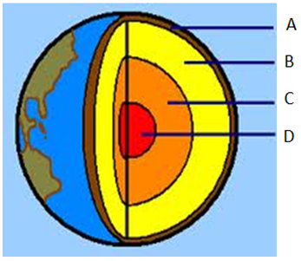

2.2 Refer to **FIGURE 2.2** illustrating the ‘Structure of the earth’. Choose a term

from Column B to match the description in Column A. Write only the terms next to the question number (2.2.1 – 2.2.7) in the ANSWER BOOK, for example 2.2.4 liquid.

|  |  |  |
| --- | --- | --- |
| Column A | Column B | |
| 2.2.1 The state of balance between the continental and oceanic rocks of the Earth’s surface | A | Outer core |
| 2.2.2 The oceanic crust made of Silica and magnesium | B | Isostasy |
| 2.2.3 The upper level of ground that is saturated with water | C | Sima |
| 2.2.4 Molten layer of rock known as magma | D | Crust |
| 2.2.5 The thin plane separating the molten layers from the crust | E | Water table |
| 2.2.6 The upper layer of the Earth's crust made of rocks rich in silicates and aluminium minerals | F | Inner core |
| 2.2.7 The core that is liquid in nature | G | Mantle |
|  | H | Moho discontinuity |
|  | I | Sial |

#########################################

2.4.1 Refer to **Figure 2.4 A** showing different types of folding that can

occur if crustal layers of the earth bend or fold. 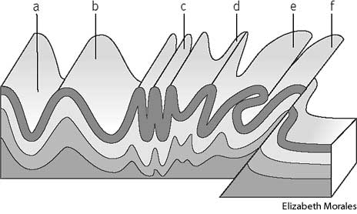

2.4.1.1 Which letter on the diagram represents an over thrust fold? (1x1) (1)

2.4.1.2 Which letter on the diagram represents an over fold? (1x1) (1)

2.4.1.3 Which letter represents an asymmetrical fold? (1x1) (1)

2.4.1.4 The force which forms folds is (compressional / tensional) (1x1) (1)

2.4.1.5 The part of the fold indicated by letter ‘a’ represents a/an

(anticline / syncline). (1x1) (1)

1.1 Determine whether the following statements are **TRUE** or **FALSE**.Write down the question number and **True** or **False** as your answer.

1.1.1 A climatologist studies weather. (1)

1.1.2 Igneous rocks are crystalline and have many layers. (1)

1.1.3 Compressibility, mobility and weight are all properties of the atmosphere. (1)

1.1.4 The Earth’s outer core is dense and molten. (1)

1.1.5 Latent heat is released during evaporation. (1)

1.1.6 Terrestrial radiation is heat emitted from the earth. (1)

1.1.7 Carbon dioxide is a permanent gas. (1)

1.1.8 Sedimentary rocks are formed by compression. (1)

1.1.9 Volcanic eruptions may offset the effects of global warming. (1)

1.1.10 Bedding planes are found in igneous rocks. (1)

^^^^^^^^^^^^^^^^^^^^^^^^^^^^^^^^^^^^^^^^^^^^^^^^

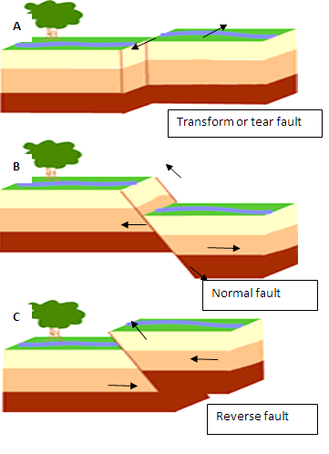

2.4.2 Study **Figure 2.4B.** Illustrations A, B and represents different types of faulting and answer the following questions.

1. Define the term *faulting*. (1x2)
2. Identify the force depicted in figure 2.4 A (1x1)
3. Differentiate between the two forces:

A. a normal fault

B. a reverse fault (2x2)(4)

1. Explain the formation of Block Mountains. (4X2)(8)

[15]

**********************************************************************************

2.6 Refer to **FIGURE 2.6** and read the case study on the Soufriere Hills volcano and answer the questions that follow:

|  |
| --- |
| Montserrat is a small island in the Caribbean, and it has been affected by a volcano since 1995. The volcano is caused by the South American and North American plates plunging under the Caribbean plate. Rocks at the edge of the plate melt and the rising magma formed a volcanic islands.  In July 1995 the Soufriēre Hills volcano erupted after being dormant for nearly 400 years. At first Soufriēre Hills gave off clouds of ash and steam. Then in 1996 the volcano erupted. It caused mudflows and lava flows. Part of the cone collapsed, boiling rocks and ash were thrown out and a new cone was created. Ash, steam and rocks were hurled out forcing all the inhabitants in the south, the main agricultural part of the island, to flee. The largest settlement, Plymouth, with a population of 4 000 people, was covered in ash and abandoned. This has had a severe impact on Montserrat as Plymouth contained all the government offices, most of the shops and services on the island, such as the market, post office and cinema.  The hazard posed by the volcano was just one of the risks that the people of Montserrat were exposed to. Many people had to stay in temporary shelters in overcrowded, unhygienic conditions where the risk of contaminated water and the spread of diseases, such as cholera, were greatly increased. |

2.6.1 How did the Island of Montserrat form? (1 x 1) (1)

2.6.2 Explain what is meant by a *dormant volcano*. (1 x 1) (1)

2.6.3 Why did the Soufriēre Hills volcano erupt after so many years? (1 x 2) (2)

2.6.4 List **THREE** types of material that was ejected by the volcano after so many

years of being dormant. (3 x 1) (3)

2.6.5 Write a short essay (no longer than 8 lines) in which you discuss the short and

long term consequences that the volcanic eruption had on the people of

Montserrat. (4 x 2) (8)

+++++++++++++++++++++++++++++++++++++++++++++

* 1. Refer to the information on volcanoes in Figure 1.4.

**MOUNT PELEE ERUPTS**

The town of St. Pierre lay peacefully at the foot of Mount Pelee in the West Indies. Mount Pelee towered over the town. Although the people knew that Mount Pelee was a volcanic mountain, few looked upon it with concern. The young people laughed at the elders when they spoke about it erupting 50 years before. Yes, Old Pelee was dead, no longer to be feared, but a friend. Suddenly in the spring of 1902 Mount Pelee came to life.

There was a terrible explosion that rocked the town and tore a gigantic hole in the side of the mountain. A flood of boiling mud and glowing cinders swept down the mountainside into the town. In a matter of minutes the town was on fire and half buried. Ships in the harbour caught on fire and people burnt to death. The town remains in ruins.

* + 1. Give a geographical term for the phrase 'Old Pelee was dead'. (1 x 2) (2)
    2. What is the name given to the big hole through which material is ejected? (1 x 2) (2)
    3. State TWO characteristics of Mount Pelee that suggests that it is a composite volcano. (2 x 2) (4)
    4. Volcanic activity has many positive effects for some areas. How can volcanic activity be of value to the economy? (3 x 2) (6) [14]

2.1.1 Match the following statements in **Column A** with the terms or examples in **Column B**. Write down only the question number and correct letter.

|  |  |  |  |
| --- | --- | --- | --- |
| **Column A** | | **Column B** | |
| 2.1.1 | Transfer of heat by contact | A | Fossils |
| 2.1.2 | A line on a map joining places with the same temperature | B | Folding |
| 2.1.3 | Rocks that have been changed by heat or pressure, or both | C | Continental climate |
| 2.1.4 | The condition of the atmosphere at any place at a specific time | D | Thermograph |
| 2.1.5 | The point on the Earth’s surface immediately above the focus of an earthquake | E | Metamorphic |
| 2.1.6 | The increase in temperature with an increase in height | F | Conduction |
| 2.1.7 | Remains of dead plants and animals that have been preserved in rocks | G | Laccolith |
| 2.1.8 | Molten rock that is extruded either from a volcano when it erupts or from cracks in the Earth’s crust | H | Epicentre |
| 2.1.9 | The amount of water vapour in the atmosphere | I | Dyke |
| 2.1.10 | A mushroom-shaped igneous intrusion that is formed when magma forces the overlying strata upwards | J | Weather |
|  |  | K | Heat balance |
|  |  | L | Isotherm |
|  |  | M | Temperature inversion |
|  |  | N | Absolute humidity |
|  |  | O | Lava |

……………………………………

2.4 Figure 2.4 shows intrusive volcanic features.

2.4.1 Explain the term intrusive volcanism. (1 x 2) (2)

2.4.2 Identify intrusive land features A , B and c. (1x 3) (3)

2.4.3 State ONE difference, visible in Figure 2.4, between features B and C.

(1 x 2) (2)

2.4.4 Describe the difference in the formation of a sill and a dyke. (2 x 2) (4)

[11]



2.3 Read the newspaper article in FIGURE 2.3 and answer the following questions:

**EARTHQUAKE IN SA A MATTER OF TIME**

*Pouza van der Fort*

A major earthquake in South Africa is a real possibility but there is no way of predicting when it might occur. Durban has been singled out as the area of greatest concern in the event of an earthquake on the continent.

A major fault line starts underground at Port Shepstone and runs north through KwaZulu-Natal.

Dr Hartnady from Umvoto Africa, a company that specialises in earth science research and consultancy, said that earthquakes occur when the tectonic plates of the Earth's crust move, slide, shear and grind against each other.

The intervals between major earthquakes of magnitudes greater than seven ranged between 500 and 1 000 years, he said. In some parts of the East Africa rift system, the last major quake might have occurred 1 000 years ago. The next time might be due anytime soon.

'It is not a question of if, but when and it could even be tomorrow,' said Hartnady.

2.3.1. Define the term earthquake. (1 x 2) (2)

2.3.2. Name the instrument used to record earthquake tremors. (1 x 2) (2)

2.3.3. What is the difference between the epicentre and the focus? (2 x 1) (2)

2.3.4. State ONE consequence of an earthquake with a magnitude of 7,9. (1 x 2) (2)

2.3.5. What type of boundary forms when two plates of the Earth's crust grind

against each other? (1 x 2) (2)

2.3.6. Give TWO reasons why scientists predict that an earthquake will most likely

occur in South Africa, specifically in Durban, in the near future. (2 x 2) (4)

2.3.7 Why should South Africans be concerned about the possibility of such an

earthquake in Durban? Give TWO possible reasons for this concern(2 x 2)(4)

[18]

OOOOOOOOOOOOOOOOOOOOOOOOOOOOO

2.2 Refer to FIGURE 4 showing faulting and folded rock strata.

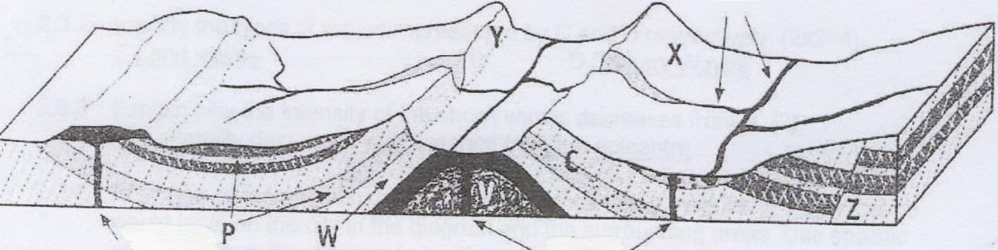

2.2.1 Label P as the *anticline* OR *syncline*. Give a reason (2 x 2) (4)

2.2,2 Which slope, X or Y, can be labelled as the dip slope? Explain your choice. (2 x 2)

* + 1. Identify the type of rock that would form at V? (1 x 2) (2)
    2. Identify the type of fault that developed at Z and explain how it developed (3 x 2) (6)
    3. To which main group do the rocks at P belong? Explain your answer. (2 x 2) (4)

Refer to Fig 1.3.1 and answer the following questions.

1.3.1 Name the three rock types 1,2 and 3. (3)

1.3.2 Name the volcanic features at X, Y and Z (3)

1.3.3 List an example of igneous rocks and give two characteristics. (2)

1.3.4 Why is granite often used in the building industry? (2)

1.3.5 Explain the difference between pervious rocks and porous rocks, giving an example for both. 2

1.3.6 How are the rocks at 4 and 5 affected by the intrusion of Y? (2)

1.3.7 You are a volcanologist, write a report no longer than ½ page on the advantages and

disadvantages of volcanoes. (6)

1.3.8 What is meant by a sedimentary rock of organic origins and why would

Palaeontologists study these rocks? Give an example. (4)

1.3.9 How do Palaeontologists support the theory of Continental drift? (2)

1. 3.10 Explain the theory of Continental drift, using fig 1.3.2 (4)

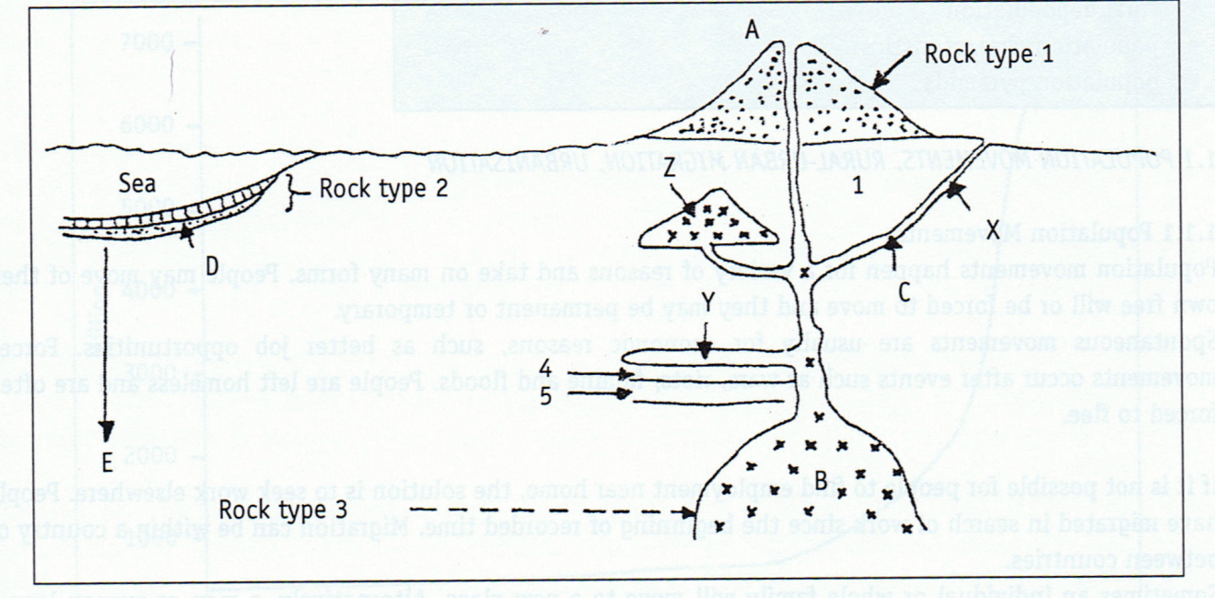

**QUESTION 3**

Use the next figure to help you answer the questions that follow.

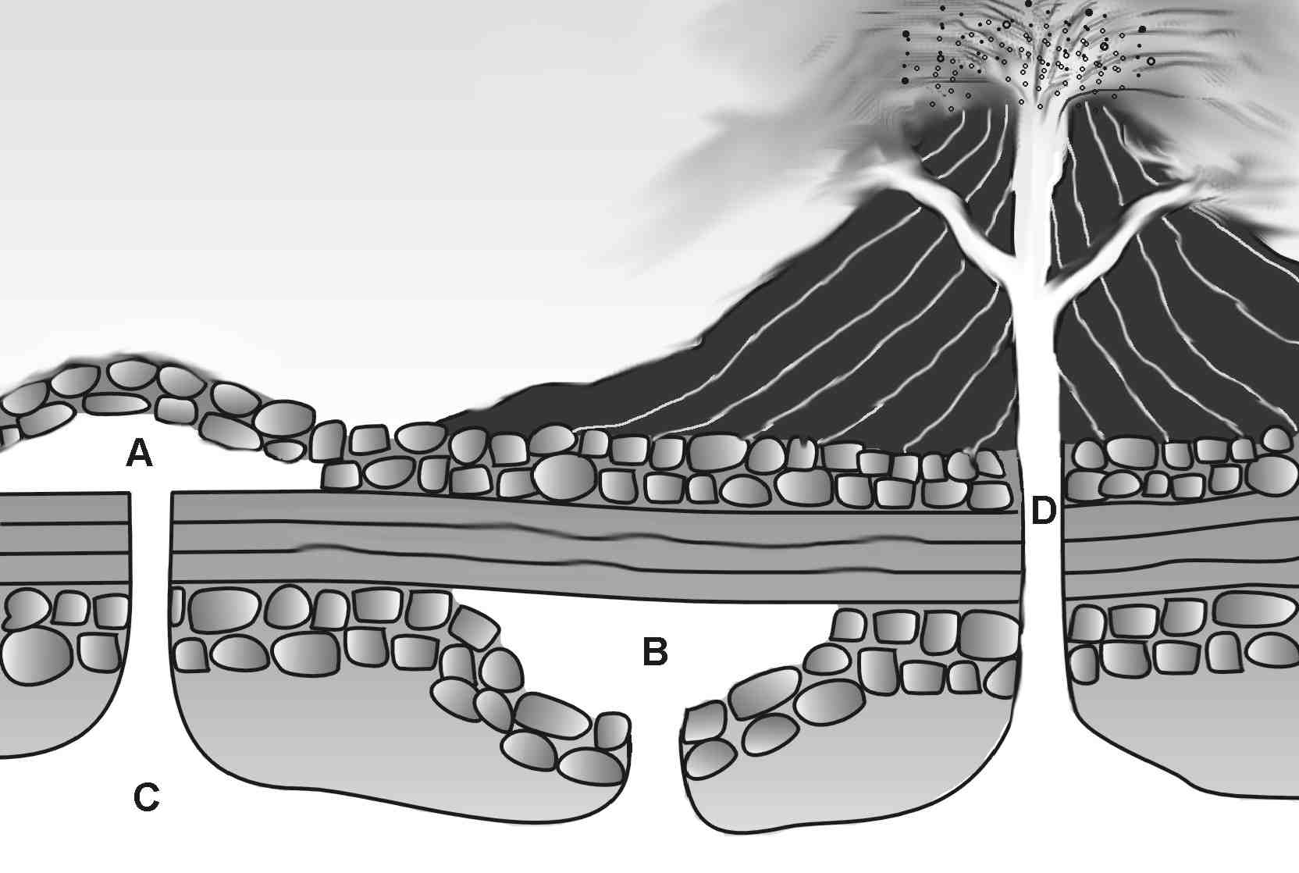

3.1 The figure shows examples of both intrusive and extrusive volcanism. What do these terms mean? (2x2) (4)

3.2 What is the difference between magma and lava? (2x2) (4)

3.3 Provide labels for intrusive features A, B and C. (3x1) (3)

3.4 What valuable mineral could possibly be mined from feature D? (1x1) (1)

3.5 Name **TWO** igneous intrusions that cannot be seen in the figure. (2x1) (2)

3.6 When igneous intrusions are exposed at the Earth’s surface, they are eroded. Place the following features in order, from youngest to oldest:

• Mesa

• Conical hill

• Butte (3x1) (3)

3.7 What type of volcano is shown in the figure? Give a reason for your answer. (2x1) (2)

3.8 List **TWO** types of material, other than lava, that may be ejected from a volcano. (2x1) (2)

3.9 Describe the formation of a caldera. (3x1) (3)

3.10 Volcanic action may result in the formation of new islands. Draw a diagram or a series of diagrams that demonstrate this process. (4x1) (4

3.11 In South Africa, we experience very little tectonic activity. Why is this the case? (2x1) (2)

**[30]**

**QUESTION 5**

Study the next series of diagrams and then answer the questions that follow:

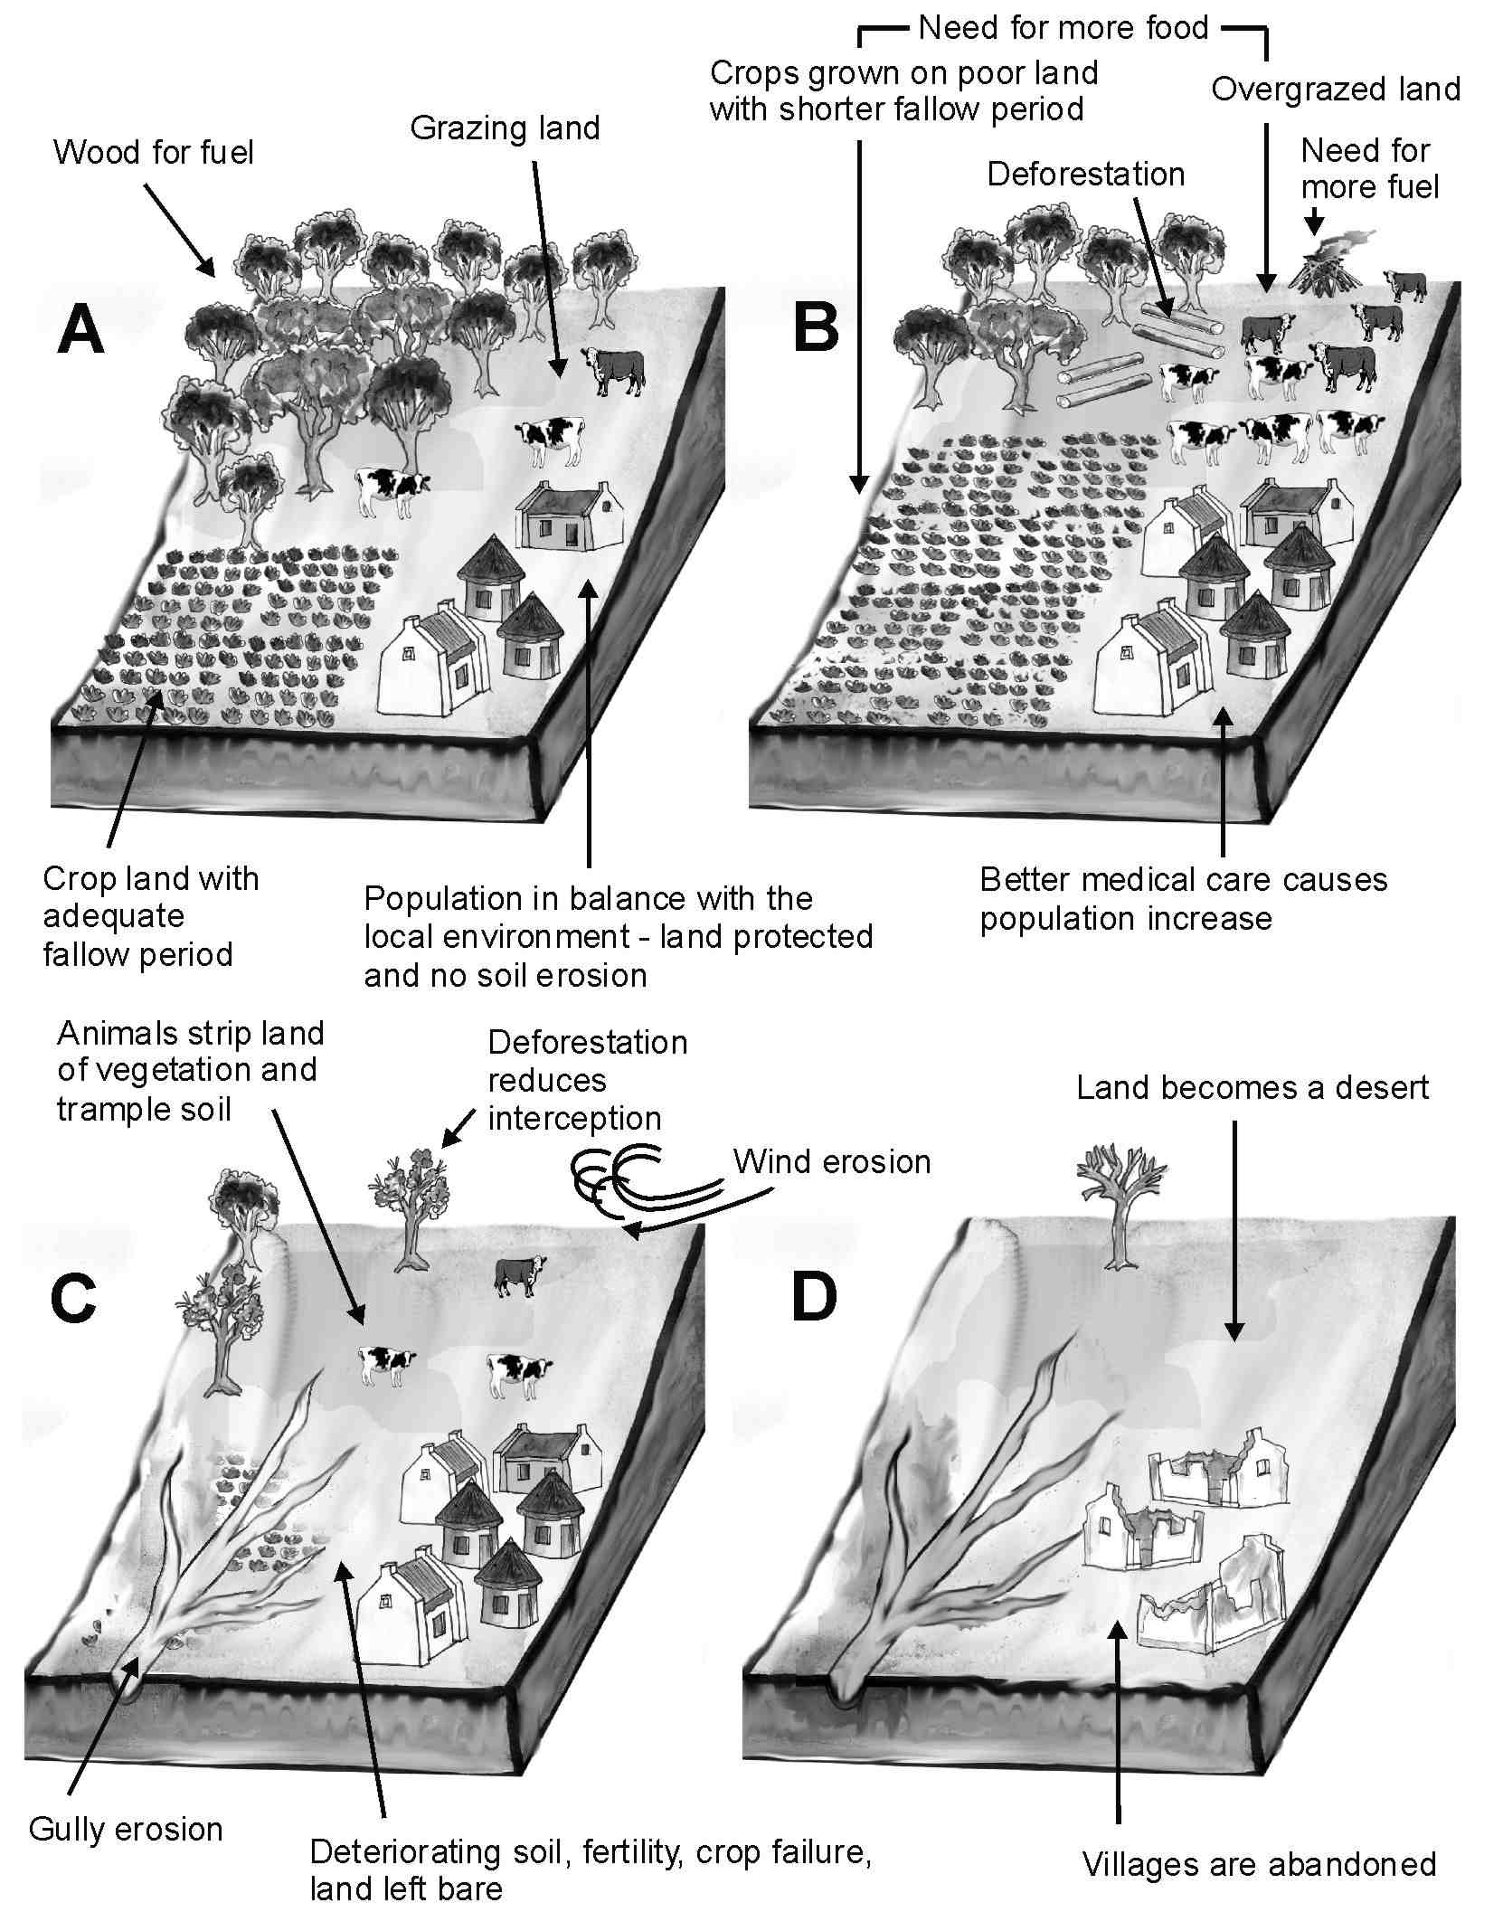

5.1 What led to the population increase shown in Diagram B? (1x1) (1)

5.2 List **THREE** ways in which the increased need for food had a negative effect on the environment. (3x1) (3)

5.3 Describe a gully and explain how gullies speed up soil erosion. (2x2) (4)

5.4 How did the gullies shown in Diagram C form? (1x2) (2)

5.5 Why has the soil fertility shown in Diagram C deteriorated? (2x1) (2)

5.6 Suggest **TWO** ways in which soil erosion could have been prevented in this area. (2x2) (4)

5.7 Soil that is washed away may be deposited in dams. How do these soil deposits affect the capacity of the dam? (1x1) (1)

5.8 Why are dams constructed on many of South Africa’s rivers? (1x2) (2)

5.9 In the beginning, how does the construction of the dam negatively affect the area upstream from the wall? (2x2) (4)

5.10 Suggest **ONE** positive and **ONE** negative effect of dam construction for agriculture. (2x2) (4)

5.11 How do people use dams for recreational purposes? (3x1) (3)

**[30]**

**QUESTION 6**

Refer to the next diagram showing world plate boundaries and then answer the questions that follow.

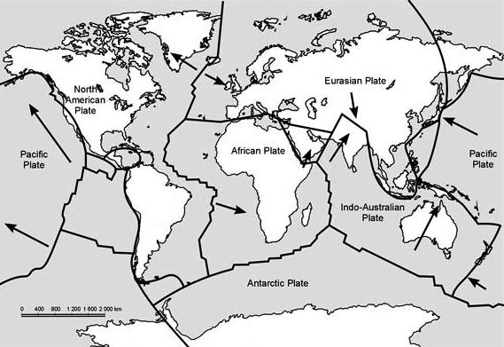

6.1 What name did Alfred Wegener give to the one large supercontinent that existed before the continents broke up? (1x2) (2)

6.2 Describe **TWO** pieces of evidence that scientists use to prove the continents of Africa, Antarctica and South America were once joined. (2x2) (4)

6.3 All the continents and adjacent water masses are divided into tectonic plates. What is a tectonic plate? (2x2) (4)

6.4 Briefly explain how the continents move. In your answer you need to make use of the following words: **convection currents, mantle, heat** and **plates.** (4x2) (8)

6.5 Name the plates found on either side of the plate boundary on the west coast of South America. (2x2) (4)

6.6 Are the plates moving towards or away from each other? (2x1) (2)

6.7 Name this type of plate boundary. (1x2) (2)

6.8 Name **ONE** feature found at this plate boundary. (1x2) (2)

6.9 Name the mountain range formed at this plate boundary. (1x2) (2)

**[30]**

**QUESTION 7**

Study the next diagram, which shows a volcano, and then answer the questions that follow.

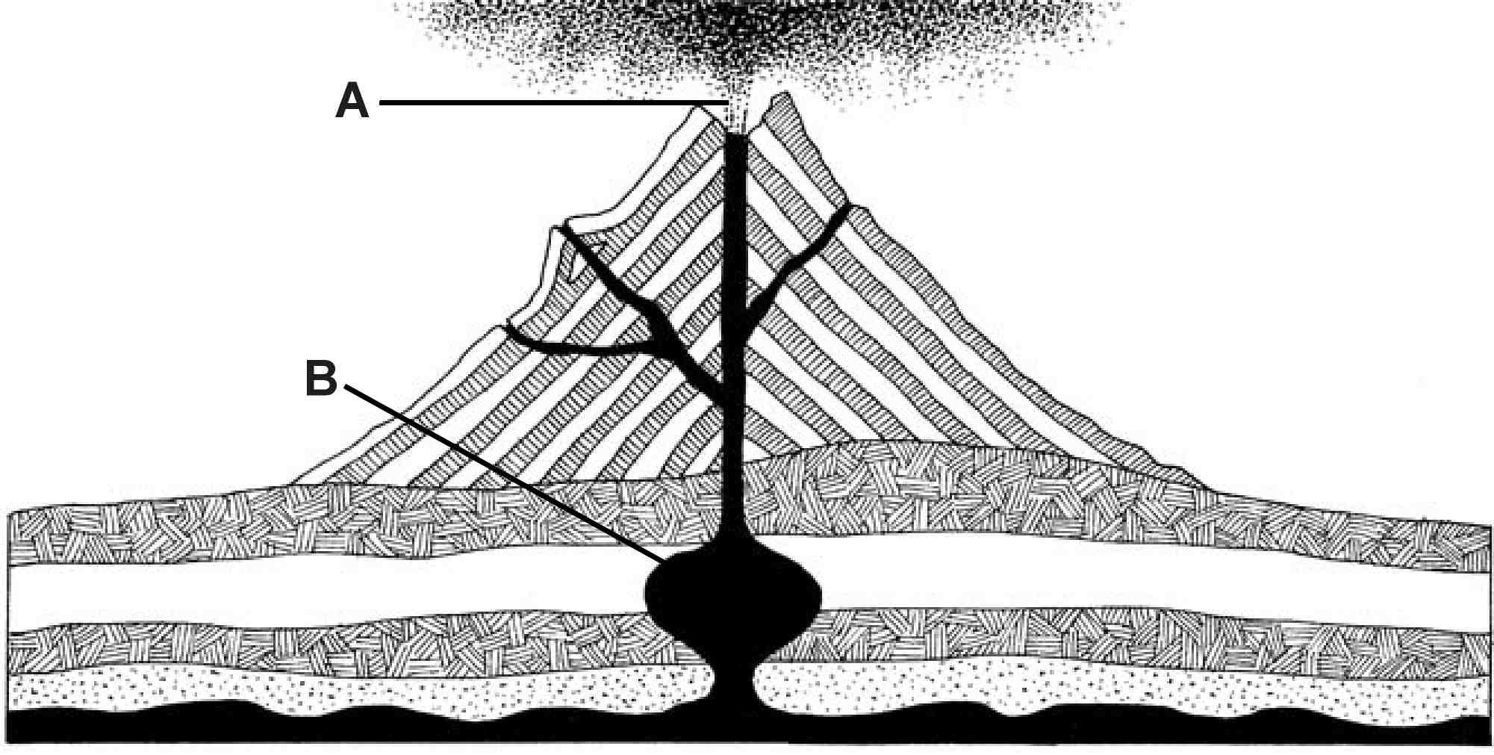

7.1 Name the type of volcano shown in the diagram. (1x2) (2)

7.2 What does this volcano consist of? (3x2) (6)

7.3 What do we call the molten material at A that erupts out of a volcano onto the Earth’s surface? (1x2) (2)

7.4 Name the feature B below the surface where the molten volcanic material is stored. (1x2) (2)

7.5 Give an example of the type of volcano you mentioned in your answer to Question 7.1. (1x2) (2)

7.6 Sometimes a volcanic cone can form a caldera. What is a caldera? (1x2) (2)

7.7 Briefly explain how a caldera can form. (3x2) (6)

7.8 ‘Volcanic eruptions do cause much death and destruction, but they also often have positive effects on people and the environment.’ Give three positive effects of volcanic eruptions. (3x2) (6)

7.9 Define a dormant volcano. (1x2) (2)

**[30]**

**QUESTION 8**

Study the next diagram, which shows the weathering processes in granite, and then answer the questions that follow.

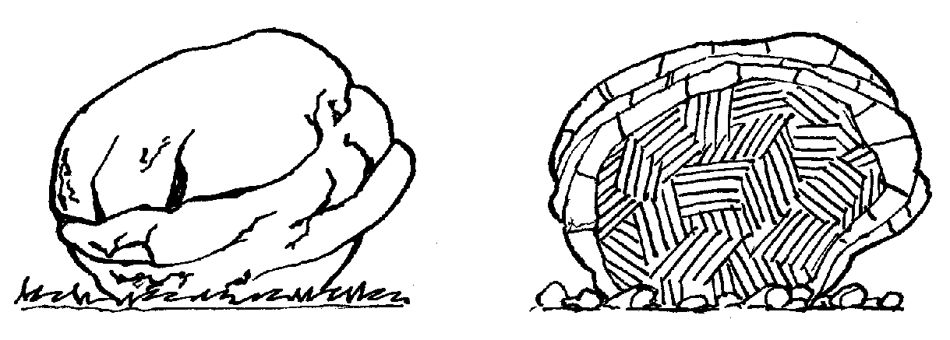

8.1 To which type of rock does granite belong? (1x2) (2)

8.2 Briefly explain how the rock type asked for in Question 8.1 is formed. (2x2) (4)

8.3 Name the **THREE** types of crystal that can be found in granite. (3x1) (3)

8.4 Give **TWO** characteristics of the rock type asked for in Question 8.1. (2x2) (4)

8.5 Name the weathering process that is taking place in the diagram. (1x2) (2)

8.6 Fully explain this weathering process. (3x2) (6)

8.7 What do you call the resultant feature? (1x2) (2)

8.8 What is the name given to the weathered material that accumulates at the base of the granite feature? (1x1) (1)

8.9 Give **TWO** uses of granite. (2x2) (4)

8.10 If granite is exposed to extreme pressure and heat it can become a metamorphic rock. Name this rock. (1x2) (2)

**[30]**

**QUESTION 9**

Study the next diagram and then answer the questions that follow.

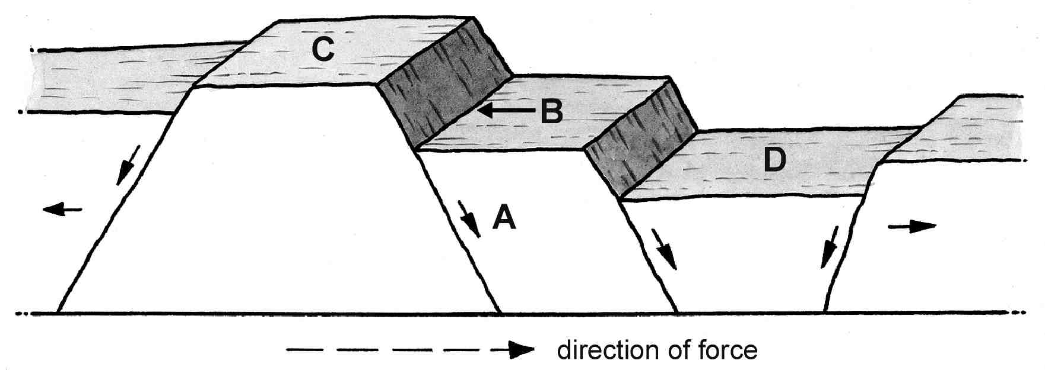

9.1 Name the fault labelled A. (1x2) (2)

9.2 Name the part of the fault labelled B. (1x2) (2)

9.3 Name the feature labelled C. (1x2) (2)

9.4 Where could one find an example of the feature labelled C? (1x2) (2)

9.5 Name the land formation illustrated at D on the diagram. (1x2) (2)

9.6 Briefly explain how feature D formed. (3x2) (6)

9.7 Where would one find an example of this landform? (1x2) (2)

9.8 Give **ONE** use of the landform labelled D. (1x2) (2)

9.9 How many times has faulting occurred in the diagram above? (1x2) (2)

9.10 Draw a well-labelled diagram to illustrate the type of fault that occurred at the San Andreas Fault. (4x1) (4)

9.11 Give **TWO** devastating (very disturbing) occurrences that are associated with faulting taking place. (2x2) (4)

**[30]**

**QUESTION 10**

Read the article reporting the Mexico City earthquake of 1985 and study the diagram. Then answer the questions that follow.

|  |
| --- |
| **Mexico City earthquake, 1985** |
| Two weeks before the Mexico City earthquake, two Mexican seismologists published a map showing that there was a 160 km gap which had been free of small earthquakes for several years along the junction of the two plates in that area. It was probable that this lack of earthquake activity resulted in the build up of pressure that was suddenly released in September 1985.  Although the epicentre was just off the west coast, shock waves reached Mexico City. Unfortunately, several parts of the city had been built upon silt and peat that had accumulated when the site was previously a shallow lake. The shock waves brought water to the surface, turning the silt into mud.  As Mexico City ‘wobbled like jelly’ over 1 000 large buildings, all without rock foundations, collapsed and sank into the mud. Nearly 30 km² of the city was devastated. |
| GEO1063 |

10.1 Name the **TWO** plates involved in causing the Mexico City earthquake. (2x1) (2)

10.2 Name the area below the surface of the Earth, where the earthquake originated. (1x2) (2)

10.3 What type of plate boundary is this? (1x2) (2)

10.4 This earthquake registered 7,8 on the Richter Scale. What is the Richter Scale? (1x2) (2)

10.5 Briefly explain why, according to the article, so many buildings collapsed. (3x2) (6)

10.6 If collapsing buildings is a primary effect of earthquake activity, give **TWO** possible secondary effects of the Mexico City earthquake.  (2x2) (4)

10.7 Why are these two effects usually far more severe than the actual earthquake itself? (2x2) (4)

10.8 ‘Time is always against rescuers.’ Suggest **TWO** other factors that could hamper rescue attempts. (2x2) (4)

10.9 Explain why water can become a very critical commodity after an earthquake. (2x2) (4)

**[30]**