Primrose High
Lockdown lessons Grade 9 English HL
Pronouns
Generalisation
Quotation marks
Abbreviations
Subject and Predicate
Paragraph Structure

Please complete all the activities in your workbook. Activities will be marked when the school starts again. You will receive planning for the coming week on a weekly basis.

Keep safe, Stay strong.
Ms Gouws and Ms Brown.

Pronouns Worksheet
Directions: Circle the pronoun that best completes each sentence.
Example A- (We/Us) are going the supermarket this weekend.
Answer- We
1. (I / Us) think that you are one of the brightest students in the class.
2. (We / Us) are going to the football game this weekend.
3. I can tell that (him / you) really enjoyed the movie.
4. (That / It) is one of the best movies I have seen all year.
5. (He / They) is a very bright young man.
6. I can tell (her / she) really tried hard to perform well.
7. (They / Them) are going to the movies after school today.
8. Can you give the gift to (it / him) once you get to his party?
9. Tell (her / she) that she did a fabulous job.

Relative Pronouns Worksheet
Circle the relative pronoun in each sentence given below.
Example: A baby, whose dependency is on their parent, is often helpless.
Answer: whose
1. The man, that gave the speech, is well read.
2. A cat, whose faith is in its owner, needs to eat at least twice a day.
3. The girl, which I asked to help me, never showed up.
4. I’d like to say, whoever did that, should be banned for life.
5. The teen, who came off the bench, scored thirty points in the half.
6. I don’t know the truth, but whoever does needs to tell.
7. I ran the marathon, which means I am now very tired.
8. The man, whose car is a class, sold it for thousands of dollars.
9. I can tell, whichever option I take, it will not work out.

Generalisation VS Stereotyping

It is important to distinguish between stereotypes and generalizations. They may appear similar, but they function differently.
For example, if I meet a Hispanic woman named Maria and assume that she has a large family, I am stereotyping her. But, if I say to myself, “Hispanic people tend to have large families; I wonder if Maria does,” then I am generalizing.
A STEREOTYPE is an ending point, and no effort is then made to ascertain whether it is appropriate to apply it to the person in question.
A GENERALIZATION, on the other hand, serves as a starting point. Generalizations help us make sense of our world using information that we already know. As we get to know people from other walks of life, we may see that they do not fit the generalization. At that point, as open-minded individuals, we should adjust our way of thinking about the individual and quite possibly, all other people from the same culture or heritage.
https://www.polk.k12.ga.us/

Identify whether the following sentences are generalisations or stereotypes

- Women are reckless drivers.
_______________
- People who wear glasses are usually tech-savvy.
_______________
- All vegetarians believe that the earth is flat.
_______________
- People who go to church do not drink alcohol.
________________
- Never trust a skinny cook.
________________
- Boys like blue and girls like pink.
_________________
- Rich people only drink champagne
_________________
- British people prefer tea.
_________________
- Success is brought about by good luck
_________________

Quotation Marks Worksheet
Directions: Read each sentence. Add quotation marks where needed.
Example A: What a great day! yelled Mr. Dobbins
Answer: “What a great day!” yelled Mr. Dobbins.
1. Hi, Jim said to his friend.
2. What a wonderful day, said Mary.
3. Sharon said, take your homework out.
4. My dad asked, when do you want to go to the movies?
5. Jeremy exclaimed; I won the race!
6. Have a goodnight, said my mother.
7. Mary said, what a beautiful day.
8. Please take the trash out, said my father.
9. Make sure you do your homework, said my mother.
10. On Friday the project is due, expressed my teacher.
11. Let’s go to the park, said my sister.
12. That game was fun, said David.
13. Good afternoon, said Byron as he walked into the room.
14. It is raining outside, said Susan.
15. Let’s go to the fair, said Michael.
16. The sun is so bright, said Sarah.
17. John said, where are we going to the baseball game.

Abbreviating Words in a Sentence Worksheet
An abbreviation is a shortened form of a word or phrase.
Re-write each sentence below. Correctly abbreviate the underlined words.
Example: I went to Doctor Tom’s office.
Answer: I went to Dr. Tom’s office.
1. Mister Jacobs is our school principal.
2. Ms Rose is my math teacher.
3. Ken Griffey Junior was a great baseball player.
4. Doctor Robison took care of me when I was sick.
5. John Jacobs Senior was the head of the household.
6. Miss Whitaker teaches my science class.
7. Mrs Johnson drove me home from school.
8. I live on Light Street in the city of Hampton.
9. I drove to Fairbank Road to visit my grandparents.
10. I live in the beautiful state of California.
11. Sunday is my favourite day of the week because I get to relax.
Copyright www.englishlinx.com

Subject and Predicate Worksheet
The subject part of a sentence names whom or what the sentence is about. The
predicate part of a sentence tells what action the subject does.
Directions: For each sentence given below, underline the subject once and the
predicate twice.
Example A: John went to the movies with his friends.
Answer: John went to the movies with his friends.
1. The horse appeared at the starting line.
2. The student arrived late to class because he woke up late.
3. John looked out of the window to check the sky.
4. The audience grew very restless waiting for the play to start.
5. The air in the classroom smelled fresh.
6. I felt exhausted from the anticipation.
7. The owners grew flowers all around their house.
8. The racetrack looks very wet because it has been in the rain many hours.
9. The horse tastes the hay and oats without hesitation.
10. Birds fly often in the blue sky.
11. Birds like to land in green trees.
12. Bird watchers must always wait with patience.
13. The company pays for its workers medical insurance.
14. The bank will keep a record of your work.

Paragraph structure
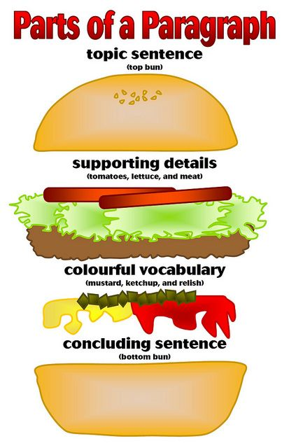

PARAGRAPH STRUCTURE PRACTICE WORKSHEET
Directions: Underline in blue the topic sentence. Circle in red any transition words.
Highlight the supporting details. Underline in green the concluding statement.

Paragraph 1
My Dog Romeo is so much fun to play with. One reason he’s fun is because he loves to play catch. What’s also fun is that he follows me around the house with a toy and drops it on my foot, so I will kick it. Additionally, he can catch just about anything, but his favourite thing to catch is a Frisbee. Finally, he loves it when I pretend like I’m falling dead, and he runs over to lick me. All these reasons show why I really have fun playing with Romeo.

Paragraph 2
Ever since I moved into my own apartment last fall, I have gotten out of the habit of making my bed--except on Fridays, of course, when I change the sheets. Although some people may think that I am a slob, I have some sound reasons for breaking the bedmaking habit. In the first place, I am not concerned about maintaining a tidy bedroom because no one except me ever ventures in there. If there is ever a fire inspection or a surprise date, I suppose I can dash in there to fluff up the pillow and slap on a spread. Otherwise, I am not bothered. In addition, I find nothing uncomfortable about crawling into a rumpled mass of sheets and blankets. On the contrary, I enjoy poking out a cosy space for myself before drifting off to sleep. Also, I think that a tightly made bed is downright uncomfortable: entering one makes me feel like a loaf of bread being wrapped and sealed. Finally, and most importantly, I think bed-making is an awful way to waste time in the morning. I would rather spend those precious minutes checking my email or feeding the cat than tucking in corners or snapping the spread.

Paragraph 3
In the mid-1980’s, the Minnesota Vikings were a very well-built team because of the draft and some big trades. For example, they picked up players like Chuck Foreman through the college draft. But perhaps more importantly, they pulled off some coups, like the Tarkington trade in 1973. Undoubtedly, the Vikings were the most evenly balanced team in professional football in the mid-1970’s.

