Mamelodi Centre Cluster Schools
Life Science June Exam
Grade 10

Educator: Ms A Sinclair Time: 2½ hours
Moderator: Ms R Kruger Marks: 150

Instructions:
- Answer all questions on the folio paper provided.
- Write neatly and legibly.
Section A
Question 1

Various possibilities are suggested as answer to the following questions and or statements. Choose the correct answer and write down only the correct letter next to the correct number on the foolscap paper provided. E.g. 1.1.1 A

If the magnifying power of the ocular (eyepiece ) in a microscope is 10X and that of the objective is 40X, the total magnification of a specimen will be :
- 10x
- 40x
- 50x
- 400x

    - An example of cells thickened with extra cellulose are …
- Tracheids
- Parenchyma
- Collenchyma
- Vessels

    - Which of the following tissues normally consist of non-living cells?
- Sclerenchyma
- Phloem
- Collenchyma
- Parenchyma

    - Which one of the following is found in phloem tissue?
- Parenchyma
- Collenchyma
- Sieve tubes
- Schlerenchyma cells

    - The endoplasmic reticulum of a cell serves….
- to store food
- as an energy source
- as an internal membrane system
- to store genetic material

    - Most photosynthesis in a plant occurs in the….
- Spongy mesophyll
- Guard cells of the stoma
- Green cortex cells
- Palisade mesophyll

Questions 1.1.7 to 1.1.9 refer to the diagram on human skeleton

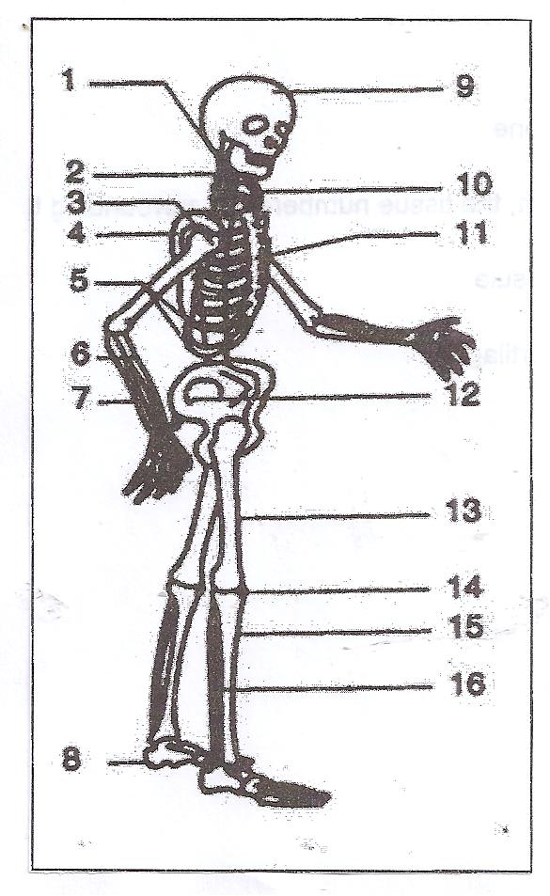

    - Bone numbered 2 is a/an …. bone and the bone numbered 14 is a/an …. bone
- Irregular; flat
- Short; sesamoid
- Sesamoid, irregular
- Irregular; sesamoid

    - The pectoral girdle consist of bone(s) numbered….
- 12 only
- 3, 4, 5, 6 and 7
- 4 and 10 only
- 4, 5 and 10 only

    - Which bones are especially designed for attaching muscles from the limb?
- 4 and 6
- 8 and 11
- 4 and 12
- 13 and 14

    - Two foods containing vitamin A are…
- Spinach and tomatoes
- Brown rice and chicken
- Oranges and strawberries
- Eggs and meat
[10 x 2 = 20]

Give the correct biological term for each of the following statements. Write only the correct term next to the number on the foolscap paper provided.

The structure of a microscope that controls the amount of light passing through a slide.

A membrane that only allows certain substances to pass through it.

The type of muscle tissue that is responsible for all voluntary actions such as walking and running.

The thin waxy, non-living outer covering of plant leaves which prevent water loss.

A disease that causes soft, weak bones in children due to the lack of Vitamin D.

Process whereby water moves across a semi permeable membrane.

Elements needed in small quantities by the body.
(7)

1.3 Indicate whether each of the following statements in COLUMN I applies to A ONLY, B ONLY, BOTH A AND B or NONE of the terms in COLUMN II. Write A only, B only, both A and B or none next to the question number (1.3.1 to 1.3.7) on the foolscap paper provided.

COLUMN I | COLUMN II
1.3.1 The branched outgrowth of a neuron  which conducts impulses towards the cell  body | - Dendrites  - axon
1.3.2 Cells found in plants which can  photosynthesise | - Guard cell  - Parenchyma
1.3.3 Vascular bundles | - Transport nutrients made during photosynthesis  - Consist of phloem and meristematic issue only
1.3.4 Rickets | - Deficiency of calcium  - Deficiency of phosphorus
1.3.5 Anaemia | - Deficiency of sodium  - Deficiency of iron
1.3.6 The tissue which attaches muscle to bone | - Ligaments  - Tendons
1.3.7 The natural tendency of liquids to move up tubes with very tiny openings on their own | - Capillarity  - Root pressure

[7 x 2 = 14]

1.4 The following type of cells occur in leaves of plants. Give the correct answers for the information given in the table. Write only the question number and the answer on the folio paper.

 | Palisade cell | Guard cells | Sclerenchyma
 | 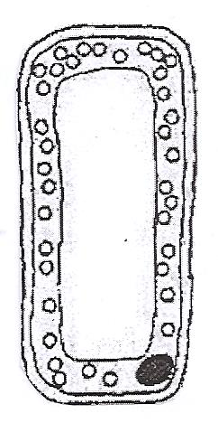 | 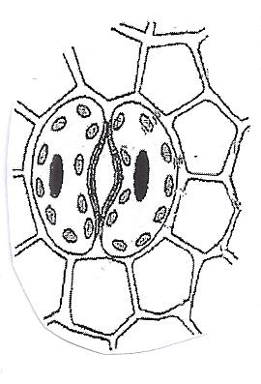 | 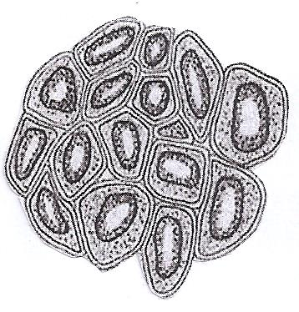
Cell contents present (yes or no) | 1.4.1 | 1.4.2 | 1.4.3
Cell wall thick or thin | 1.4.4 | 1.4.5 | 1.4.6
Function | 1.4.7 | 1.4.8 | 1.4.9

(9)

SECTION A TOTAL: 50

Section B
Question 2

The following diagram shows a transverse section of a dorsiventral leaf. Study the following diagram and answer the questions that follow.
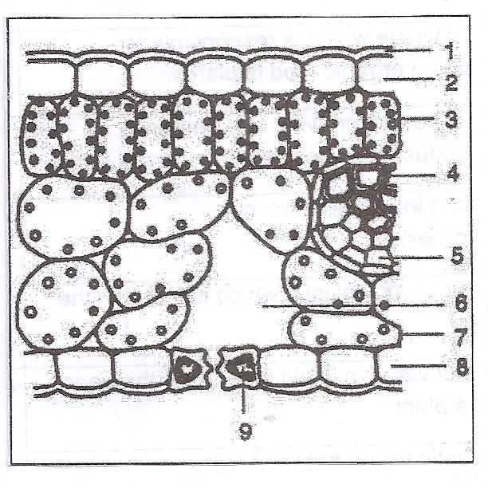
2.1.1 Write down the name of the cells where chloroplasts are more concentrated (1)
2.1.2 Name two different cell types that make up tissues labelled 4. (2)
2.1.3 Name two cell types that make up tissues labelled 5. (2)
2.1.4 What type of cell do we find at label number 9? (2)
[7]
2.2 Study the picture and answer the questions that follow.
- Micrograph showing onion cells B. Plant cell
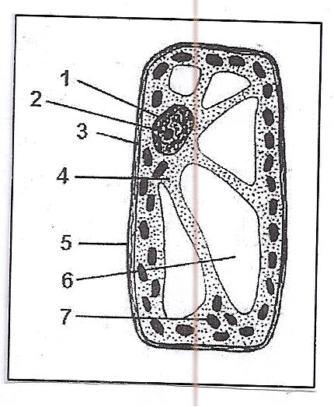
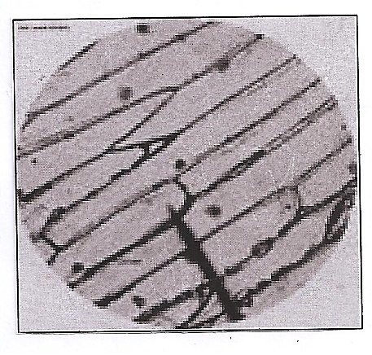
2.2.1 Name the type of tissue that is depicted in micrograph A. (1)
2.2.2 Give THREE distinguishing characteristics of the tissue in micrograph A. (3)
2.2.3 Give the name and number of the part in diagram B that will be not found in the onion cells in micrograph A. (2)
2.2.4 Compare the cell in picture B with an animal cell and give TWO distinct differences between them (4)
[10]
- The following information appears on the package of a brand of cereal eaten by a young boy. Study the table and then answer the questions based on it.

INGREDIENTS | NUTRITIONAL INFORMATION (VALUES PER 100G)
Whole rolled oats, roasted wheat flakes, cane syrup, brown sugar, vegetable oil, sun-dried raisins | Energy | 2000kj
 | Protein | 12.5
 | Carbohydrates | 50g
 | Fats | 12.5g
 | Fibre | 25g
 | Cholesterol | 0mg

    - State why the young boy requires each of the following nutrients:
- Protein (2)
- Fats (2)
2.3.2 Name the building blocks of fats. (2)
2.3.3 Why is it important that a diet should not contain high levels of cholesterol? (2)
2.3.4 Indicate which one of the nutrients contains the element N. (1)
2.3.5 Name the organelle in the cell and what the process is called that is responsible for producing energy for the organism. (2)
[11]

Study the graph below showing the effect of temperature on enzyme activity in an acidic medium.
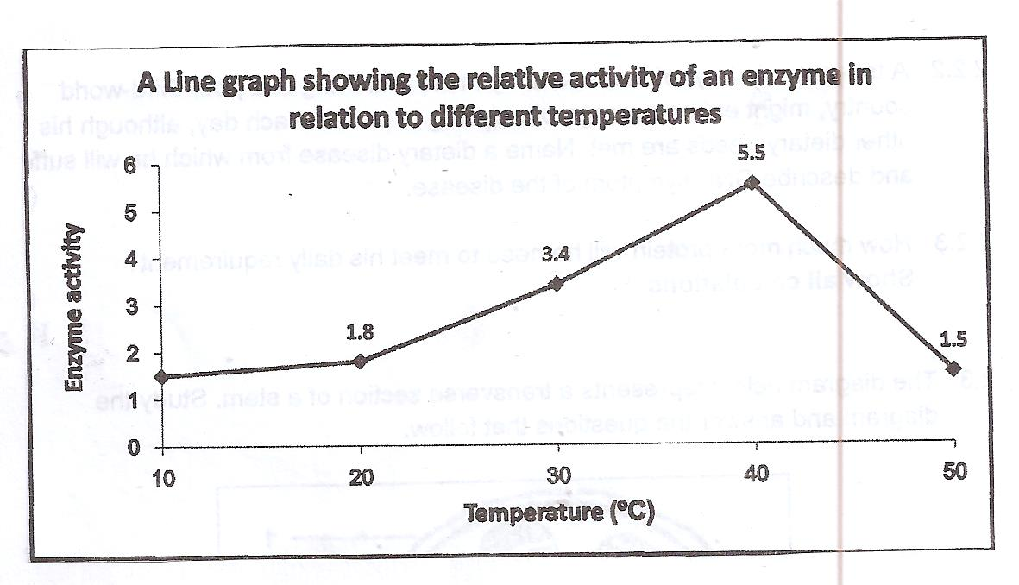
2.4.1 Identify the dependent variable from the graph (2)
2.4.2 At what temperature does this enzyme work best? (1)
2.4.3 Explain what happens to the enzyme between the temperature of 35 ͦC and 45 ͦC ( refer to enzyme activity and structure). (5)
2.4.4 What idea justifies your conclusion in question 2.4.3 when referring to the substrate in the above situation? (2)
2.4.5 What variable is considered constant in the given graph? Say why it must be controlled. (2)
(40)
QUESTION 3 [12]
Permanent tissue show a variety of shapes and cell wall features which are related to their function in the plant body”.
According to the statement above and the diagram below, answer the following questions.
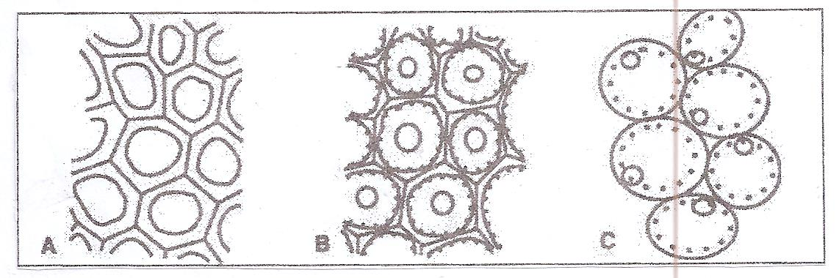
    - Identify the permanent plant tissue marked A, B and C. (3)
What is the main function of each tissue marked A, B and C respectively. (3)
Write down the letter of the plant tissue which:
- Has cell walls impregnated with lignin. (1)
- Can be found in herbaceous stems. (1)
- Cell wall are thickened with cellulose, especially in the corners of the cells (1)
[9]

Study the diagram below and answer the following questions.
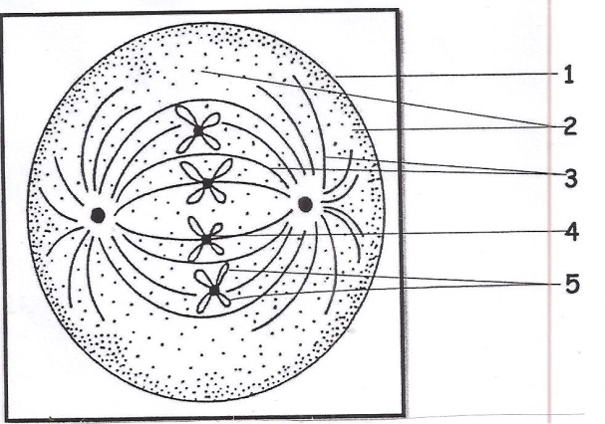
3.2.1 Which phase of mitosis is depicted in the diagram? Give a reason for your answer. (3)
3.2.2 Which phase follows this phase? (1)
3.2.3 Identify the parts labelled 1-5. (5)
3.2.4 Give THREE reasons why mitosis is important for living organisms (3)
[11]
3.3 Study the electron micrograph of a cell below and then answer the questions that follow.
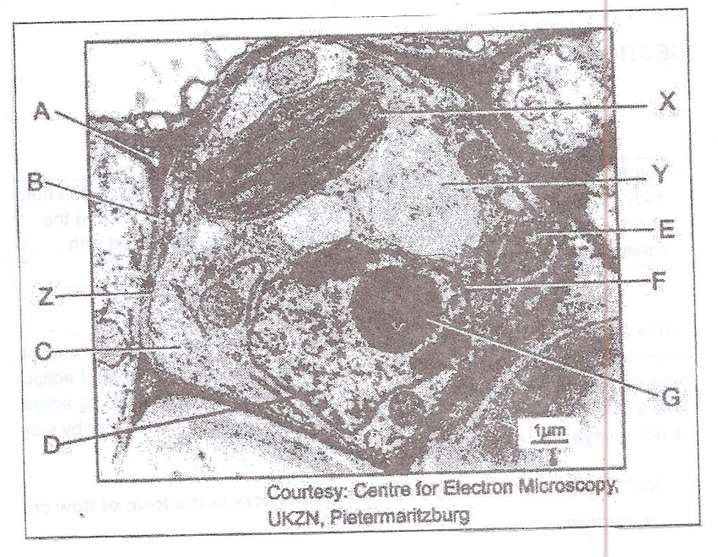
3.3.1 Does the above micrograph represent a plant or animal cell? Give THREE visible reasons for your identification. (3)
3.3.2 Name the pigment found in the structure marked X. (1)
3.3.3 State THREE functions of the structure marked Y. (3)
3.3.4 Name the types of compound molecules that make up the structure marked Z. (2)
3.3.5 Label the parts marked C and D. (2)
[11]
Study the diagram below and answer the questions that follow.
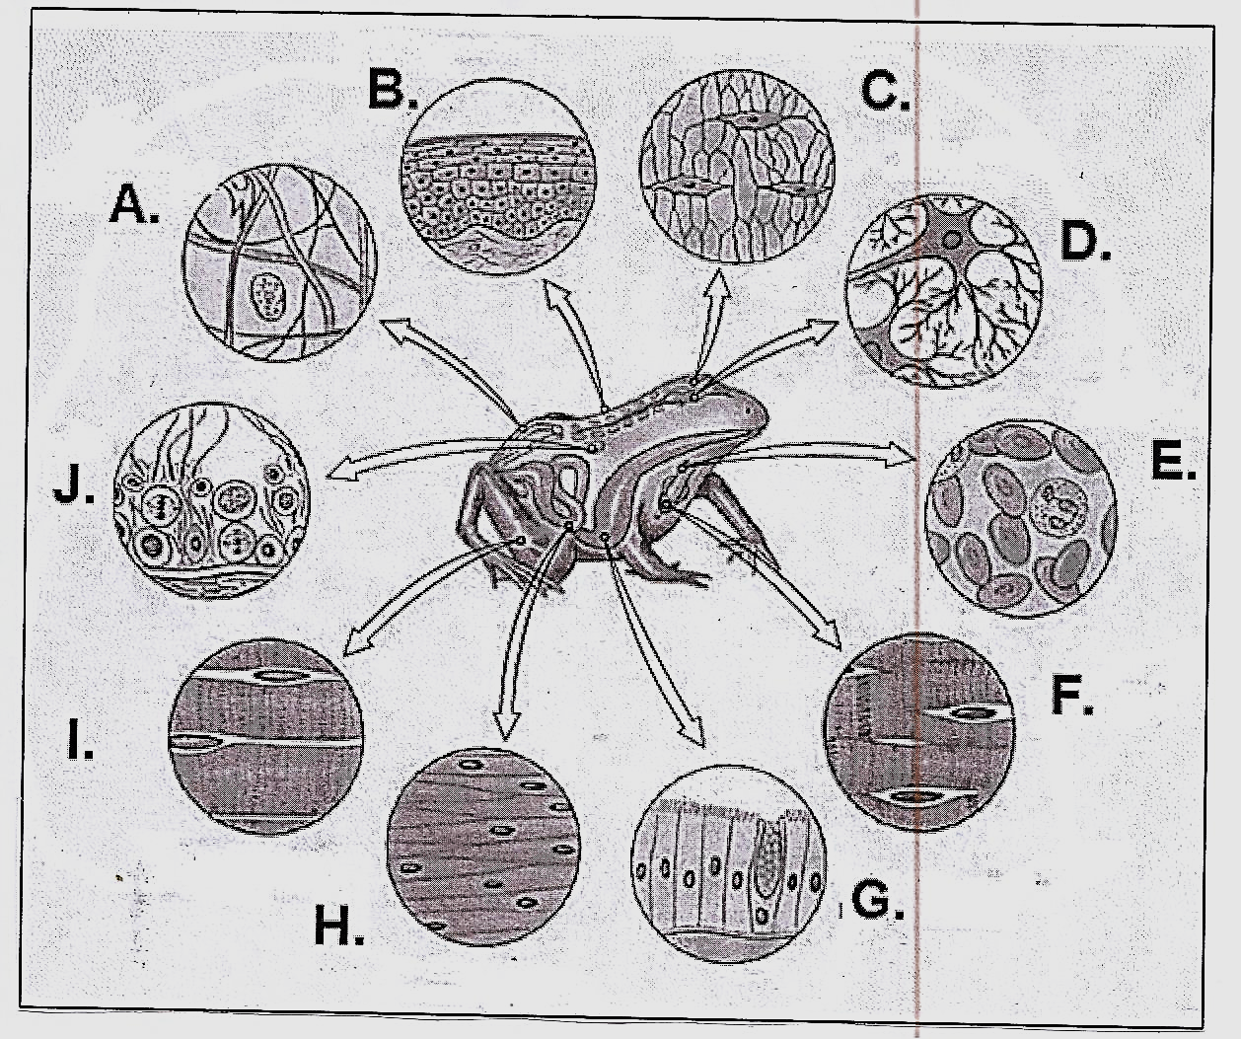
Identify tissues labelled A, D and I (3)

Name TWO differences between tissues labelled F and H (4)

Name TWO places in the frog’s body where tissues labelled G would be found (2)

[9]
[40]
SECTION B TOTAL : 80
Section C
Question 4
Mitosis is a very important cell division process that takes place in the human body. When normal regulations of the cell cycle malfunction and the check points are ignored or over ridden, cancer cells are formed with disastrous effects
Write an essay in which a suitable definition for mitosis is given, also explain important roles of mitosis in living organisms. In this essay write a brief account of how cancer begins and give two ways how the risk of getting cancer can be reduced by adjusting one’s lifestyle. Also explain in the essay why the treatment of cancer by surgery is not always successful.
NOTE THAT NO MARKS WILL BE AWARDED FOR ANSWERS IN A FORM OF A FLOW CHART OR DIAGRAM
Synthesis (3)
Facts (17)

SECTION C TOTAL: 20
GRAND TOTAL: 150

