Biodiversity card game
Have fun with a friend and discover some interesting facts about other countries.

What to do:
- Cut out the cards.
- If possible laminate or cover in clear plastic.

How to play:
- Both players must read the cards and chat about the various national symbols and the variety of biodiversity found in each country. Here are some guidelines for the discussion:
  - How many countries share the same national symbols? Either in the form of its animal, plant, tree or flower.
  - Examine the coat of arms of each country – how are their symbols represented in it?
  - Look at the map of the world, how do the country’s national symbols relate to where in the world they are?
- Divide the cards among the two players.
- One player holds up the card, showing only the flag. They then ask questions about that country, for example, what is the national flower, what does it look like? What is the national animal? What symbols are on the coat of arms, and how do these link to the other symbols?
- This game tests children’s attention to detail and short term memory skills.
- As an extension, children can select one country and do further research on it.

What is Biodiversity?
Biodiversity is the variety of all living species on Earth and their relationships to each other. It includes:
the diversity of genes within all living organisms.
the diversity of species. For example, morel, corn, rainbow trout, praying mantis and humans are all different species.
the diversity of ecosystems (coral reefs, prairies, forests, wetlands, etc.).
We rely on biodiversity for many things, including food, medicine and clothing. Some of the ways biodiversity is lost are through:
- Habitat destruction
- Foreign species being introduced to a new habitat
- Pollution
- Population growth
- Over-use

As a result of human activities, ecosystem, species and genetic diversity is being destroyed faster than nature can create it. This damage threatens all of us. By working together, we can find ways to live without negatively affecting biodiversity. Without a change in our actions half of the world's species may be lost by 2100.

What can you do to protect biodiversity?
- Learn more about biodiversity – find out the names of the trees, birds, native plants and insects that share your neighbourhood.
- Experience it – go out and experience the wonders of life's diversity. Visit a local park or take a hike through a conservation area.
- Do something – get involved! Make changes to your lifestyle which reduces your impact on the planet.

National symbols
Each country has a set of national symbols that represent the country and provides it with a individual identity. Below are the symbols of some of the countries attending the Fifa World Cup. Learn more about them all.

South Africa
National symbols
National coat of arms | 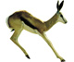  Animal: springbok | 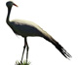  Bird: blue crane
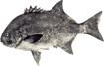  Fish: galjoen | 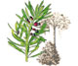  Tree: real yellowwood | 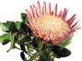  Flower: king protea

Argentina
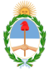
National symbols
National coat of arms | The Argentine Cockade (a knot of ribbons, or circular/oval-shaped symbol) | Bird: Andean Condor
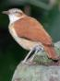  Bird: Hornero  (brown bird with short tail and long bill) | The Sun of May, a representation of the Inca sun god Inti. It has 16 straight and 16 waved sunbeams. | 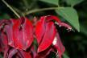  Flower: Red flower from the Cockspur Coral Tree or Ceibo tree

Australia
National symbols
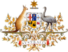  National coat of arms | 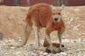  Animal: red kangaroo | 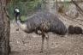  Bird: emu
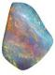  Gemstone: Opal | 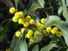  Tree: Golden Wattle | Colours: green and gold

Brazil
National symbols
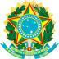  National coat of arms | 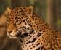  Animal: Jaguar | 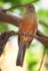  Bird:  Rufous-bellied Thrush
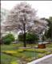  Tree: Ipês, Pau Brasil | 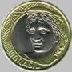  The Efígie da República (Effigy of the Republic) is an image of a young woman wearing a crown of bay leaves.

Chile
National symbols
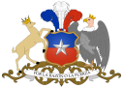  National coat of arms | 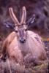  Animal: huemul
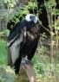  Bird: Andean Condor | 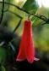  Flower: Copihue

England
National symbols
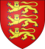  National coat of arms | 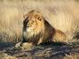  Animal: lion
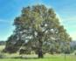  Tree: oak | Flower: rose

France
National symbols
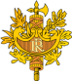  National emblem | 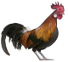  Bird: Gallic rooster
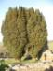  Tree: yew | 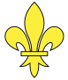  Flower: stylised lily (fleur-de-lis)

Germany
National symbols
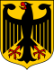  National coat of arms | 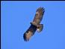  Bird: eagle
Tree: oak | 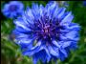  Flower: blue cornflower

Honduras
National symbols
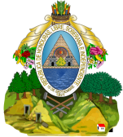  National coat of arms | 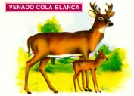  Animal: white-tailed deer
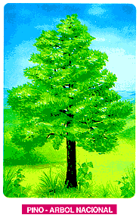  Tree: Honduras pine | 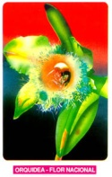  Flower: orchid

Italy
National symbols
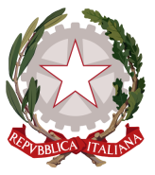  National coat of arms | 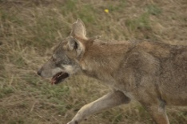  Animal: Italian wolf
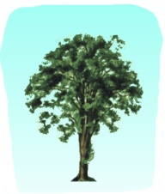  Tree: elm | 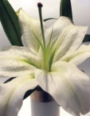  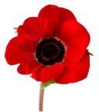  Flower: Poppy or White Lily

Japan
National symbols
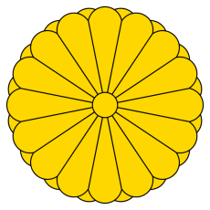  Imperial seal |  | 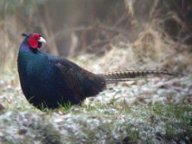  Bird: Japanese pheasant
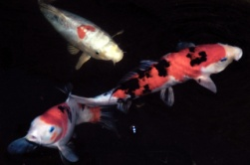  Fish: Koi | 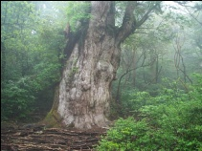  Tree: Sugi (Japanese Cedar) | 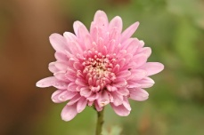  Flower: Chrysanthemum

Mexico
National symbols
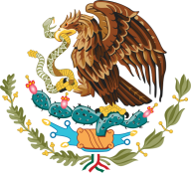  National coat of arms | Animal: Chihuahua | 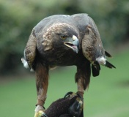  Bird: golden eagle
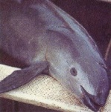  Marine mammal: vaquita (porpoise) | 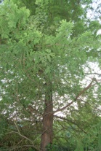  Tree:  cypress | 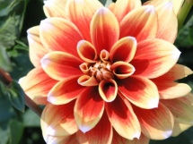  Flower: Dahlia pinnata

New Zealand
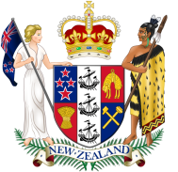
National symbols
National coat of arms | 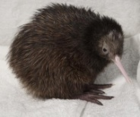  Bird: kiwi
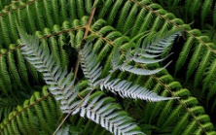  Plant: Silver Fern | 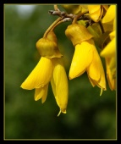  Flower: Kowhai

Portugal
National symbols
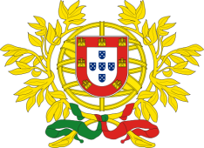  National coat of arms | 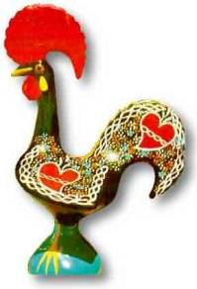  Bird: barcelos cock
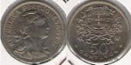  Efígie da República is represented as a young woman wearing the phrygian cap | 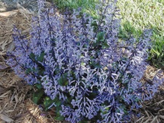  Flower: lavender

Serbia
National symbols
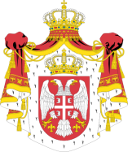  National coat of arms | 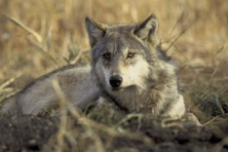  Animal: wolf | 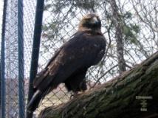  Bird: Serbian eagle
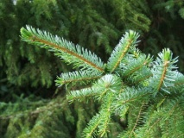  Tree: Serbian spruce | 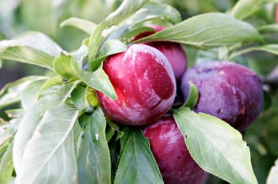  Plant: plum

Uruguay
National symbols
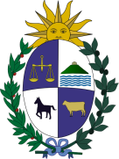  National coat of arms | 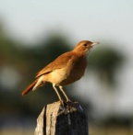  Bird: Rufous Hornero
The Sun of May, a representation of the Inca sun god Inti. | Flower: Red flower from the Cockspur Coral Tree or Ceibo tree

United States of America
National symbols
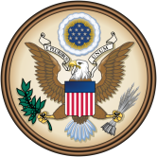  Great seal | 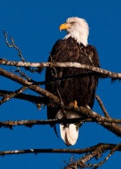  Bird: bald eagle
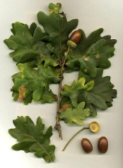  Tree:  oak | 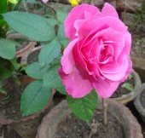  Flower: rose

