ACTIVITY 1
QUESTION 1
1.1 Various options are given as possible answers to the following questions. Choose the answer and write only the letter (A to D) next to the question number (1.1.1 to 1.1.6) in the ANSWER BOOK, for example 1.1.7 D.
1.1.1 The land mass that existed about 225 million years ago:
A Pangea
B Laurasia
C Gondwanaland
D Eurasia

QUESTIONS 1.1.2 and 1.1.3 are based on the diagrams below.
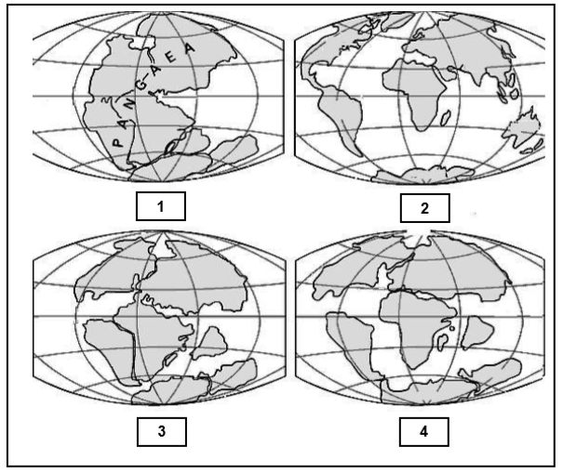
1.1.2 The diagrams above illustrate ...
A tectonic plates.
B continental drift.
C asteroid impact.
D volcanic activity.
1.1.3 The correct sequence of events during the above process is …
A 4, 3, 2, 1.
B 1, 3, 4, 2.
C 1, 2, 3, 4.
D 1, 4, 3, 2.

1.1.4 The gradual movement of the continents across the earth's surface through geological time.

A Ice Age
B Extinction
C Continental Drift
D Pangea
(4 x 2) (8)

QUESTION 2
2.1 Study the graph below and answer the questions that follow:
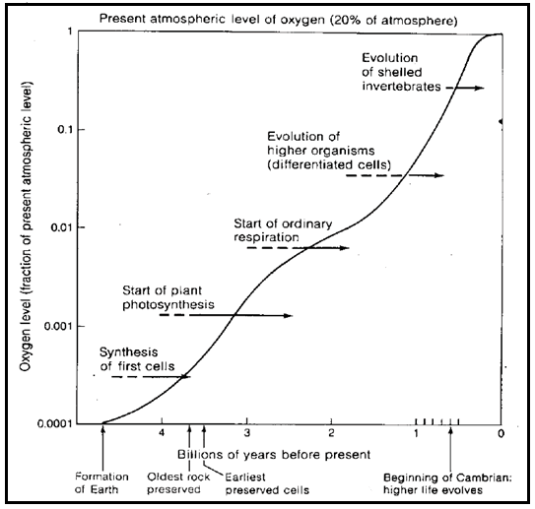
2.1.1 Explain the changes of oxygen over time as illustrated in the graph. (1)
2.1.2 How did the advent of green plants affect the level of oxygen? (1)
2.1.3 When, according the graph, were the earliest preserved cells recorded?
(1)
2.1.4 How did the change in oxygen levels affect life on earth? (2)
(5)

MEMO
ACTIVITY 1
1.1
1.1.1 A
1.1.2 B
1.1.3 B
1.1.4 C
(4 x 2) (8)

QUESTION 2
2.1.1 The level of oxygen increases steadily over time (1)
2.1.2 Caused the increase of oxygen as oxygen is released during photosynthesis (1)
2.1.3 3.5 billion years ago (1)
2.1.4 As oxygen levels increased an increase in biodiversity was noted (2)
(5)

