# DIFFERENT FORMS OR TYPES OF FOSSILS

[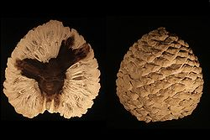](http://en.wikipedia.org/wiki/File:Petrified_Araucaria_cone_from_patagonia-Edit3.jpg) [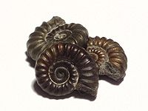](http://en.wikipedia.org/wiki/File:Amonite_Cropped.jpg)

[ammonite](http://en.wikipedia.org/wiki/Ammonite) fossils,

Petrified cone of [*Araucaria*](http://en.wikipedia.org/wiki/Araucaria) sp. from

[Patagonia](http://en.wikipedia.org/wiki/Patagonia), [Argentina](http://en.wikipedia.org/wiki/Argentina) dating from

the [Jurassic Period](http://en.wikipedia.org/wiki/Jurassic) (approx. 210 [Ma](http://en.wikipedia.org/wiki/Annum))

[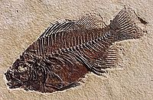](http://en.wikipedia.org/wiki/File:Priscacara-liops.jpg) [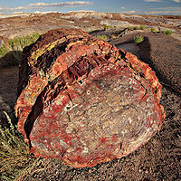](http://en.wikipedia.org/wiki/File:Petrified_forest_log_2_md.jpg)

Eocene fossil fish *Priscacara liops* Petrified wood

from [Green River Formation](http://en.wikipedia.org/wiki/Green_River_Formation) of Utah

Lower [Proterozoic](http://en.wikipedia.org/wiki/Proterozoic) [Stromatolites](http://en.wikipedia.org/wiki/Stromatolites) from [Bolivia](http://en.wikipedia.org/wiki/Bolivia),

South America

[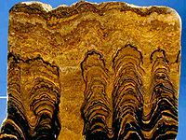](http://en.wikipedia.org/wiki/File:Proterozoic_Stromatolites.jpg) [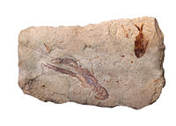](http://en.wikipedia.org/wiki/File:The_fossils_from_Cretaceous_age_found_in_Lebanon.jpg)

Earth’s oldest fossils are the [stromatolites](http://en.wikipedia.org/wiki/Stromatolite) Fossil [shrimp](http://en.wikipedia.org/wiki/Shrimp) ([Cretaceous](http://en.wikipedia.org/wiki/Cretaceous))consisting of rock built from layer upon layer

of [sediment](http://en.wikipedia.org/wiki/Sediment) and other precipitants.[[3]](http://en.wikipedia.org/wiki/Fossil#cite_note-2#cite_note-2)

A fossil [gastropod](http://en.wikipedia.org/wiki/Gastropod) from the [Pliocene](http://en.wikipedia.org/wiki/Pliocene) of [Cyprus](http://en.wikipedia.org/wiki/Cyprus).

A [serpulid worm](http://en.wikipedia.org/wiki/Serpulidae) is attached.

[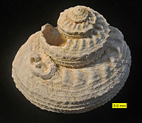](http://en.wikipedia.org/wiki/File:CyprusPlioceneGastropod.JPG) [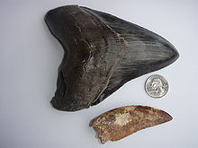](http://en.wikipedia.org/wiki/File:Carcharodontosaurus_and_Megalodon_teeth.jpg)

[Megalodon](http://en.wikipedia.org/wiki/Megalodon) and [*Carcharodontosaurus*](http://en.wikipedia.org/wiki/Carcharodontosaurus) teeth. The latter was found in the [Sahara Desert](http://en.wikipedia.org/wiki/Sahara_Desert).

### Permineralization

[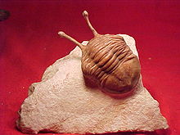](http://en.wikipedia.org/wiki/File:Asaphus_species_trilobite.jpg) [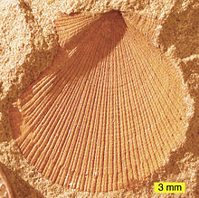](http://en.wikipedia.org/wiki/File:Aviculopecten_subcardiformis01.JPG)

[http://bits.wikimedia.org/skins-1.5/common/images/magnify-clip.png](http://en.wikipedia.org/wiki/File:Aviculopecten_subcardiformis01.JPG)

External mold of a [bivalve](http://en.wikipedia.org/wiki/Bivalve) from the

Logan Formation, Lower [Carboniferous](http://en.wikipedia.org/wiki/Carboniferous), Ohio.

Recrystallized [scleractinian](http://en.wikipedia.org/wiki/Scleractinia) coral

(aragonite to calcite) from the [Jurassic](http://en.wikipedia.org/wiki/Jurassic) of southern Israel.

[http://bits.wikimedia.org/skins-1.5/common/images/magnify-clip.png](http://en.wikipedia.org/wiki/File:Trilobite2.jpg)

## [http://upload.wikimedia.org/wikipedia/commons/thumb/7/76/MatmorScleractinian.JPG/220px-MatmorScleractinian.JPG](http://en.wikipedia.org/wiki/File:MatmorScleractinian.JPG) [http://upload.wikimedia.org/wikipedia/commons/thumb/6/65/Leptofoenus_pittfieldae_%28male%29_rotated.JPG/220px-Leptofoenus_pittfieldae_%28male%29_rotated.JPG](http://en.wikipedia.org/wiki/File:Leptofoenus_pittfieldae_(male)_rotated.JPG)

## Resin fossils

## [*Leptofoenus pittfieldae*](http://en.wikipedia.org/wiki/Leptofoenus_pittfieldae) trapped in [Dominican amber](http://en.wikipedia.org/wiki/Dominican_amber), from 20-16 million years ago

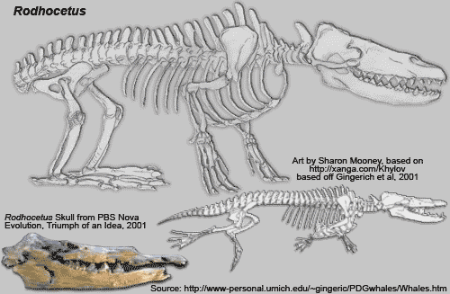

**Skeleton of whale that walked on land found in Pakistan**