Worksheet: The missing link between dinosaurs and birds
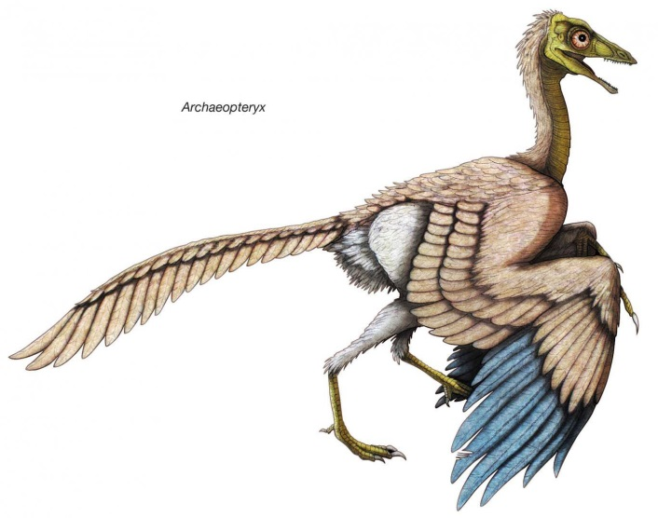

Archaeopteryx
Archaeopteryx , meaning "old wing" (sometimes referred to by its German name Urvogel ("original bird" or "first bird")), is a genus of bird-like dinosaurs that is transitional between non-avian feathered dinosaurs and modern birds. The name derives from the ancient Greek archaīos meaning "ancient", and ptéryx meaning "feather" or "wing". Between the late nineteenth century and the early twenty-first century, Archaeopteryx had been generally accepted by palaeontologists and popular reference books as the oldest known bird (member of the group Avialae).
Archaeopteryx lived in the Late Jurassic around 150 million years ago, in what is now southern Germany during a time when Europe was an archipelago of islands in a shallow warm tropical sea, much closer to the equator than it is now., the largest species of Archaeopteryx could grow to about 0.5 m in length and weighting between 0.8 to 1kilograms. Despite their small size, broad wings, and inferred ability to fly or glide, Archaeopteryx had more in common with other small dinosaurs than with modern birds. In particular, they shared the following features with the dinosaurs: jaws with sharp teeth, three fingers with claws, a long bony tail, second toes ("killing claw"), feathers (which also suggest warm-bloodedness), and various features of the skeleton.
the time.
Because it displays features common to both birds and non-avian dinosaurs, Archaeopteryx has often been considered a link between them. In the 1970s, John Ostrom, argued that birds evolved within theropod dinosaurs and Archaeopteryx was a critical piece of evidence for this argument; it had several avian features, such as a wishbone, flight feathers, wings, and a partially reversed first toe along with dinosaur and theropod features.
Adapted from Wikipedia
1. Define the term “transitional fossil”.
2. How long ago was the Archaeopteryx alive?
3. The Archaeopteryx has bird-like and dinosaur-like features. Tabulate the bird-like and dinousour-like features.
4. In which country was the Archaeopteryx discovered?
Memo:
1. It is a fossil that exhibits traits common to both an ancestral group and its derived descendant group.
2. 150mya
3.
Bird features | Dinosaur features
Feathers | Bony tail
Hollow bones | Bony sternum(breastbone)
Had a wishbone | Abdomen “Belly” ribs
Feet had three forward pointing toes and one backward pointing toe | Claws
Wings | Jaws with teeth

4. Germany

