**BBR or BSR ?**

Designed by

Mrs. H. Smal

Nigel Secondary School

BBR: Bank Buying Rate

BSR: Bank Selling Rate

**Example 1:**

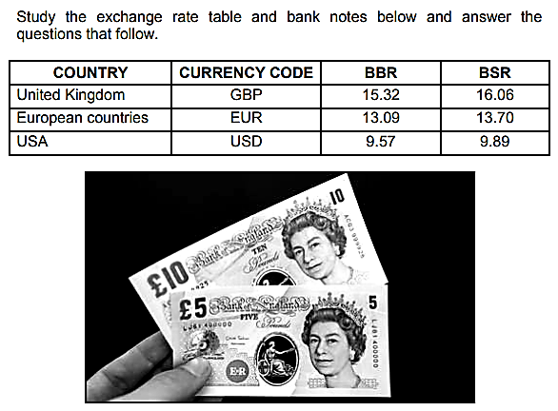

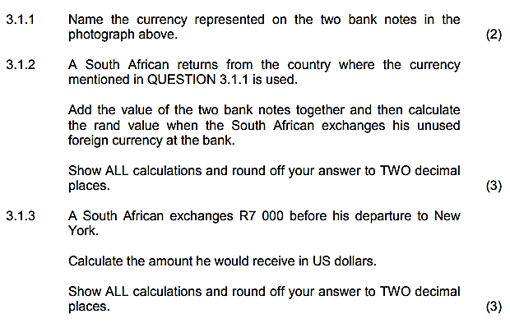



**Example 1:**

**Explanation**

SA

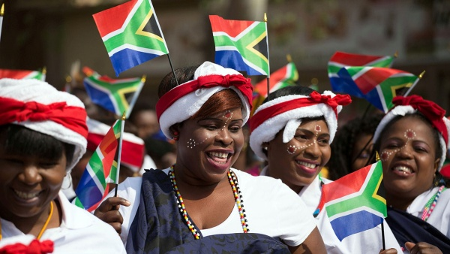

SA Citizen

OR







THE SA BANK WILL:

DOLLARS to him/her

SA Citizen: Exchange R7000

In SA to DOLLARS

**Example 1:**

**Calculation**



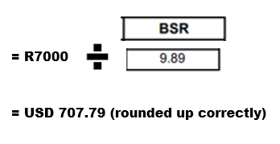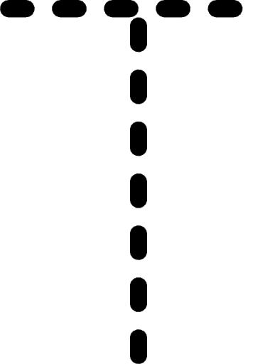







**Example 2:**

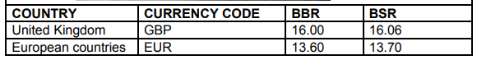

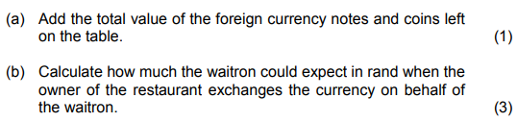

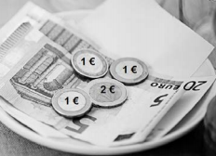



**Example 2:**

**Explanation**

SA



SA Citizen

OR







The Waitron change

to ZAR (Rand)

THE **SA BANK** WILL:

**The EUROS** from her.

**Example 2:**

**Calculation**



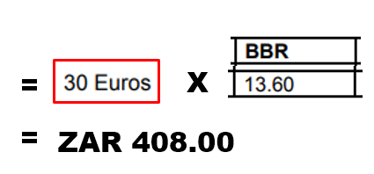





**Example 3:**

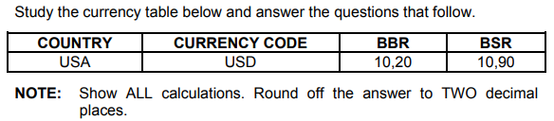

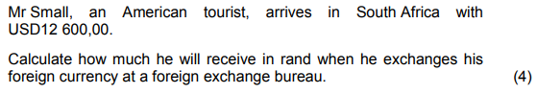



USA Tourist

In SA

SA

**Example 3:**

**Explanation**



OR







Exchange 12 600 US$

To ZAR, while in SA.

THE **SA BANK** WILL:

**The DOLLARS** from him.

**Example 3:**

**Calculation**







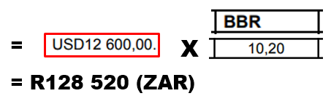



**ACTIVITY 1:**

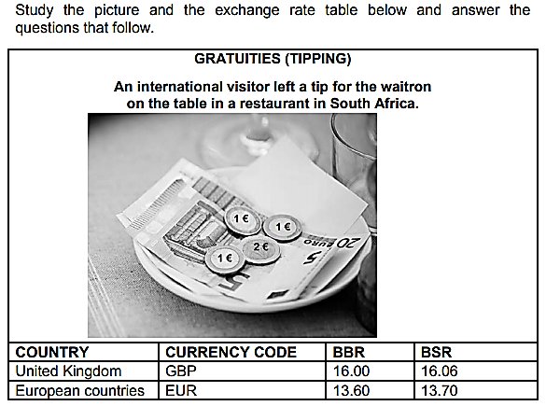

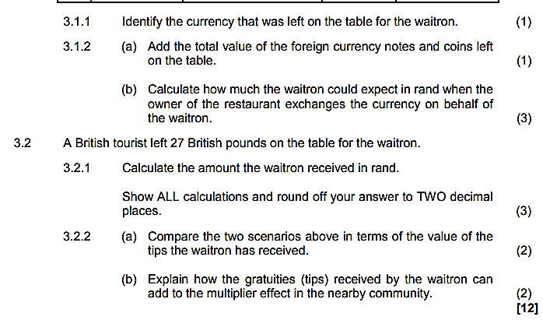

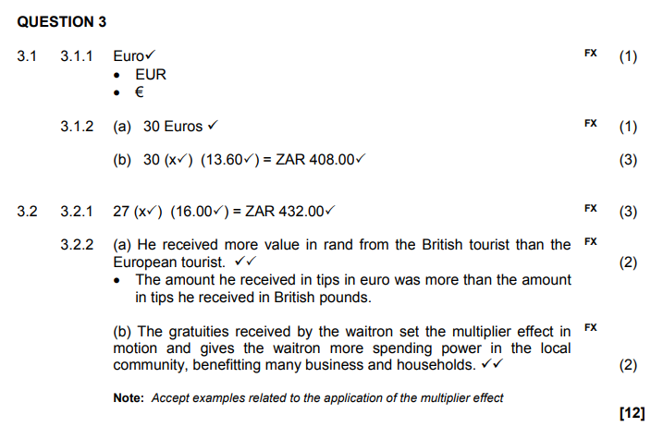

**MEMO**

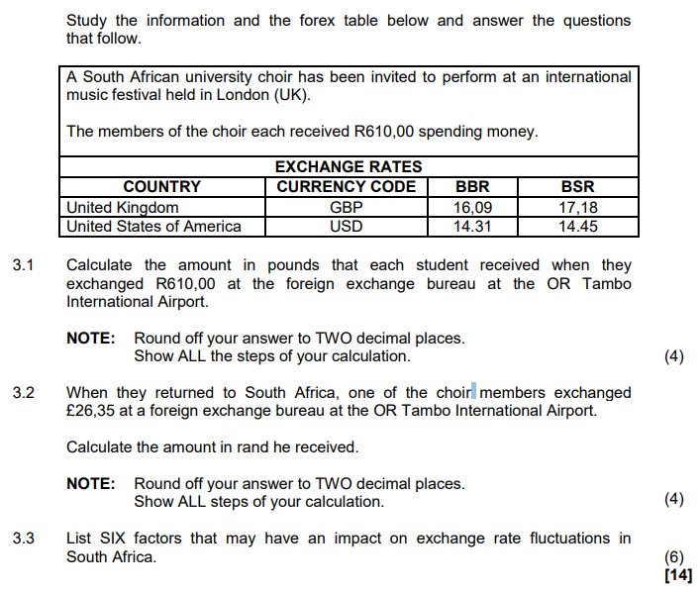

**ACTIVITY 2:**

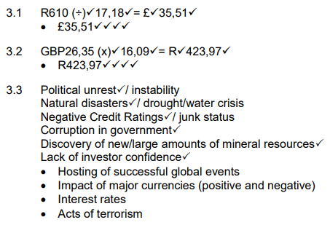

**MEMO**

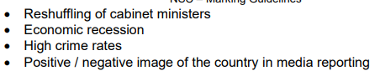

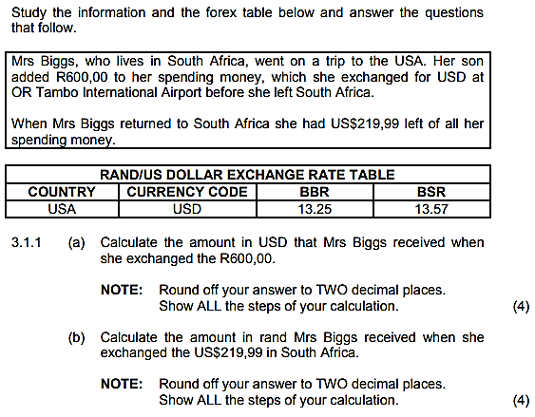

**ACTIVITY 3:**

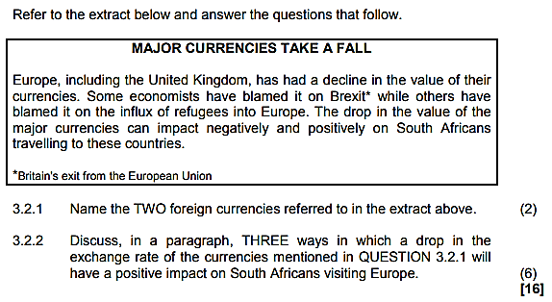

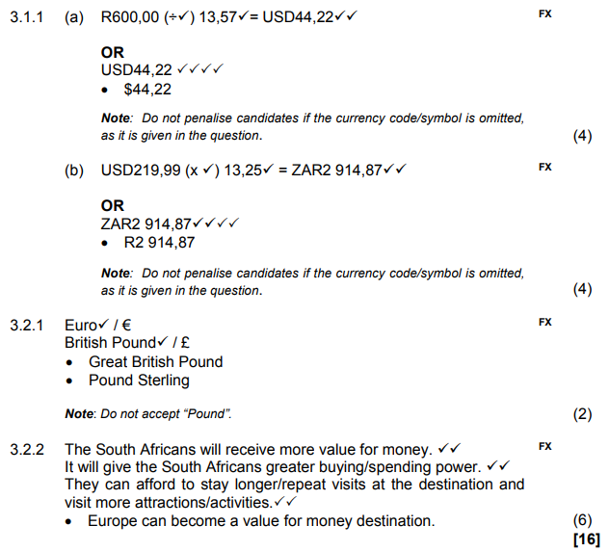

**MEMO**

**ACTIVITY 4:**

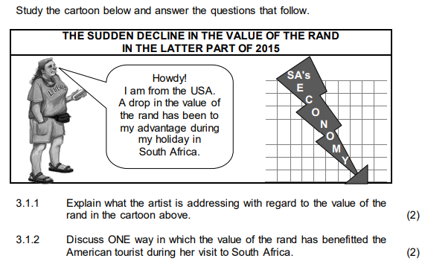

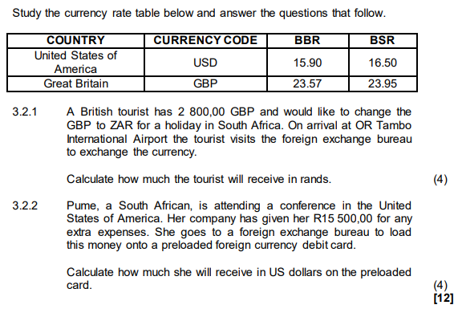

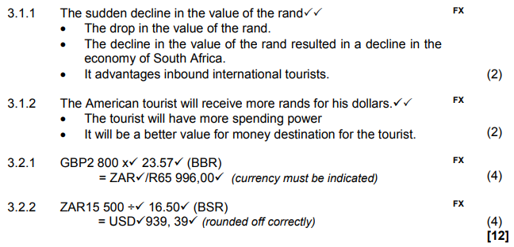

**MEMO**

**ACTIVITY 5:**

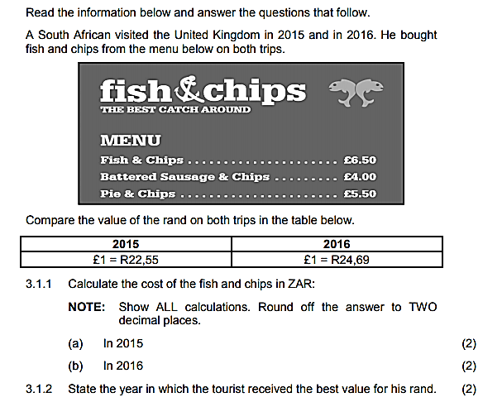

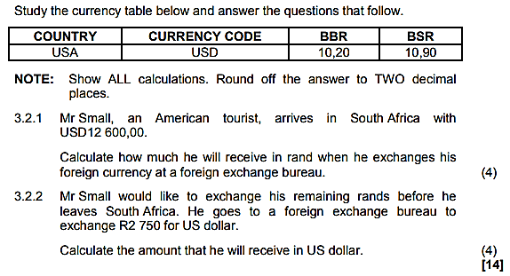

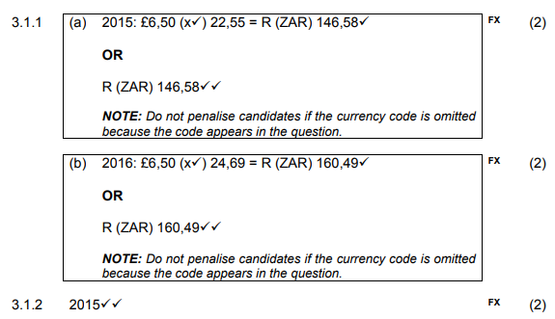

**MEMO**

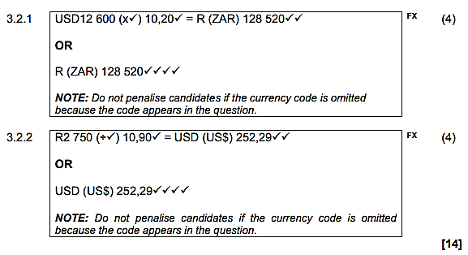

**ACTIVITY 6:**

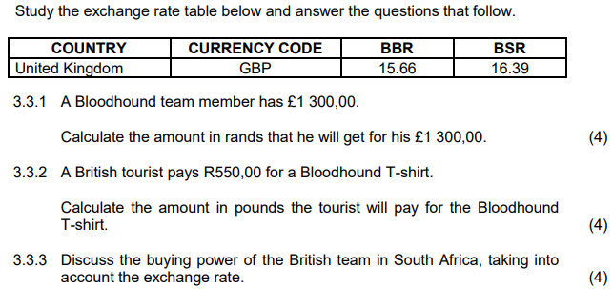

**MEMO**

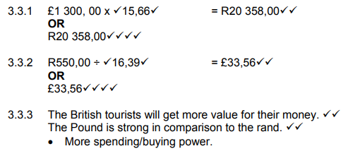

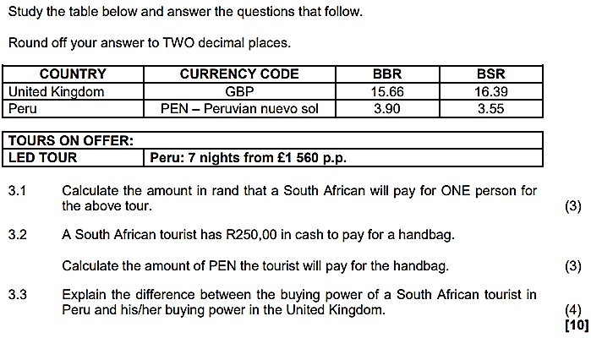

**ACTIVITY 7:**

**MEMO**

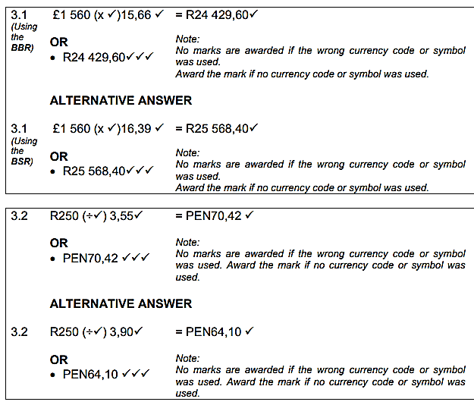

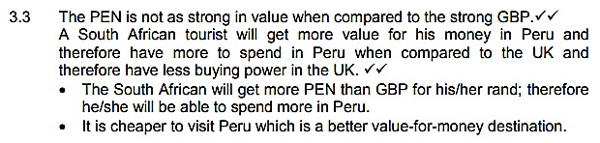

**ACTIVITY 8:**

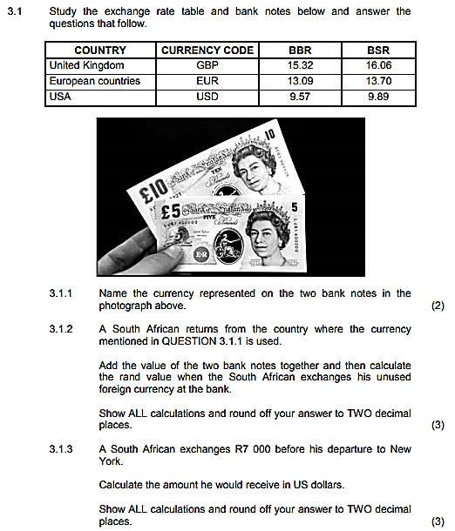

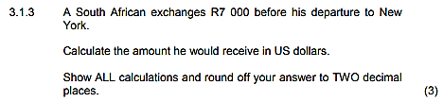

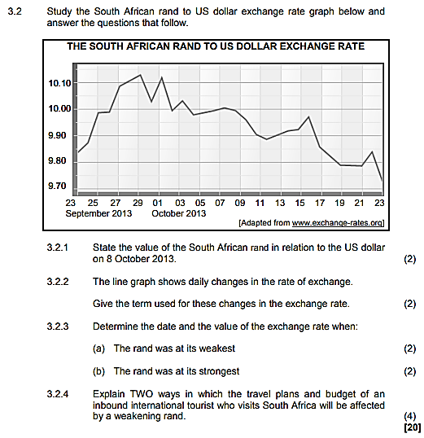

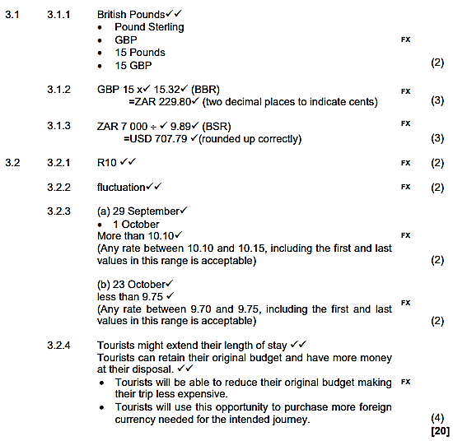

**MEMO**