The ‘missing link’ between dinosaurs and birds, e.g. Archaeopteryx

Study the articles and information and write a short report in which you explain why Archaeopteryx is considered to be the ‘missing link’ between dinosaurs and birds. Also provide a bibliography for your report.

New species of missing link between dinos and birds
Posted by Eleanor Imster in EARTH | October 29, 2018
Known as “the missing link” between dinosaurs and birds, Archaeopteryx lived in the Late Jurassic around 150 million years ago. Now, an international team of scientists has identified a new species of Archaeopteryx that they say is closer to modern birds in evolutionary terms and distinctive and different enough to be described as a new species – Archaeopteryx albersdoerferi.
Archaeopteryx lived in what is now southern Germany during a time when Europe was an archipelago of islands in a warm, shallow tropical sea. It was about the size of a magpie, with the largest individuals possibly attaining the size of a raven.
Archaeopteryx was first described as the “missing link” between reptiles and birds in 1861. Only 12 fossil specimens have ever been found.
Adapted from: https://earthsky.org/earth/new-species-archaeopteryx-missing-link-dinosaurs-birds
Retrieved on 11 May 2019

Archaeopteryx: Definition, Facts & Characteristics
Archaeopteryx lithographica, first found in a specimen from southern Germany, is a coelurosaurid. It's about 150 million years old, placing it in the late Jurassic era. Archaeopteryx is considered to be the first bird. But there are many things about Archaeopteryx that you would not recognize in a modern bird.
First and foremost, Archaeopteryx had teeth, rather than a beak. It also had a flat sternum (breastbone). Most modern birds have a keeled breastbone, which allows them to attach powerful flight muscles. Archaeopteryx also had little claws on the end of its wings that would allow it to grasp prey.
However, Archaeopteryx had wings, feathers, and a wishbone much like modern birds. It does look very much like a bird!
Adapted from:https://study.com/academy/lesson/arhcaeopteryx-definition-facts-characteristics.html
Retrieved on11 May 2019
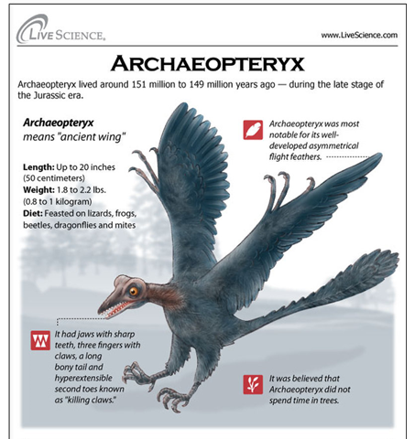

Retrieved on 13 May 2019

Life History of Archaeopteryx lithographica
David Bartfai and Gunit Kang

Anatomy & Physiology
Archaeopteryx exhibits both reptilian and bird like characteristics. Similar to reptilians, Archaeopteryx had a complete set of teeth. Unlike all living birds, Archaeopteryx had a flat sternum, a long, bony tail, and three claws on the wing, believed to be used in grasping its prey or maybe trees. However, it also had characteristics of a modern bird, which included feathers, wings, and reduced fingers

Avian Features
Feathers: Feathers are generally a defining structure when looking at modern birds. Archaeopteryx appears to have possessed well developed flight feathers, which are asymmetrical and contain a large amount of curvature as well as three distinct vanes. In some aspects however, the feathers of Archaeopteryx appear to be slightly more primitive than extant bird capable of flight with slightly less apparent asymmetry.
Limbs: The hallux, or first toe, in Archaeopteryx appears to be flexible, a trait not seen in remains of dinosaurs.

Flight
The structure of feathers of the wings and tail appear to entail the ability of the animal to generate lift, although the extent to which it was able to do this is still a topic of debate.
Adapted from: http://tolweb.org/treehouses
Retrieved on 11May 2019

