COELACANTHS  Living fossils  First appeared 410 MYA | CROCODILES  First appeared 200 MYA
HORSESHOE CRABS  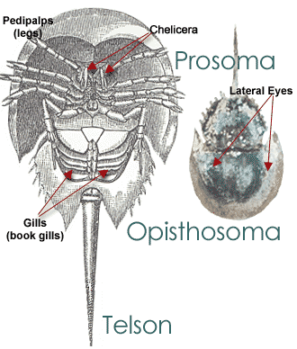  First appeared 250 MYA | COCKROACHES  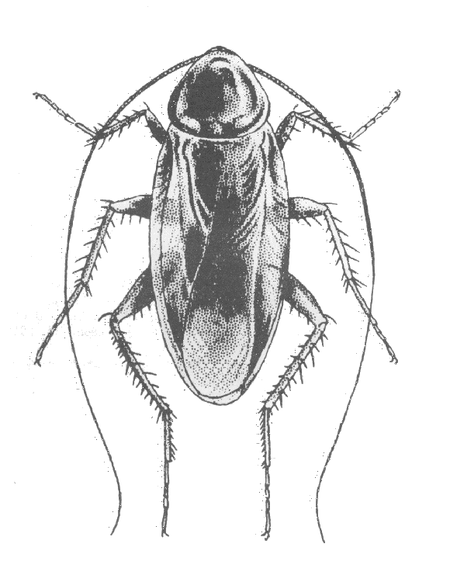  First appeared 350 MYA

These animals lived at the same time as the dinosaurs, yet unlike the dinosaurs, they have survived.
Why have they survived?
COELACANTHS
Coelacanths were known only from fossils until a live Latimeria chalumnae was discovered off the coast of South Africa in 1938.
Coelacanths have a unique form of locomotion. One striking feature of the coelacanth is its four fleshy fins, which extend away from its body like limbs and move in an alternating pattern. The movement of alternate paired fins resembles the movement of the forelegs and hind legs of a tetrapod walking on land.
Their jaws are hinged to open wide. Unique to any other living animal, the coelacanth has an intracranial joint, a hinge in its skull that allows it to open its mouth extremely wide to consume large prey.
Instead of a backbone, they have a notochord. Coelacanths retain an oil-filled notochord, a hollow, pressurized tube that serves as a backbone. In most other vertebrates, the notochord is replaced by the vertebral column as the embryo develops.
Coelacanths have an electric sense. Coelacanths have a rostral organ in their snouts that is part of an electrosensory system. They likely use electroreception to avoid obstacles and detect prey.

They have tiny brains. A coelacanth's brain occupies only 1.5 percent of its cranial cavity. The rest of the braincase is filled with fat.

Coelacanths give birth to live young. After an extremely long gestation period, possibly up to three years, female coelacanths give birth to live offspring.
They're nocturnal and spend their days resting in caves. During the day, coelacanths rest in caves and crevices. They leave these daytime resting places the same time late each afternoon to feed, mostly on fish and cephalopods. Coelacanths are passive drift feeders, moving lethargically near the ocean bottom and using the current and their flexible lobed fins to move about. They live in the relatively unchanging environment of deep-sea caves where there are few predators. .
CROCODILES
Crocodiles could have survived mass extinction because of their mostly unknown ability to hibernate for years at a time. They are also smaller than dinosaurs which could also have allowed them to survive. ... Crocodiles will also go dormant during long periods of drought.

Theory #1: Crocodiles Were Exceptionally Well-Adapted
Whereas dinosaurs came in all shapes and sizes—huge, elephant-legged sauropods, tiny, feathered dino-birds, towering, ravenous tyrannosaurs—crocodiles have stuck with pretty much the same body plan for the last 200 million years. Perhaps the stubby legs and low-slung posture of crocodiles allowed them to literally "keep their heads down" during the K/T upheaval, thrive in a wide variety of climatic conditions, and avoid the fate of their dinosaur pals.

Theory #2: Crocodiles Lived Near the Water
As stated above, the K/T Extinction wiped out land-dwelling dinosaurs and pterosaurs, as well as sea-dwelling mosasaurs (the sleek, vicious marine reptiles that populated the world's oceans toward the end of the Cretaceous period). Crocodiles, by contrast, pursued a more amphibious lifestyle, perched halfway between dry land and long, winding freshwater rivers and saltwater estuaries. For whatever reason, the Yucatan meteor impact had less of an impact on freshwater rivers and lakes than it did on saltwater oceans, thus sparing the crocodile lineage.

Theory #3: Crocodiles Are Cold-Blooded
Most paleontologists believe that theropod dinosaurs were warm-blooded and thus had to constantly eat to fuel their metabolisms—while the sheer mass of sauropods and hadrosaurs made them slow to both absorb and radiate heat, and thus able to maintain a steady temperature. Neither of these adaptations would have been very effective in the cold, dark conditions immediately following the Yucatan meteor impact. Crocodiles, by contrast, possess classically "reptilian" cold-blooded metabolisms, meaning they don't have to eat very much and can survive for extended periods in severe darkness and cold.

Theory #4: Crocodiles Grew More Slowly Than Dinosaurs
This is closely related to theory #3, above. There's an increasing amount of evidence that dinosaurs of all types (including theropods, sauropods, and hadrosaurs) experienced a quick "growth spurt" early in their life cycles, an adaptation that better enabled them to avoid predation. Crocodiles, by contrast, grow steadily and slowly throughout their lives and would have better been able to adapt to the sudden scarcity of food after the K/T impact. (Imagine a teenaged Tyrannosaurus rex experiencing a growth spurt suddenly needing to eat five times as much meat as before, and not being able to find it!)

Theory #5: Crocodiles Were Smarter Than Dinosaurs
This is probably the most controversial hypothesis on this list. Some people who work with crocodiles swears that they're almost as smart as cats or dogs; not only can they recognize their owners and trainers, but they can also learn a limited array of "tricks". Crocodiles and alligators are also fairly easy to tame, which may have allowed them to adapt more readily to the harsh conditions after the K/T impact. The problem with this theory is that some end-Cretaceous dinosaurs (like Velociraptor) were also fairly smart, and look what happened to them!
HORSESHOE CRABS
Because horseshoe crabs (Limulus polyphemusz) have lived for millions of years in relatively unchanged form, some biologists refer to them as living fossils. Relatives of the living species have inhabited the world’s oceans for at least 400 million years. Before their 400-million-year reign began, horseshoe crabs developed a number of adaptations that allow them to survive, including numerous eyes, hard shells, a specialized assortment of appendages and a primitive immune-like response to bacteria.
When environmental changes happen, they can move to safety. An ability to live with low levels of oxygen is also important. The horseshoe crab was able to cope with periods of oceanic deoxygenation that were fatal to many marine organisms.
Marine biologists identify 10 different eyes and other light-sensing organs on horseshoe crabs. Seven eyes are on the top of the animal’s carapace; the lateral eyes are the two most obvious, and are compound in design. Additionally, horseshoe crabs have a pair of rudimentary eyes behind each lateral eye, and a cluster of three eyes at the front of their carapace. Two very simple eyes are located near the mouth, on the underside of their carapace, but their function is not clear. The final light sensing organ is located along the length of their tail, scientists think that they help the arthropods to synchronize their activity pattern with the lunar cycle.
One of the most important adaptations of horseshoe crabs is their hard shell, termed a carapace. Though their carapace does not provide absolute protection from all predators, it discourages the majority of small- and medium-sized predators. Many organisms cling to the carapace of horseshoe crabs, including algae, barnacles and mollusks. Before they develop the hard carapace, young horseshoe crabs avoid the bottom of the ocean, and instead swim higher in the water column.
Horseshoe crabs have five pairs of walking legs, and one additional pair that has been modified into chelicerae -- pincers -- that help bring food to their mouth. Horseshoe crabs primarily eat creatures buried in the sediment. Using their legs, they dig -- primarily at night -- for flatworms, mollusks and other prey.
Horseshoe crabs do not produce antibodies to fight infection. However, they do demonstrate a novel approach to dealing with pathogens. Presumably, this allows these long-lived creatures to survive in their bacteria-laden habitats. When a horseshoe crab’s body detects the presence of endotoxin -- a compound associated with a variety of gram-negative bacteria -- its blood cells begin to exhibit massive clotting. This effectively seals off the invading pathogens before they can harm the horseshoe crab.
COCKROACHES
Cockroaches are ancient insects that have been around for some 300 million years, and one of the reasons they've been able to stick around that long is that they're able to change with the times. These insects survived the mass extinction that wiped out the dinosaurs, and now they're adapting to resist our efforts to eradicate them.
Cockroaches are not only flexible in the contents of their meals, but also the timing of when they are able to eat. Some roaches can last more than a month without food and over a week without water.
Perhaps most well known is that cockroaches can survive a week without its head. If a cockroach loses its head and later dies as a result, it will typically succumb to dehydration.
No matter how cockroaches produce future generations, one thing they nearly all have in common is that they're able to produce swarms of new roaches in a short time.
Most cockroaches are night owls. They do their foraging and feeding at night and avoid the light. This allows them to avoid potential predators and competitors.
Cockroaches have the ability to withstand radiation
Scientists are still debating why these animals have survived.

