Grade 10 : Life Sciences
Week 35
1.1 The graph below indicates the amount of oxygen on earth over years.
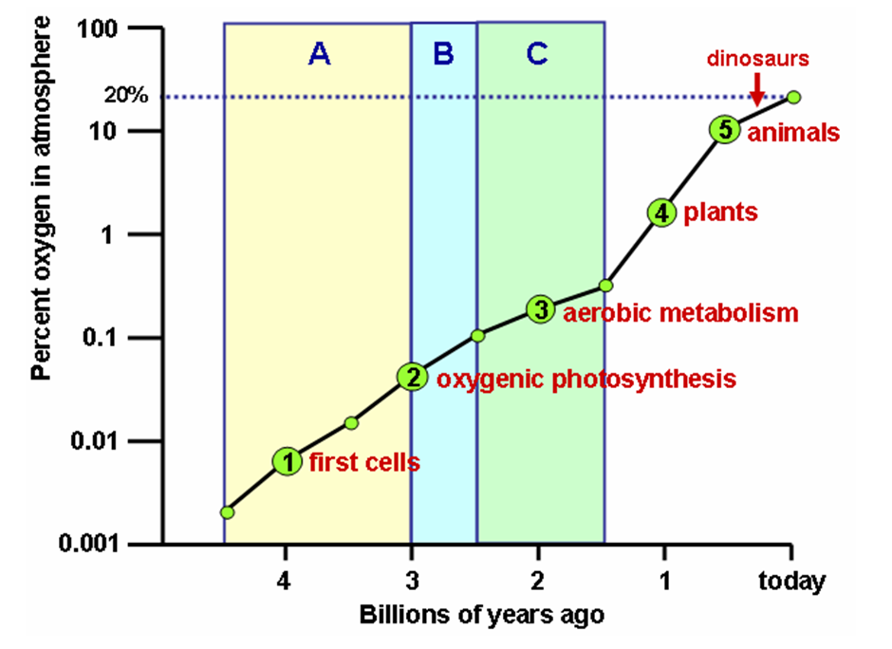

1.1 Explain the changes of oxygen over time as illustrated in the graph. (1)
1.2 Explain how the beginning of green plants affect the level of oxygen? (2)
1.3 When, according the graph, were the earliest preserved cells recorded? (2)
1.4 How did the change in oxygen levels affect life on earth? (2)

  - The following table shows earth atmosphere through time. Study the table and match the gases present in the atmosphere with the correct date or event.

 | Important date and event |  | Gases Present in the Atmosphere
2.1.1 | Earth formed more than 4.5 billion years ago | A. | Water vapour, carbon dioxide, nitrogen, sulphur dioxide
2.1.2 | Erupting Volcanoes | B. | 20% carbon dioxide
2.1.3 | Water condensed into liquid water on earth’s surface | C. | 21% oxygen
2.1.4 | 3.5 billion years ago, the oceans absorbed carbon dioxide | D. | 0.0377% carbon dioxide
2.1.5 | 2-3 billion years ago, living organisms produce oxygen | E. | 78% nitrogen, 21% oxygen, less than 1% carbon dioxide
2.1.6 | 400-500 million years ago, land plants produce oxygen | F. | Hydrogen, helium
2.1.7 | Modern atmosphere | G. | 70% carbon dioxide, 30% nitrogen
2.1.8 | 19% increase in carbon dioxide from 1959 to 2004 | H. | 15% carbon dioxide, less than 1% oxygen
 |  |  | (1*8=8)

2.2 Study your completed table and answer the following questions:
2.2.1 How has the amount of carbon dioxide gas in the atmosphere changed over the earth’s history? (2)
2.2.2 How has the amount of oxygen gas in the atmosphere changed over the earth’s history? (3)
2.2.3 What effect have living organisms (including people) had on the composition of the earth’s atmosphere? Support your answer with examples from this activity. (3)
2.2.4 Do you think that the atmosphere will have different amounts of oxygen and carbon dioxide in the future? Explain your answer. (3)
[11]

Answers
1
  - The level of oxygen increases steadily over time
  - It caused the increase of oxygen, as oxygen is released from the process of photosynthesis by green plants
  - 3.5 billion years ago
  - As oxygen levels increased an increase in biodiversity was noted

2.1
 | Important date and event |  | Gases Present in the Atmosphere
2.1.1 | Earth formed more than 4.5 billion years ago | F. | Hydrogen, helium
2.1.2 | Erupting Volcanoes | A. | Water vapour, carbon dioxide, nitrogen, sulphur dioxide
2.1.3 | Water condensed into liquid water on earth’s surface | G. | 70% carbon dioxide, 30%  nitrogen
2.1.4 | 3.5 billion years ago, the oceans absorbed carbon dioxide | B. | 20% carbon dioxide
2.1.5 | 2-3 billion years ago, living organisms produce oxygen | H. | 15% carbon dioxide, less than 1% oxygen
2.1.6 | 400-500 million years ago, land plants produce oxygen | C. | 21% oxygen
2.1.7 | Modern atmosphere | E. | 78% nitrogen, 21% oxygen, less than 1% carbon dioxide
2.1.8 | 19% increase in carbon dioxide from 1959 to 2004 | D. | 0.0377% carbon dioxide 20

2.2.1After earth formed the amount of carbon dioxide gas increased, from one to 70%. It then began to decrease, dropping to about 15% by 2–3 billion years ago. Today, the atmosphere is less than 1% carbon dioxide. (2)
2.2.2 There was no oxygen gas in the atmosphere until about 2–3 billion years ago, when photosynthetic organisms began to produce lots of oxygen. The amount of oxygen continued to increase until it reached the 21% it is today. (3)
2.2.3 Living organisms have caused an increase in both the amount of oxygen and the amount of carbon dioxide in earth’s atmosphere. Beginning about 2–3 billion years ago, the presence of photosynthesizing organisms began to increase the amount of atmospheric oxygen, until it reached present day levels. Today, the amount of carbon dioxide gas is increasing, in part due to human actions. (3)

2.2.4
- the earth is likely to continue to undergo changes in the amount of carbon dioxide gas due to a growing human population
- and increasing use of fossil fuels.
- Oxygen will decrease over time, as the human population increases and uses more oxygen while simultaneously reducing the land area of photosynthesizing plants. (Any 3) (3)

