Content: Life History on earth- Geological Time Scale
Activities on Lesson 5 (Week 35)
Question 1
Study the given representation of a geological time scale and answer the questions that
follow:

Era | Period | Start in millions of years | Major Events
Caenozoic | Holocene | .01 | Agriculture, civilization
 | Pleistocene | 1.6 | Neanderthals, modern humans
 | Pliocene | 5.3 | Earliest hominids
 | Miocene | 23.7 | Evolution and spread of mammals
 | Oligocene | 36.6 | First elephants
 | Eocene | 57.8 | First horses, rhinos and camels
 | Paleocene | 66.4 | First primates
Mesozoic | Cretaceous | 144 | Evolution and spread of flowers, extinction of dinosaurs
 | Jurassic | 208 | First birds and mammals, dinosaurs flourished
 | Triassic | 245 | First dinosaurs
Paleozoic | Permian | 286 | Mammal-like reptiles
 | Pennsylvanian | 320 | First reptiles, large insects
 | Mississippian | 360 | Sharks, insects
 | Devonian | 408 | First amphibians, forests
 | Silurian | 438 | First air-breathing animals
 | Ordovician | 505 | First fish
 | Cambrian | 543 | Rapid diversification of animals
Pre-Cambrian times |  | 610 | Diverse range of animals
 |  | 2500 | Eukaryotic cells
 |  | 3800 | First prokaryotic cells
 |  | 4500 | Formation of Earth

1.1 Why did scientists develop the geological timescale? (1)

1.2 How old is Earth estimated to be according to the geological timescale? (1)

1.3 How long after the creation of Earth did the first cells appear? Show all
calculations. (3)

1.4 The first algae appeared in the Pre-Cambrian Period. What important process
did they undergo which helped other organisms to develop. Explain how this
process led to the evolution of new organisms. (4)
ANSWERS

1.1. Scientists have divided the history of life into different time periods using the geological timescale.

1.2. 4,500 million years old

1.3. 4500-3800= 700 million years later

1.4. Cell divisions and mutations have caused evolution of new organsims

NOTES ON GEOLOGICAL TIME SCALE

Scientists have divided the history of life into different time periods using the geological timescale. In this section we will present the key evidence scientists have used to construct this time scale. We will discuss the continental drift theory which explains how the continents were formed. We will also briefly touch on the theory of natural selection which explains how one life form can evolve into another over many years by adapting to its changing environment. We will then present the methods by which we are able to determine evolution of life forms over time through examining the fossil record.
The geological timescale is a 'calendar' of events in the Earth's history. It shows major geological and climactic events, and how these events affected the emergence and disappearance of species over time. In order to help us make sense of this vast amount of time, scientists divided it into smaller units of time. In descending order, these units are: eons, eras and periods.
- An Eon: is defined as a unit of time equal to a billion years.
- An era: is a division of time within an eon but does not have a fixed number of years. The Mesozoic era for example lasted from 252 million years to 66 million years ago.
- A period: typically refers to a subdivision of an era and its length is determined by a system of dating based on examining fossil evidence belonging to a particular era.
Figure 1.1 below shows one method of representing the geological timescale:
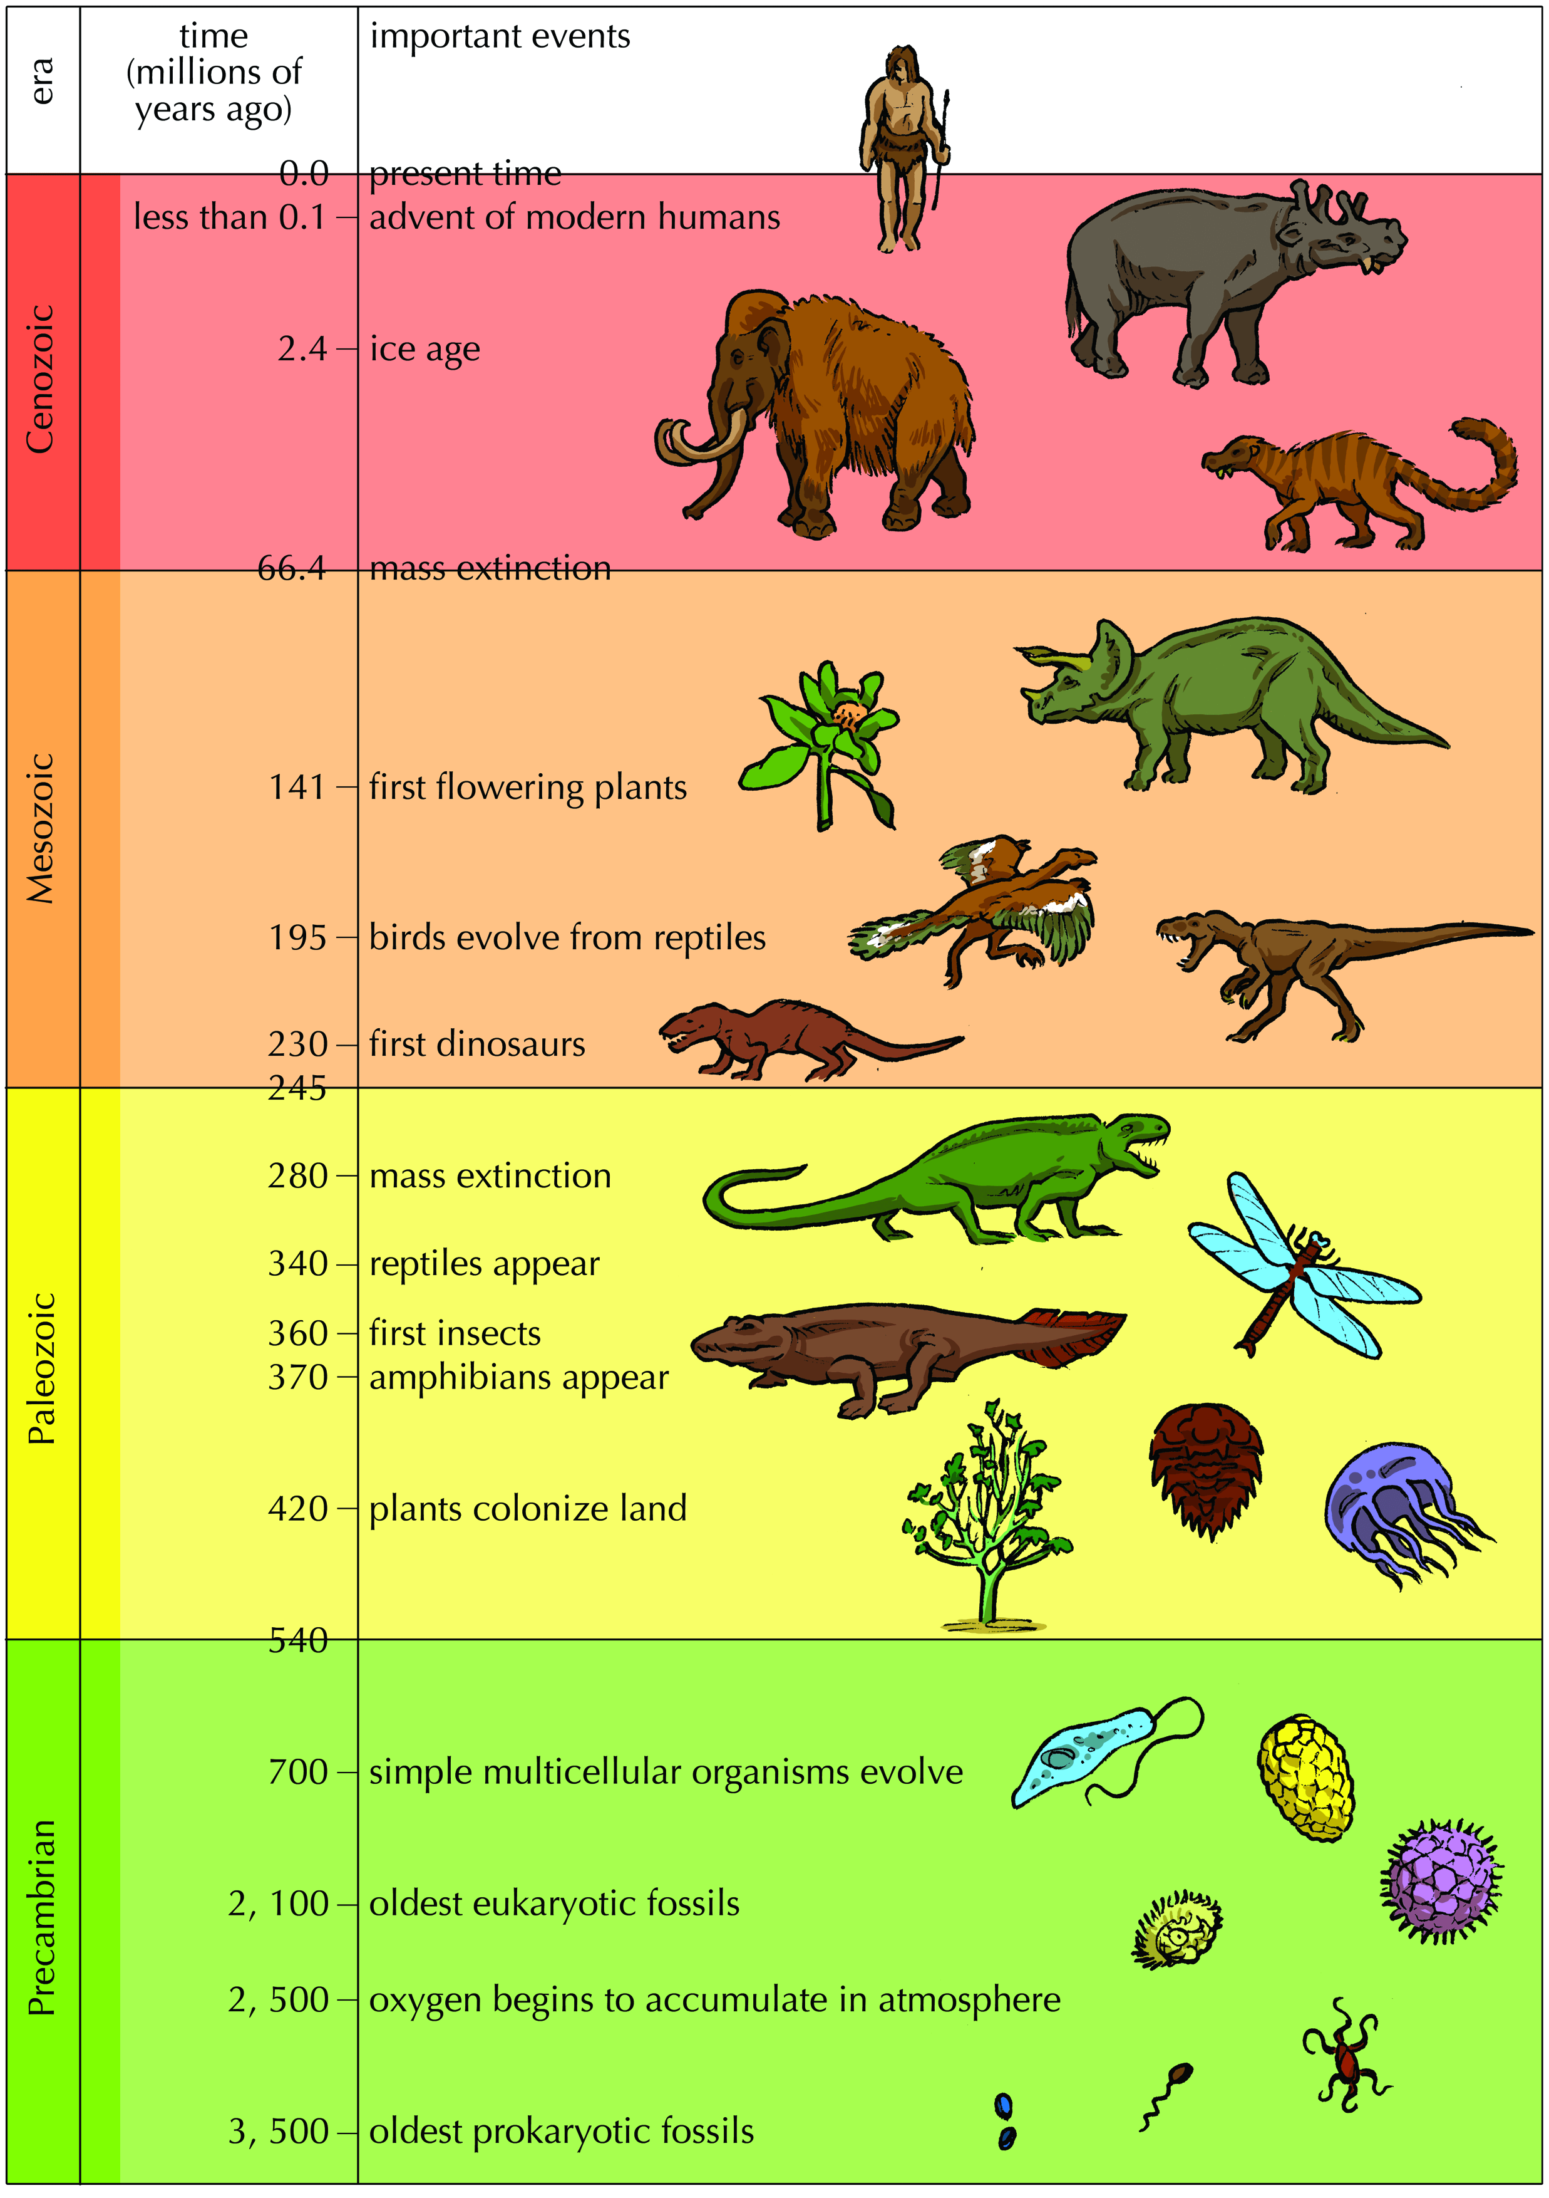
Figure 1.1: Geological timescale with key events and characteristics shown.
Another visually powerful way of representing Earth's history is via the use of the geological `clock' (Figure 1.2).
Human history occupies just 2 million of the 4 500 4 500 million year long history of the Earth. On this clock, human existence constitutes less than a minute of the evolutionary history of life on Earth.
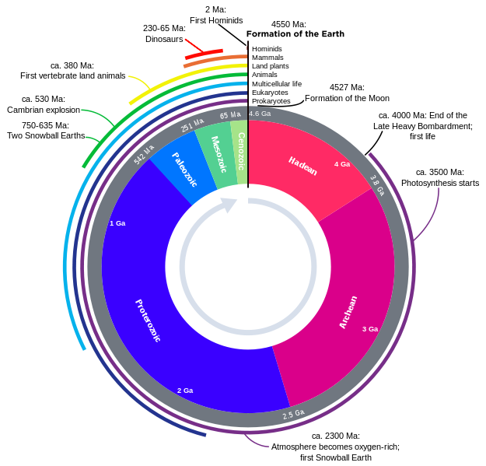
Figure 1.2: "Human history on Earth is a mere second on the clock". In this representation, the two million years' of human history constitute an effect too small to be visible on the timescale.

- Scientists use deductive reasoning to understand fossils and the history of
life on Earth.

- Geological events often caused changes in climate, which in turn influence
the emergence and disappearance of species.

- It takes special circumstances for fossils to form, and fossils can be dated
by radiometric or relative dating.
- Climate and geography helped shape the evolution of life on Earth.

- Geological timescales are divided into eons, eras and periods.

- The Cambrian explosion was a rapid explosion in the diversity of life-forms.

- All animal groups have their origin in the Cambrian explosion.

- During the Paleozoic the first fish, animals with shells and insects evolved
and plants first colonised land.

- The Mesozoic was the `age of dinosaurs', later in the era birds evolved, and
gymnosperms evolved.

- The Cenozoic is the most recent era and was the `age of mammals'.

- Mass extinctions are massive losses in life, and there have been five mass
extinction events in history.

- In the last 4 million years significant changes have occurred in species
occurring in Africa, including the evolution of humans.

- Humans have a massive effect on biodiversity and the natural environment
and are partially responsible for the '6th mass extinction'.

- South Africa is rich in many fossils from diverse time periods.

- Fossil tourism is a source of income and employment in fossil localities.

