PRACTICAL TASK
30 minutes
Materials and Resources:
Different types of stationary could also be used e.g. pens, pencils, rulers, etc.
Sequence Instruction
- Group learners into small groups (3-5).
- Give each group a set of everyday objects (see resources).
- Learners must group these objects based on similarities and differences.
- Learners should construct a tree diagram (on large sheets of paper) to indicate how they have classified their objects.
3. Conclusion
Learners display their tree diagram and use these to explain to the class how classification was done.
Show learners that there can be different classifications even of the same objects by different groups, using different criteria.

Activity 1 on classification
Look at the pictures of these animals, and then fill in the chart below:
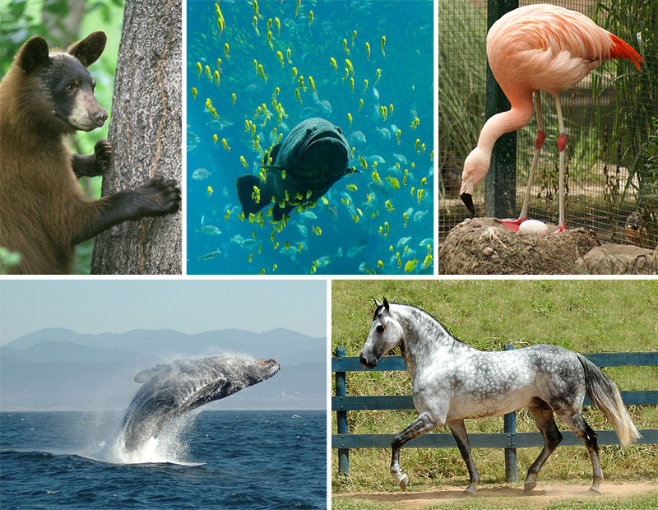
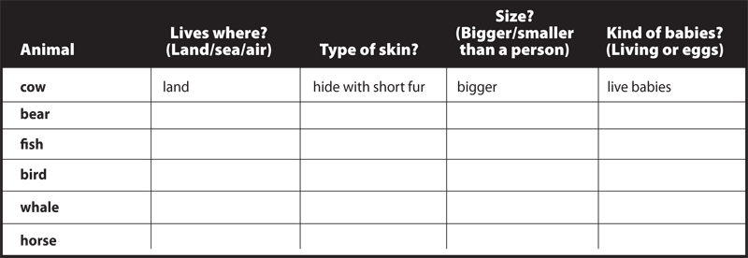
(20)

Activity 2 on 7 taxa
Name the 7 different categories or taxa developed by Linnaeus. (7)

Activity 3 on classifying thing in the house
You are going to devise a seven-level system for classifying the things in your house.
If you get confused at any time as you are doing this, you can look at the examples listed later in the lesson.
- First, let's think about the broadest level. Is everything inside your house or do you have some things outside, too? Maybe your first level needs to be the Kingdom Inside and the Kingdom Outside. If your family has other places that you keep things you own (like a separate house or a storage unit), that might be a third kingdom. You may want to have kingdoms based on sides of the house or things for parents and things for kids. List your kingdoms.
- Next, you need the next level down, phylum. Think about the things you have in one of your kingdoms. Can you think of a few categories you could divide them into? You may want to choose phyla based on rooms (such as Phylum Living Room, Phylum Kitchen). You may want to choose phyla based on the items' size or what they are made of. It's up to you. Choose just one kingdom from your list above and create three phyla for it on the next page (remember that phyla is the plural of phylum).
- Pick one of the three phyla you created above and put it on the line below. Write the kingdom that phylum belongs to on the line next to Kingdom. Think about the phylum you picked. In your mind, break it down into some categories. For example, if your phyla were broken down by rooms, and you picked "Living Room" as your phylum, how could you divide the things in your living room into categories? Could you break them down by what you do with them? How about who uses them? How about what they are made of or where they are (wall, floor, closet)? Don't try to make the categories too small, because you have several levels left! These categories are your classes. Think of three classes and list them on the diagram below:
- Now you are going to repeat this until you get to species. After class comes order (remember your sentence!), so choose one class from above, list in on the line below and create three orders to go underneath it. Just keep thinking about how you could narrow that group of things even more. Remember to look at the example at the end of this section if you get stuck. List the kingdom and phylum, too, so you can keep track.
- You only have a few levels to go! After order comes family, so choose one of your orders from above and do the same thing you've been doing. Break it down into smaller categories.
- You only have two levels left! You are almost to a single item! Wow! Choose one family from your list above and then break it down into three smaller groups. Remember that the next level will be an individual item, so be sure to make the genera (that's plural for more than one genus) very narrow.
- You are at the last step! You are down to individual items! Choose a genus from your list above, and name three different species, or items, within that genus.
- Now choose one of your species listed above (activity 1) and list its entire scientific classification from kingdom on down:

Activity 3 : Copy and complete to classify things in your house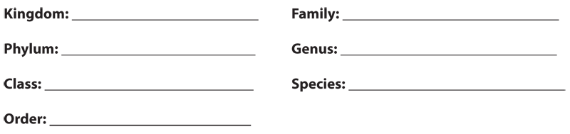

Activity 1 answers
Animal | Lives where? | Type of Skin | Size? | Kind of babies
cow | land | Hide/skin with short fur | bigger | Live babies
Bear | land | Hide/skin with longer fur | bigger | Live babies
Fish | sea | Skin with scales | smaller | eggs
Bird | land | Skin with feathers | smaller | eggs
Whale | sea | Skin without fur or scale | bigger | Live babies
horse | land | Hide/skin with short fur | bigger | Live babies
(20)

Activity 2 answer
Kingdom, phylum, class, order, family, genius and species. (7)

Activity 3: Rubric for classifying things in the house your house
________/2 completed all levels
________2/ Systems make sense (higher point should be given if system is obviously
reasonable and clear’ or if student can explain a less obvious classification system
that demonstrates expanded thinking)
________/1 Levels are progressively narrower
________/1 Species is a single, distinguishable item
________/6 Total

