GRADE | 10 | SUBJECT | Life Sciences | WEEK | 34  (Lesson 2) | TOPIC | Biodiversity and classification
LESSON SUMMARY FOR: DATE STARTED: |  |  | DATE COMPLETED: | TIME : 75MIN
LESSON OBJECTIVES | Content: p. 35 (CAPS). Classification of everyday objects  The learners must be able to:  .Classify everyday objects  .Recognise that similarities and differences are the basis of classification  .Construct a tree diagram to show classification
Lesson plan

TEACHER ACTIVITIES | LEARNER ACTIVITIES | TIMING | RESOURCES NEEDED
Teacher direct instruction  Hands on practical group-work  Discussion  1. Introduction  - Mark and recap previous day’s lesson.  - Consider answers of learners to questions posed at the end  of lesson 1.  Question 1 Scientists can measure biodiversity by counting the number of species/ecosystems/different genes.  Question 2 Animals that are the same will be in one species and those that are different will form another species.  - Discuss the everyday meaning of the words classify and class. | 1. Individual work: learners to answer questions and mark work. | 5 min | CAPS aligned Life Sciences Text books:

Class: A set or category of things having some property or attribute in common and differentiated from others by kind, type, or quality.  Classify: Arrange (a group of people or things) in classes according to shared qualities.  2. Main Body (Lesson presentation)  Describe an example of classification in everyday life.  Draw the following tree diagram on the board/OHP.  People in school  Staff Learners  Maths Science Languages L.O  Secretaries  Management  Teachers  Cleaners  Grade 8  Grade 9  Grade 10  Grade 11  Grade 12  Stress to learners that those people that are similar, are grouped together and where they differ, they will be classified differently. The above tree diagram could be further divided, for example, learners in each grade could be divided into male and female or by subject choice.  Another example of classification in everyday life can be seen in the shopping malls. Similar items are packed next to one another (e.g. coffee, creamer and tea, compared to where soaps and toothpaste etc. are packed).  EXAMPLES  Look here for ideas if you get confused. There is an example of how to break things down into smaller categories, and then there is an example of a scientific classification for an item. So that you don't get stuck trying to copy the example, we've used a school instead of a house for the example.  Do you see how the groups get smaller and smaller, ending in a single item? That is what you are trying to do.  Kingdom: School  Phylum: Grade 10  Class: Life sciences  Order: Classroom  Family: Books  Genus: Biodiversity  Species: Classification  Putting animals in order like this is called taxonomy. The taxonomists — people who name animals — use a book called the International Code of Zoological Nomenclature, or ICZN, to tell them the rules for classifying animals.  Linnaeus's system has seven levels:  - Kingdom  - Phylum  - Class  - Order  - Family  - Genus  - Species  Every animal on the planet, down to the most microscopic creature you can imagine, can be classified according to this system. You can remember the order the system comes in with one of the following phrases. The first letter of each word is the first letter of the level of classification. Pick the one you like the best and practice saying it five times.  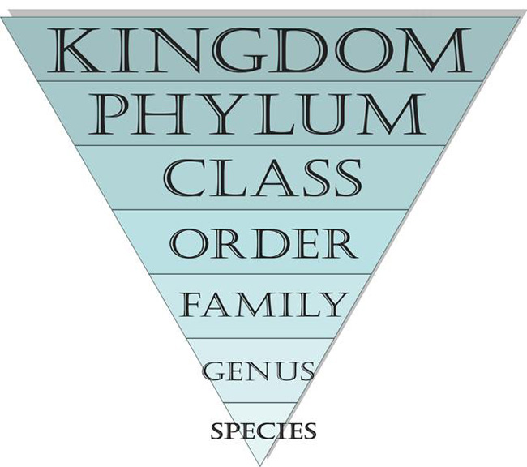  These levels start out broadly — that means the top levels have the most animals, and they get narrower and narrower as you go down. So, by the time you get to the species, there is only one animal in the group. You can imagine these levels as an upside-down triangle.  Kingdom  Generally, scientists agree there are six kingdoms. The animal kingdom (called Kingdom Animalia) is just one of those. In case you're interested, the others are Achaebacteria, Eubacteria, Protists, Fungi and Plants. Originally, Linnaeus only identified two kingdoms: plant and animal. Some scientists think that viruses should have their own kingdom, but currently they are not included under this system.  Phylum  Within the animal kingdom, the animals are divided into more than 30 phyla (which is the plural of "phylum"). You might be interested in Phylum Chordata — it's the one humans and all animals with backbones are in (do you see how "chordata" looks like the word "cord" — like spinal cord?). Phylum Arthropoda contains insects, spiders and other animals with segmented bodies, like shrimp. Arthropods have their skeletons on the outside of their bodies (think of the hard shell of a lobster) and other characteristics in common.  Class  The third level of classification is class. For example, Phylum Chordata has classes in it like birds, mammals (Mammalia) and reptiles.  Order  The next level, or rank, is order. Orders are smaller groups within the different classes. Lepidoptera is the order of moths and butterflies. Carnivora is the order within Mammalia that has the most diversity in animal size.  Family  The fifth rank of classification is family. (When you get to this rank, people sometimes disagree about which family an animal belongs to, so you may find that different sources tell you different things. This can even happen with orders.) The family for dogs is Canidae.  Genus  This rank looks like "genius," doesn't it? It's the second-to-last rank, and a genus may have only one or two animals in it. If animals are in the same genus, they are really closely related. In fact, you may not be able to tell them apart just by looking at them! When we write the name of the genus, we capitalize it and italicize it. For example, the genus of dogs (and wolves, too!) is Canis.  Species  If animals can breed together successfully, they are a species. When an animal is called by its scientific name, then that means it is being identified by its genus and species. We use a lowercase letter and italics for the species. The scientific name of dogs is Canis familiaris; however, the scientific name of wolves is Canis lupus. | Learners pay attention and ask questions.  Group work: learners to follow instructions and group objects.  Construct a tree diagram based on classification of objects.  Report back to class explaining how classification was done | 10 min | Everyday objects e.g. screws, nails, paper clips also of different sizes.
PRACTICAL TASK  Materials and Resources:  See resources.  Sequence Instruction  - Group learners into small groups (3-5).  - Give each group a set of everyday objects (see resources).  - Learners must group these objects based on similarities and differences.  - Learners should construct a tree diagram (on large sheets of paper) to indicate how they have classified their objects.  Alternative activity Oxford Successful Life Sciences p. 169  3. Conclusion  Learners display their tree diagram and use these to explain to the class how classification was done.  Show learners that there can be different classifications even of the same objects by different groups, using different criteria. | Assessment: Marks could be allocated for the keys. | 20  10 min | Different types of stationary could also be used e.g. pens, pencils, rulers, etc.
Activity 1 on classification
Look at the pictures of these animals, and then fill in the chart below: 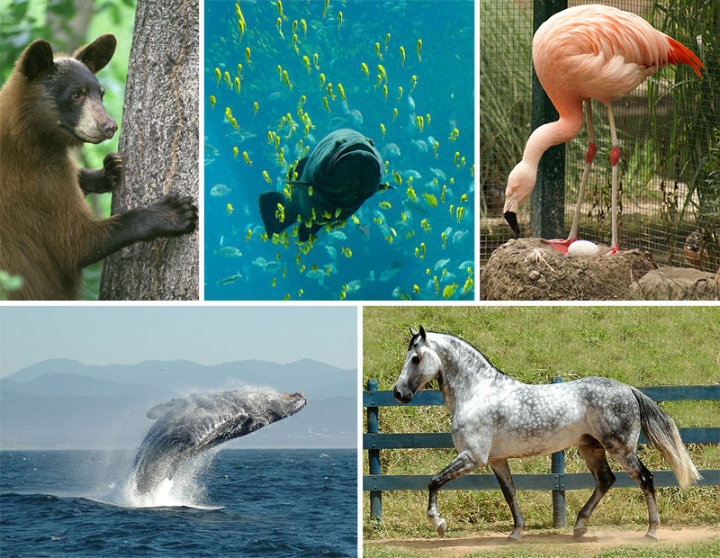
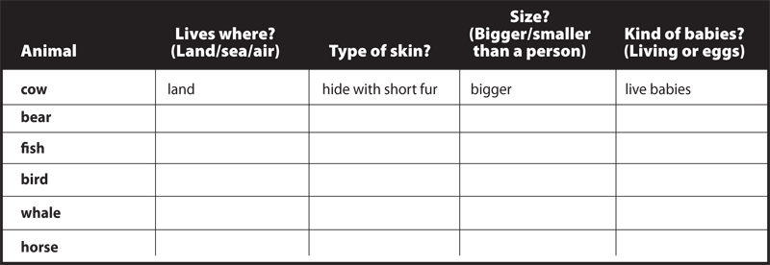

Activity 2 on 7 taxa
Name the 7 different categories or taxa developed by Linnaeus.
Answer
Kingdom, phylum, class, order, family, genius and species.

Activity 3 on classifying thing in the house
You are going to devise a seven-level system for classifying the things in your house.
If you get confused at any time as you are doing this, you can look at the examples listed later in the lesson.
- First, let's think about the broadest level. Is everything inside your house or do you have some things outside, too? Maybe your first level needs to be the Kingdom Inside and the Kingdom Outside. If your family has other places that you keep things you own (like a separate house or a storage unit), that might be a third kingdom. You may want to have kingdoms based on sides of the house or things for parents and things for kids. List your kingdoms.
- Next, you need the next level down, phylum. Think about the things you have in one of your kingdoms. Can you think of a few categories you could divide them into? You may want to choose phyla based on rooms (such as Phylum Living Room, Phylum Kitchen). You may want to choose phyla based on the items' size or what they are made of. It's up to you. Choose just one kingdom from your list above and create three phyla for it on the next page (remember that phyla is the plural of phylum).
- Pick one of the three phyla you created above and put it on the line below. Write the kingdom that phylum belongs to on the line next to Kingdom. Think about the phylum you picked. In your mind, break it down into some categories. For example, if your phyla were broken down by rooms, and you picked "Living Room" as your phylum, how could you divide the things in your living room into categories? Could you break them down by what you do with them? How about who uses them? How about what they are made of or where they are (wall, floor, closet)? Don't try to make the categories too small, because you have several levels left! These categories are your classes. Think of three classes and list them on the diagram below:
- Now you are going to repeat this until you get to species. After class comes order (remember your sentence!), so choose one class from above, list in on the line below and create three orders to go underneath it. Just keep thinking about how you could narrow that group of things even more. Remember to look at the example at the end of this section if you get stuck. List the kingdom and phylum, too, so you can keep track.
- You only have a few levels to go! After order comes family, so choose one of your orders from above and do the same thing you've been doing. Break it down into smaller categories.
- You only have two levels left! You are almost to a single item! Wow! Choose one family from your list above and then break it down into three smaller groups. Remember that the next level will be an individual item, so be sure to make the genera (that's plural for more than one genus) very narrow.
- You are at the last step! You are down to individual items! Choose a genus from your list above, and name three different species, or items, within that genus.
- Now choose one of your species listed above and list its entire scientific classification from kingdom on down:
Copy and complete to classify things in your house
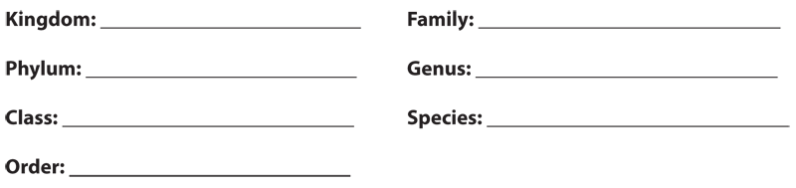

Rubric for classifying things in the house your house

________/2 completed all levels

________2/ Systems make sense (higher point should be given if system

is obviously reasonable and clear’ or if student can explain

a less obvious classification system that demonstrates

expanded thinking)

________/1 Levels are progressively narrower

________/1 Species is a single, distinguishable item

________/6 Total

