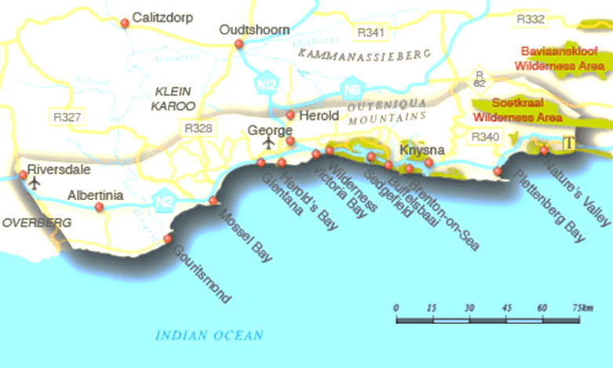
GRADE 10
WORKBOOK
2020
TOURISM
TERM 2
MAPWORK

UNIT 1
IN THIS UNIT YOU WILL BE ABLE TO UNDERSTAND THE FOLLOWING
- Scale Direction
- Distance indicators Map legends
- Map grid references Equator
- Hemisphere North- and South pole
- Longitude Latitude
- Times zones Greenwich
- IDL
- Universal Time Co-ordinate (UTC) was GMT

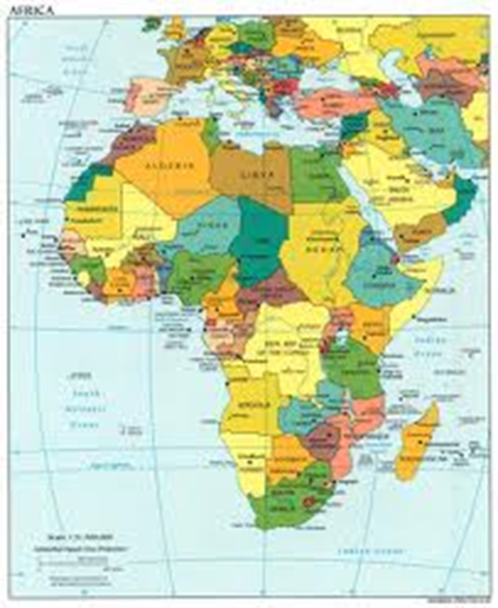

A Map is a drawing of the earth or part of the earth.
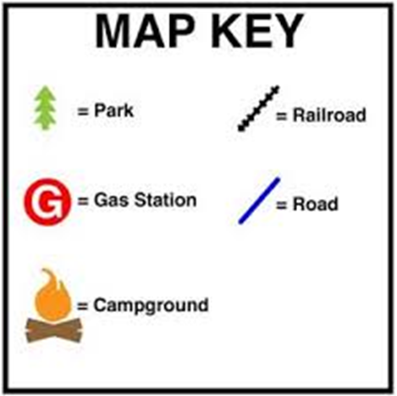

Symbols are necessary to
understand maps.

Map symbols are small pictures or symbols drawn on a map to show the position of attractions and services in real life.
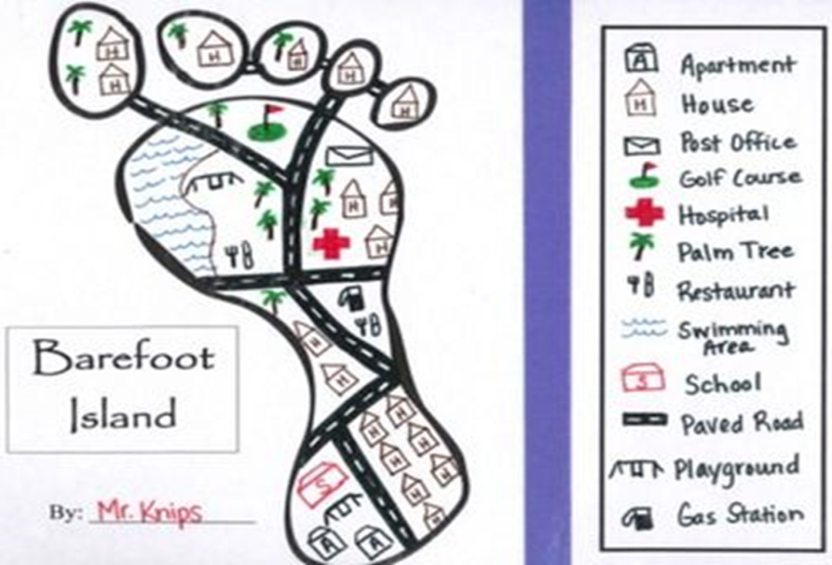

MAPSCALE
Scale refers to how much smaller the map is in relation with the real world.
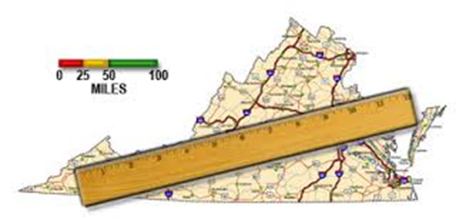

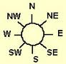

DIRECTION
To determine the position of one place
according to another.
4 Main directions: North, south,
east and west
16 directions
A | 1 | 2 | 3 | 4
B
C |  | X
D
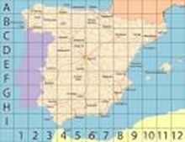
Map grid references
To find places on maps.
Coordinates – vertical
and horizontal lines forms
a grid. Columns and rows
are numbered with letters
or the alphabet. Find C2.

Columns and rows are
numbered with letters
or the alphabet.
Find C2.
ACTIVITY 1 [IN YOUR NOTEBOOK]
COLUMN 1 | COLUMN 2 |  | COLUMN 3
NEW WORD | YOUR OWN WORD / SYNONYM |  | EXPLANATION – AFTER PRESENTATION
PART ONE
Scale

Direction

Distance indicators
Map legends

Map grid references

Use the following map to answer the questions.

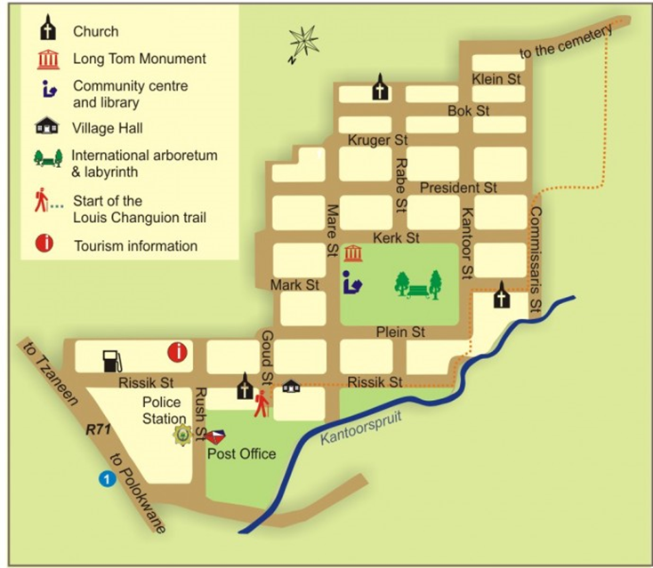

- Draw a compass and complete the 16 directions.
- What does a scale of 1: 200 means?
- In what general direction is the:
3.1 Church in Bok Street from the Tourism information office?
3.2 Village Hall from the Tourism information office?
- Tell a tourist the way from the Post Office to the Long

LATITUDE
Imaginary lines that run across the earth from east to west.
Main latitude: Equator
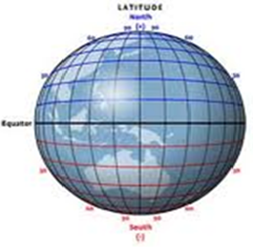

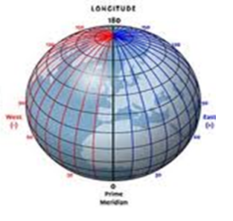

LONGITUDE
Imaginary lines that runs from the south pole to the north pole.
Main longitude:
0°Line of Longitude

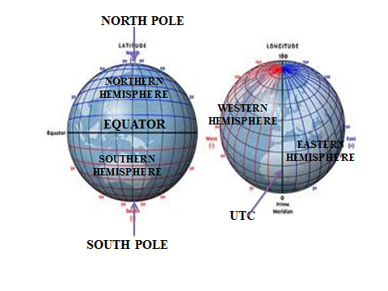

Universal Time Coordinate (UTC)
A standard international time measurement that is used all over the world. It is the time experienced at 0° longitude.
Runs through a town in England called Greenwich.
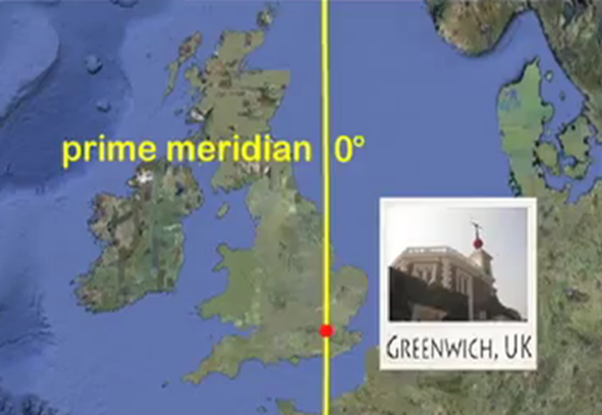

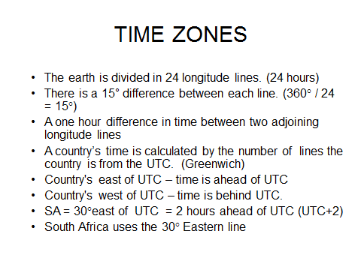

Worksheet 1:
Use a World Time Zone Map to do the following:
Show the following on your Time Zone Map:
Equator
UTC
IDL
South Africa
North pole and south pole
Now answer the following questions by using the Time Zone Map.
What time zone does South Africa use?
How many degrees is this line from the UTC? Explain your answer.
What would the time difference be between South Africa and the UTC?
(DO IN NOTEBOOK]
USE THE TIMEZONE MAP TO ANSWER THE QUESTIONS.
How many time zones are between South Africa and England?
If it is 8:00 in England, how late would it be in South Africa?
How many time zones (longitude) are on earth?
What is the use of the IDL?
What would be the reason for this line never crossing a country?

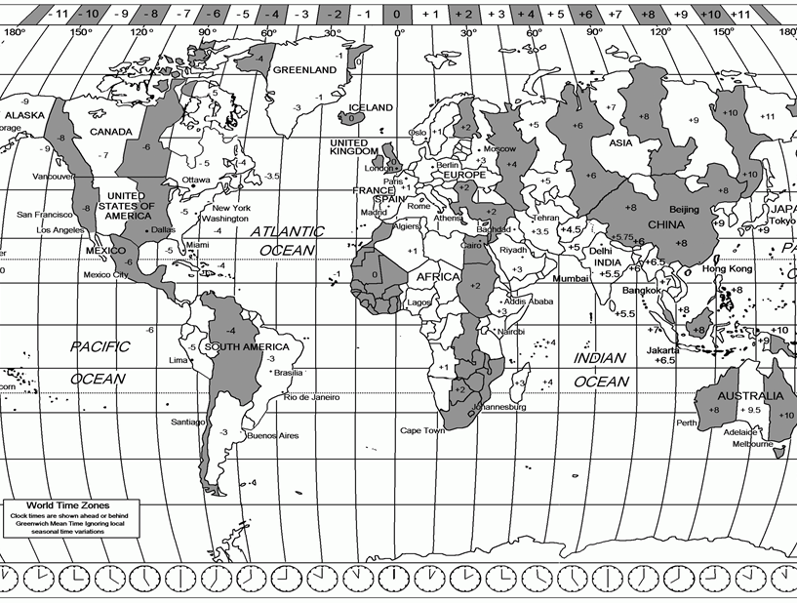

UNIT 2
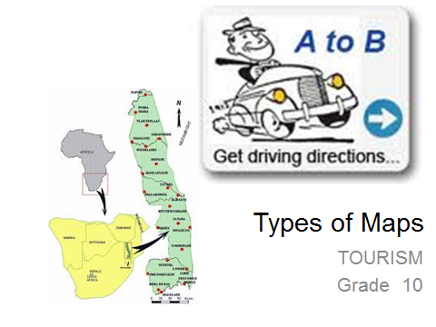

Learners must know:
• The difference between road maps and street maps.
• The use of these two types of maps for tourists.
• The difference between political and physical maps.
• The use of these two types of maps for tourists.
Learners must know how to read specialist maps like:
• Climate
• Airports
• Tourist routes etc.
And be able to interpret tourist information maps.

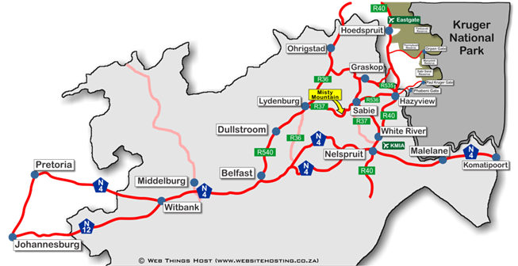
Roadmaps
Shows roads between cities.
Often indicates distances.-
to calculate travel time -
100km for every hour
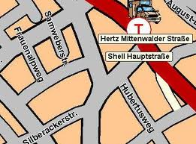

Streetmaps
\Street plans, street names, a
ttractions , malls, hospitals, parking etc.

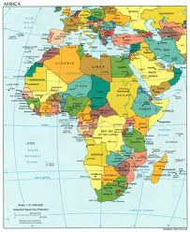
Political maps

Shows borders between countries. No detail about the terrain. Shows the position of the countries and names of capitals.

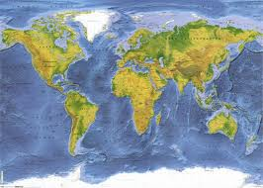
Physical maps
Shows natural features of an area or country. Rivers, mountain ranges, deserts, forests etc.

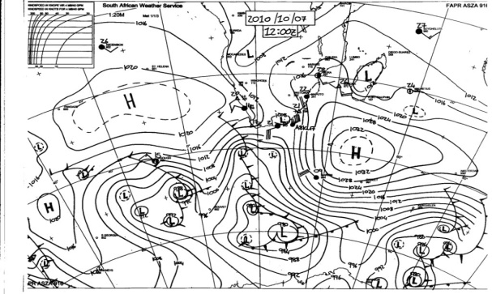
Specialist maps
Shows specific information. Railways, climate maps, airport maps, etc.

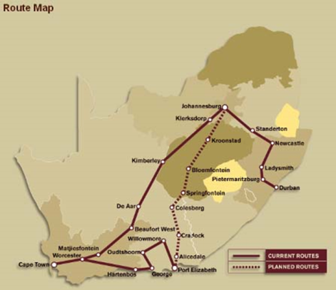
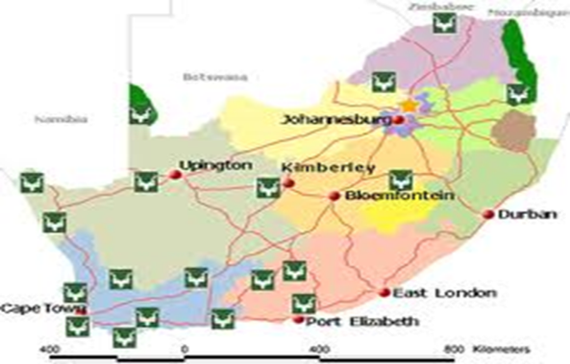

Shosholoza
Meyl

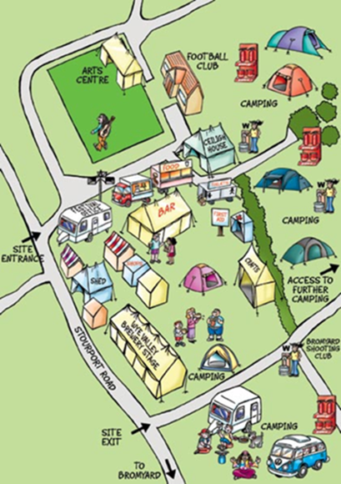
Tourist Information Maps
(National Parks, World Heritage Sites,
Tourist attractions in an area, accommodation, hiking trails
Rambles or Meanders)

Electronic maps
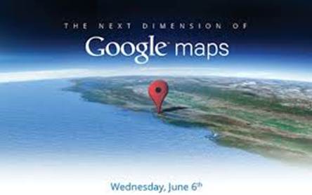
On computers and smart phones
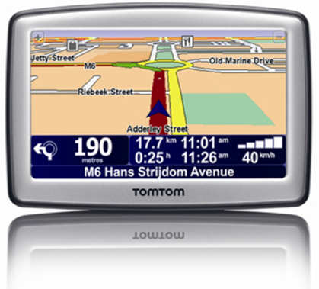
Interactive maps
GPS – Global Positioning System.
A devise that uses satellites to
Determine its position according
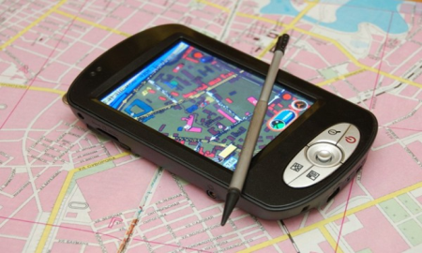
to latitude and longitude.
Some GPS with a voice

COPY THE TABLE AND COMPLETE THE CAPITAL CITIES OF EACH PROVINCE PROVIDED
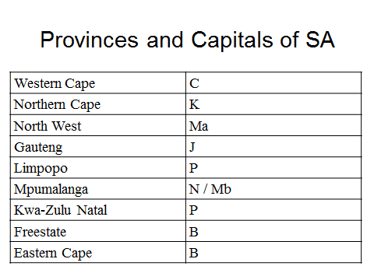

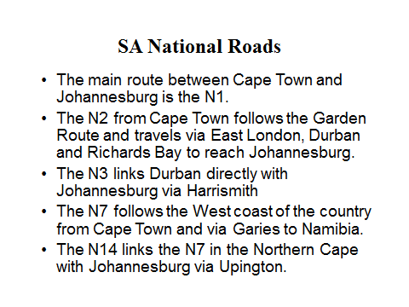
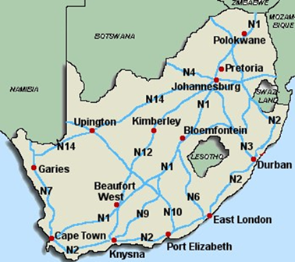

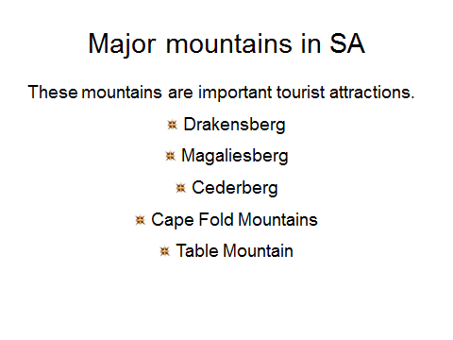
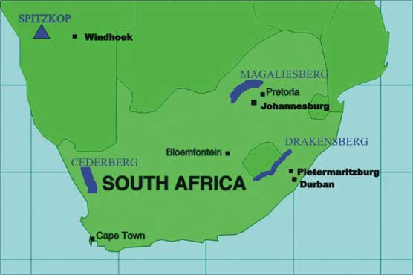
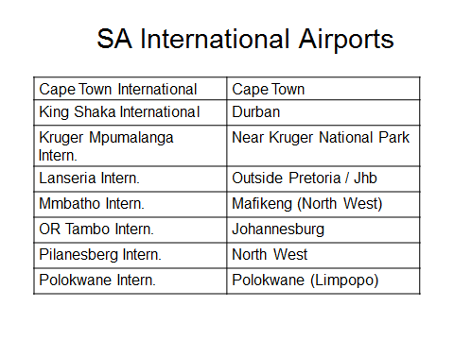

Major rivers in SA
Orange
Vaal
Limpopo
Tugela

Domestic Airports
- Bloemfontein
- East London
- George
- Kimberley
- Port Elizabeth
- Upington

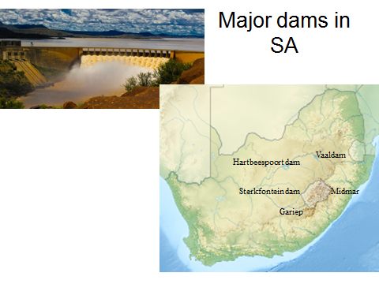

WORKSHEET 2
1. What is the difference between manmade and natural features?
2. Draw a symbol that is used to indicate mountains, dams and rivers on maps.
3. Indicate the following rivers on the map:
3.1 Limpopo
3.2 Orange
3.3 Vaal
3.4 Tugela
4. Indicate the following dams on the SA map:
4.1 Gariep
4.2 Vaal
4.3 Hartbeespoort
4.4 Midmar
4.5 Sterkfontein
5. Indicate the following mountains on a map of SA.
5.1 Drakensberg
5.2 Magaliesberg
5.3 Cederberg
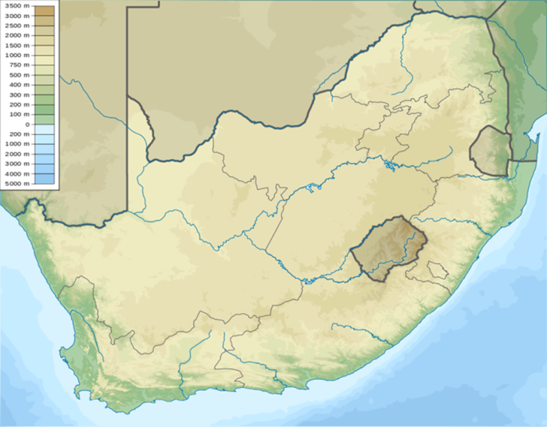
5.4 Table Mountain

5.2
4.2

5.1
3.5
5.3
5.4
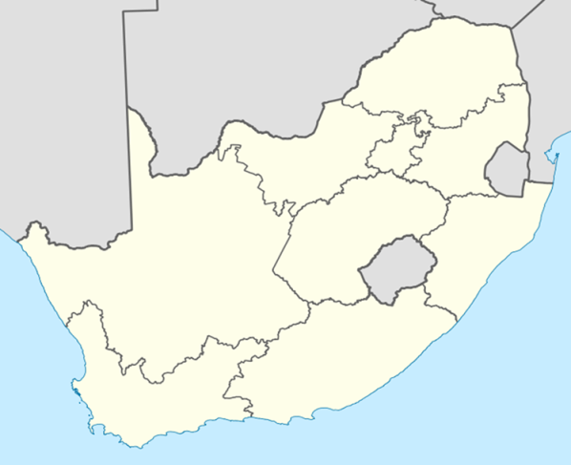
SA BORDERS AND GATEWAYS
F
E
D
B
C
A
COUNTRY CAPITAL BORDER POST
Namibia Windhoek Vioolsdrif A
Botswan Gaborone Skilpadshek B
Zimbabw Harare Beitbridge C
Mozambique Maput Lebombo D
Swaziland Mbabane Ngwenya E
Lesotho Maseru Maseru Bridge F
ACTIVITY 3
COMPLETE THE FOLLOWING TABLE

 | PROVINCE(S) | MOUNTAIN,RIVERS OR  DAM? | MANMADE OR NATURAL?
GARIEP
LIMPOPO
ORANGE
MIDMAR
VAAL
VAAL
HARTBEESPOORT

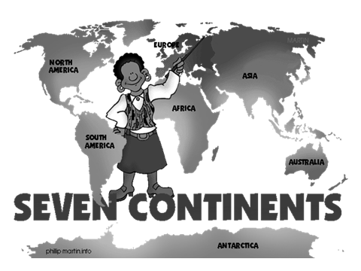
UNIT 3
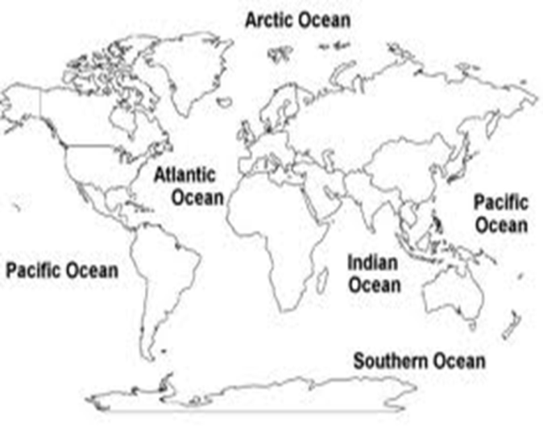

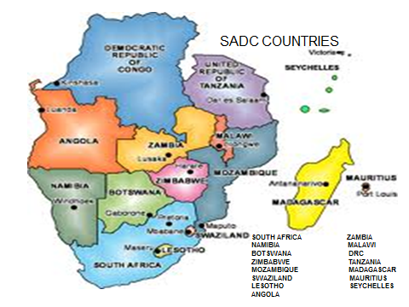

ACTIVITY 4
1. On which continent are the following located?  1.1 Namibia  1.2 Washington DC  1.3 Perth (Australia)  1.4 South pole  1.5 Germany  1.6 Argentina  1.7 Russia  1.8 Cairo | 2. Would you find the following places in the northern or southern hemisphere?  2.1 Canada  2.2 New Zeeland  2.3 Cairo (Egypt)  2.4 London (England)  2.5 Chile  2.6 Mauritius  2.7 Iceland  2.8 India  2.9 Antarctica

ACTIVITY 5
Name the continents numbered 1-7.
1. Which one of the North- or South Pole is not located on a continent?
2. Name the oceans named A, B and C.
3. What is the name of the ocean on the eastern side of
Australasia?
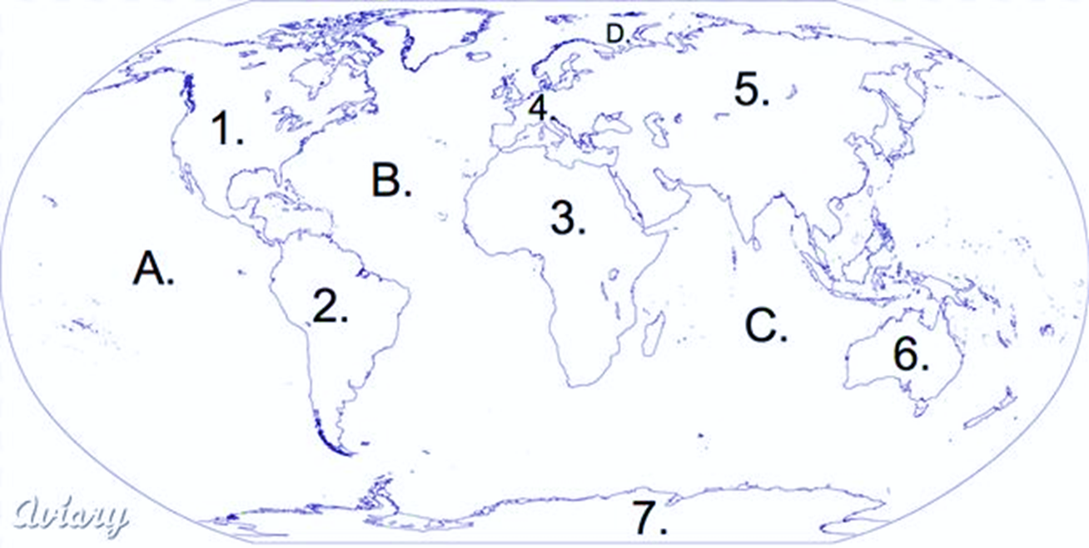

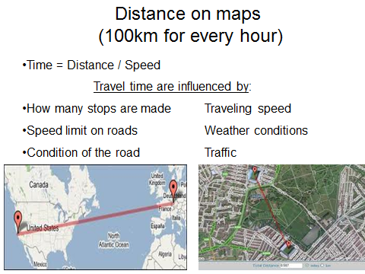
ACTIVITY 6

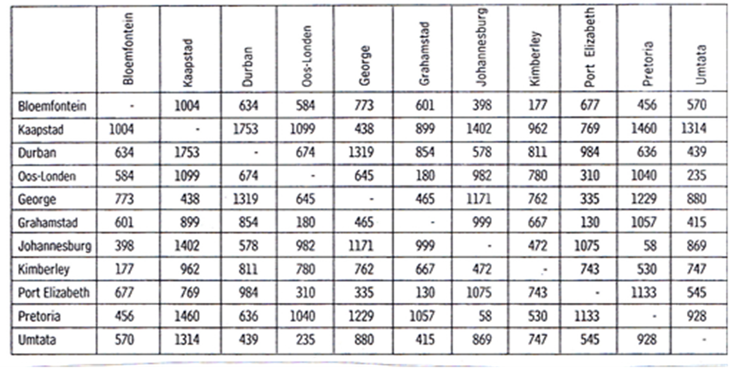

- A tourists rents a car and paid for 1500 km in advance.  - He gets the car in Johannesburg and travels to Pretoria.  - From Pretoria he wants to go to Cape Town. He desided to travel via Kimberley.  - In Kimbelrey he is informed of road works on the N12 and he decides to use the N1. That means he had to go to Bloemfontein.  - His GPS give him the wrong information and sends him all the way to Port Elizabeth.  - He left PE after two days and proceed to George.  He spend some time in George and fell in love with the Garden Route. After a couple of days he travels to Cape Town. | He left the car at Cape Town International Airport.  Calculate the total distance of his trip. Show your calculations.  At what stage during his trip did he used all his paid kilometers?  What is the distance he still have to pay for?  If the car rental company charge R 4.21 / km, how much would it cost him? Show your calculations.

ACTIVITY 7
In what province would you find this map?
Name the National road on the map.
Name one Nature Reserve on the map.
What is the name of the dam North-north-east of Lydenburg.
What National Park could you enter through the Numbi Gate on the
eastern side of the map?
What is the name of the road from Sabie to Hazyview?
What is the distance between these two cities?
What is the distance between from Waterval Boven to Nelspruit if you take the
R539?
Show your calculations.
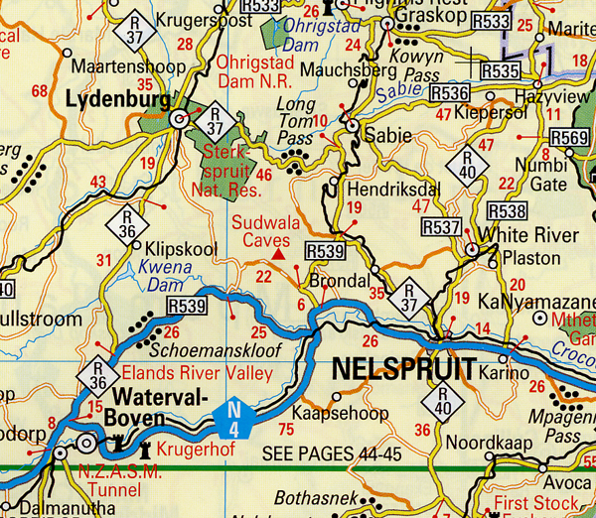

DOMESTIC TOURISM
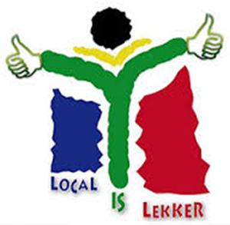

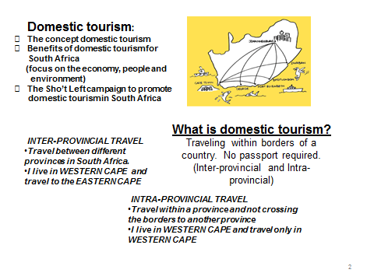
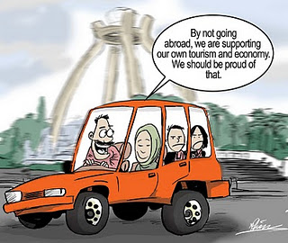

IMPACT OF DOMESTIC TOURISM ON TRIPLE BOTTOM LINE
PEOPLE:
Employment for own people
Skills development for South Africans
Sense of pride

ENVIRONMENT:
Better environmental practice
Awareness of nature
Devolving of environment
ECONOMY:
More money for the country
Cheaper than abroad.
Discount for South Africans
No exchange rate

ACTIVITY 8
Use the above words. Write a letter to your friend to convince him/her to have a South African holiday with you instead of an overseas holiday abroad. Your letter must consist of an introduction, 3 paragraphs (one on each group) and a conclusion | Letter must have:  - Be written in full sentences  - Make sense  - Benefits in each group must fit the group. Eg. Don’t write about money in the environment paragraph.
ACTIVITY 9
TRANSPORT: DAY TRIPS + OVERNIGHT TRIPS
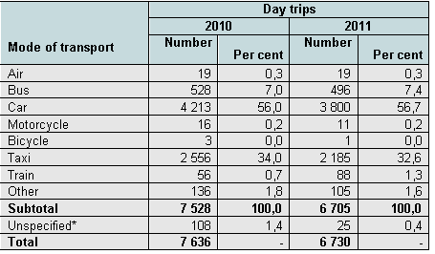
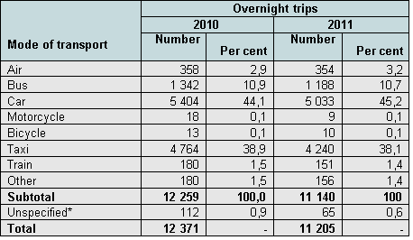

- According to the heading, what is the main difference between these two tables?
- Name the most popular mode of transport for day trips.
- Name the most popular mode of travel for Overnight trips.
- Why is air transport more popular for overnight trips?

TERM 2 | DONE | NOT DONE
Terminology (Map work)
- Concepts
Types of maps
- Street and road maps
- Political maps
- Physical maps
- Specialist maps
- Tourist information maps
- Electronic maps
Location on maps (SA)  - SA borders  - Provinces  - Capital cities  - International airports  - Harbours  - National roads  - Gateways  - Mountains, rivers and dams |  | CHECKLIST: TERM 2
Location on maps (World)
- SA
- SADC
- 7 Continents
- 3 Oceans
- 3 Island groups
- 6 Tourism regions
Distance
- Distance indicators
- Distance tables
- Distance and travel time
Domestic tourism
- Concept: Domestic tourism
- Sho’t Left
- Benefits of domestic tourism for SA:
- Economy
- People
- Environment

Domestic tourism (Statistics)
- Statistics
- Inter provincial travel
- Intra provincial travel
- Interpretation of statistics

TERMINOLOGY
COLUMN 1 | COLUMN 3
NEW WORD | EXPLANATION
Scale | Scale refers to how much smaller the map is in relation with the real world.
Direction | To determine the position of one place according to another.  North, south, east, west.  Northeast, northwest, southeast and southwest
Distance indicators | 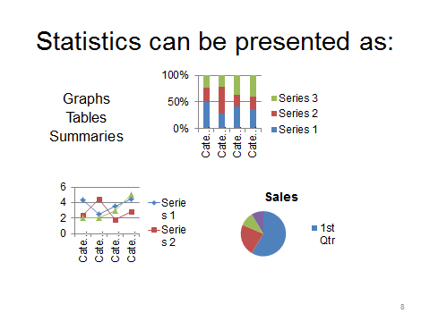  Shows the distance between two places or intersections indicated on a map.
Map legends | Small pictures or symbols drawn on a map to show the position of attractions and services in real life
Map grid references | Helps people find a specific place on a map. Columns and rows are numbered with letters or alphabet to form a grid
Equator | An imaginary line that cuts the world in half horizontally.
Hemisphere | Equator divides the earth into two hemispheres. Northern and southern
North and South pole | Northern and southern most point on the earth
Longitude | Imaginary lines that runs from the south pole to the north pole.  Greenwich meridian
Latitude | Imaginary lines that run across the earth from east to west.  Equator
Time zones | A 15° difference in longitude that results in a one hour difference in time between two adjoining longitude lines  24 lines on earth
IDL | Imaginary line that determines where in the world one day (date) ends and the next starts.  Passes through the middle of the Pacific ocean at about 180° longitude.
UTC | A standard international time measurement that is used all over the world. It is the time experienced at 0° longitude.

