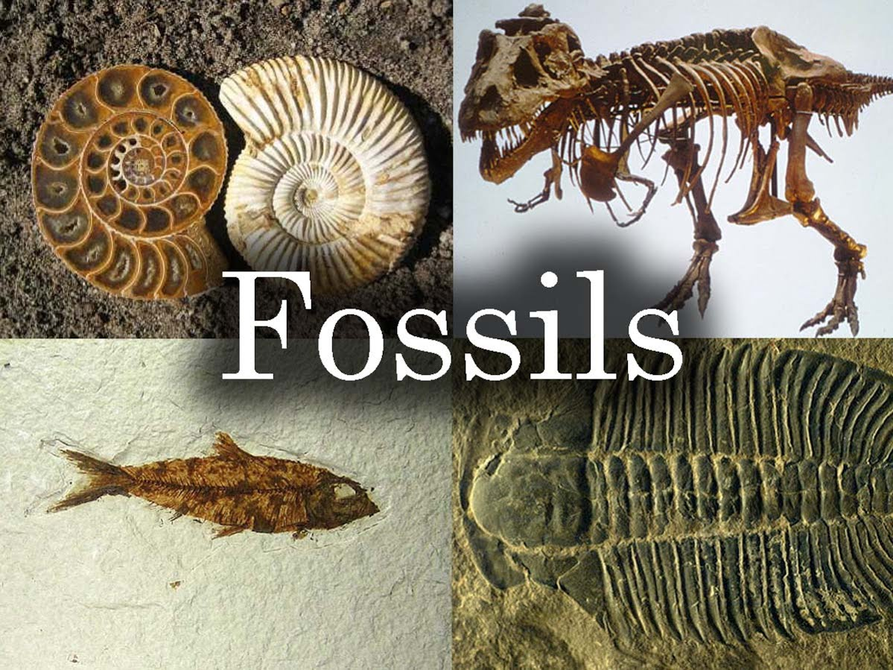

A fossil is any preserved remains, impression, or trace of any once-living thing from a past geological age. Examples include bones, shells, exoskeletons, stone imprints of animals or microbes, objects preserved in amber, hair, petrified wood, oil, coal, and DNA remnants

HOW FOSSILS ARE FORMED: 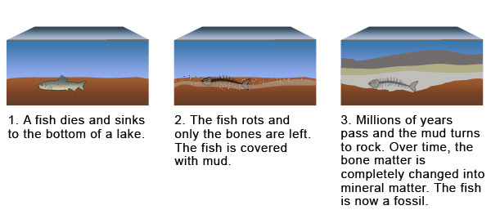

Activity:

How to make a Fossil
1. Gather your materials.You will need :
- A small natural object(shell,leaf, bone, etc)
- Petroleum jelly
- Plaster of Paris
- Water
-Small disposable dish or Tupperware container
(such as a margerine tub)
2. Choose the object you want to make the fossil of
Any object from nature works—shells, leafs,and animal bones are all
good choices. If you do choose a leaf ,make sure its not dry and
crackly.It must also fit into your container.

3. Coat the object in Petroleum Jelly.
This will keep the object from sticking to the plaster when you try to
remove it.Coat it thoroughly.
4. Mix plaster and water in a bowl.
Follow the directions on the Plaster of Paris packaging.Mix them
together thoroughly and and let the mixture sit for a few minutes
without stirring.You will need approximately twice as much water
as plaster,but you can adjust the ratio as you see fit.
5. Press the object into the Plaster of Paris.
Be careful not to push too hard.Now your part is done. Set it aside
and let it dry for atleast one day.
6. Remove the object.
After you have waited 24hours pop your item out of the Plaster of
Paris. There is your fossil. It’s just like a shell that was enveloped in
soil for thousands of years, disintegrated, and left behind this image.

Study the diagram below and arrange the sentences below in the correct Chronological Sequence.You may write the correct sentences in the spaces provided
