

GRADE 11

LIFE SCIENCES

JUNE EXAMINATION 2016

EKURHULENI SOUTH DISTRICT

MARKS: 150

TIME: 2½ hours

This question paper consists of 13 pages.

INSTRUCTIONS AND INFORMATION

Read the following instructions carefully before answering the questions.

1.  2.  3.  4.  5.  6.  7.  8.  9.  10.  11. | Answer ALL the questions.  Write ALL the answers in your ANSWER BOOK.  Start the answers to each question at the top of a NEW page.  Number the answers correctly according to the numbering system used in this question paper.  Present your answers according to the instructions of each question.  ALL drawings should be done in pencil and labelled in blue or black ink.  Draw diagrams or flow charts only when asked to do so.  The diagrams in this question paper are NOT necessarily drawn to scale.  Do NOT use graph paper.  You may use a non-programmable calculator, protractor and a compass.  Write neatly and legibly.

SECTION A

QUESTION 1

1.1 | Various options are provided as possible answers to the following questions. Choose the correct answer and write only the letter (A to D) next to the question number (1.1.1 to 1.1.10) in your ANSWER BOOK, for example  1.1.11 D.

 | 1.1.1 | Name the microorganism that is classified as acellular.

 |  | A  B  C  D | Virus  Fungus  Bacterium  Protozoa

 | 1.1.2 | The short-lived immunity that mothers pass to their babies is called…

 |  | A  B  C  D | passive immunity.  maternal immunity.  innate immunity.  active immunity.

 | 1.1.3 | Which of the following is present in the Bryophytes?

 |  | A  B  C  D | Seeds  Xylem  Spores  Flowers

 | 1.1.4 | The pistil of a flower consists of the…

 | A  B  C  D | Anther, style and ovary.  Stigma, filament and ovary.  Anther, filament and ovary.  Stigma, style and ovary.

 | 1.1.5 | Fertilisation in Angiosperms occurs when …

 | A  B  C  D | The pollen tube grows down the style.  Pollen moves from the anther to the stigma.  A sperm unites with an egg cell.  The ovary enlarges into a fruit

 | 1.1.6 | Platyhelminthes are termed acoelomate because they

 | A  B  C  D | Only have one external opening  Are bilaterally symmetrical.  Possess a body cavity  Have no cavity in the mesoderm between the ectoderm and endoderm.

The cartoon below illustrates the possible human impact on our environment. Study the cartoon and answer question 1.1.7

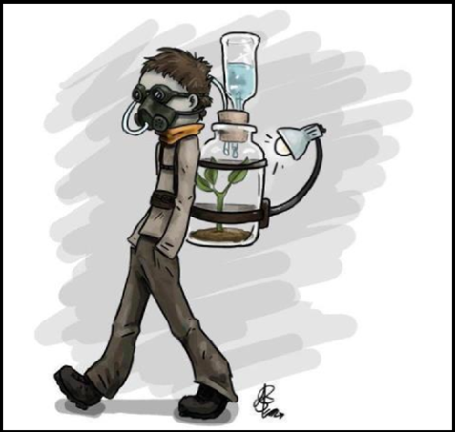

 | 1.1.7 | Which ONE of the following basic requirements for human survival is produced by the innovative design, as illustrated in the cartoon?

 | A  B  C  D | Water  Oxygen  Antibodies  Optimum body temperature

Study the accompanying diagram and answer Question 1.1.8 and 1.1.9

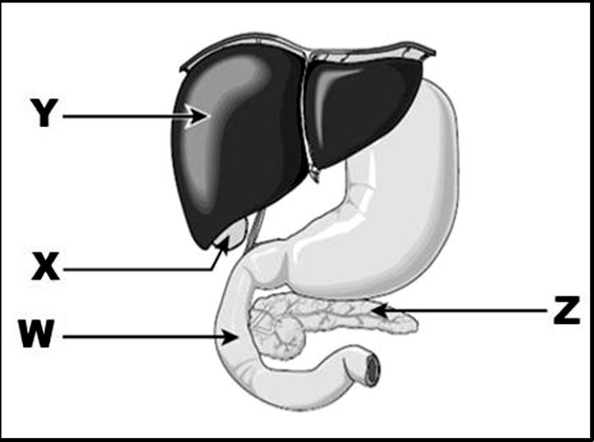

 | 1.1.8 | Which labelled structure secretes a hormone which causes an increased production of glycogen?

 | A  B  C  D | Z  Y  X  W

 | 1.1.9 | One of the following functions is not the function of part labelled Y:

 | A  B  C  D | deaminates excess amino acids resulting in the formation of urea.  serves as a storehouse for minerals such as iron.  secretes the hormones insulin and glucagon.  detoxifies harmful substances

 | 1.1.10 | A high carbohydrates diet lacking in proteins is characteristic of the nutritional disorder called:

 | A  B  C  D | Bulimia  Kwashiorkor  Marasmus  Anorexia nervosa |  | (20)

1.2 | Give the correct biological term for each of the following descriptions. Write only the term next to the question number (1.2.1 to 1.2.8) in your ANSWER BOOK.

 | 1.2.1  1.2.2  1.2.3  1.2.4  1.2.5  1.2.6  1.2.7  1.2.8 | An organism without a true nucleus  The type of alimentary canal which stretches from the mouth to the anus  A group of plants that have naked seeds.  Places which store seeds as a source of planting in case seed reserves elsewhere are destroyed.  An evolutionary trend in the animal kingdom toward centralization of neural and sensory organs in the head or anterior region of the body.  A chemical compound which helps break down complex molecules into smaller molecules.  Yellow, green alkaline liquid that has no enzymes.  A mechanism of maintaining a constant internal environment by mammals. |  | (8)

1.3 | Indicate whether each of the statements in COLUMN I apply to A ONLY, B ONLY, BOTH A AND B or NONE of the items in COLUMN II. Write A only, B only, both A and B, or none next to the question number (1.3.1 to 1.3.6) in the ANSWER BOOK.

 |  |  | COLUMN I |  |  | COLUMN II
 | 1.3.1 |  | Always cause diseases |  |  | A: Bacteria  B: Virus
 | 1.3.2 |  | Gametophyte is dominant over sporophyte |  |  | A: Bryophytes  B: Pterophytes
 | 1.3.3 |  | Triploblastic organism |  |  | A: Porifera  B: Cnidaria
 | 1.3.4 |  | Oxygen is released |  |  | A: Light phase  B: Dark phase
 | 1.3.5 |  | Breaks down glucose in the absence of oxygen |  |  | A: aerobic respiration  B: anaerobic respiration
 | 1.3.6 |  | Carbohydrate that is stored in the mammalian muscle and liver |  |  | A: Glucagon  B: Glycogen
 |  |  |  |  | (6 x 2) |  |  |  | (12)

1.4 | Study the diagram below about vaccination and cholera and answer the questions that follow

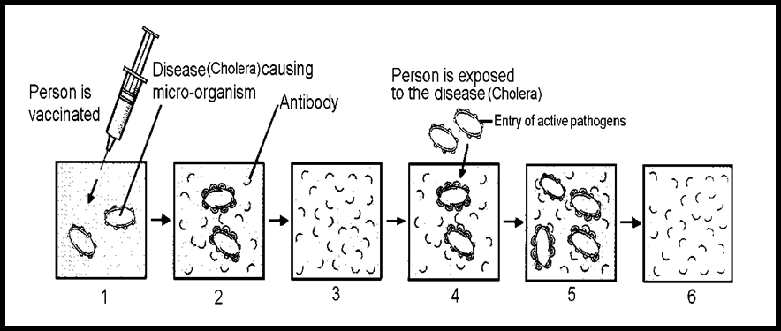

 | 1.4.1  1.4.2  1.4.3  1.4.4  1.4.5  1.4.6 | What is a vaccine?  What is injected in to the human body as a vaccine?  Briefly explain what is happening in diagram 2.  What happens when a person is exposed to the cholera bacteria as shown in the diagram 4?  Name the type of immunity obtained through vaccination.  Suggest THREE strategies to prevent a cholera outbreak in rural villages of our country. |  | (1)  (1)  (2)  (2)  (1)  (3)  [10]

TOTAL SECTION A: |  | 50

SECTION B

QUESTION 2

2.1 | Study the diagrams below and answer the questions that follow

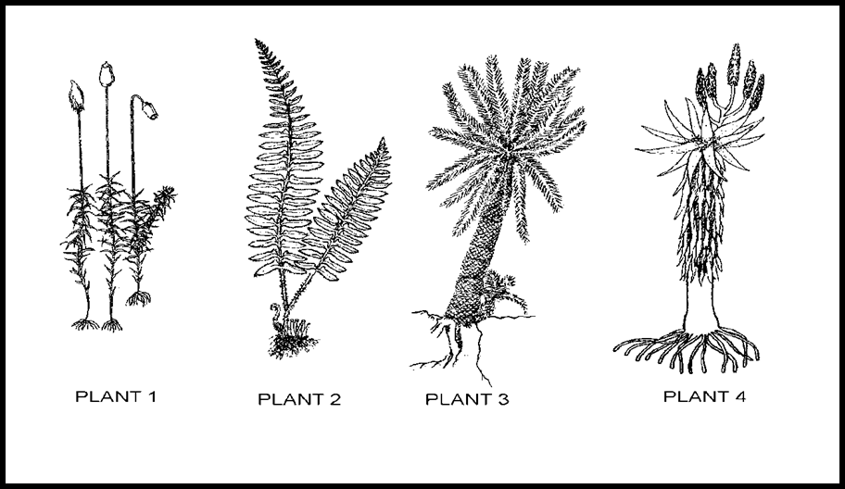
Plant A
Plant B
Plant D
Plant C

 | 2.1.1  2.1.2  2.1.3 | Identify the groups to which each of the above plants belongs.  Which of the four groups identified in QUESTION 2.1.1 …  (a) are dependent on water for fertilisation?  (b) produce seeds for reproduction?  Mention TWO similar structural adaptations of the prothallus in  ferns and the gametophyte in mosses, which make them to be  poorly adapted to a terrestrial life. |  | (4)  (2)  (2)  (2)  [10]

2.2 | Use the diagrams below to answer the questions that follow:

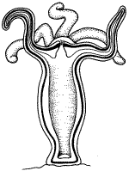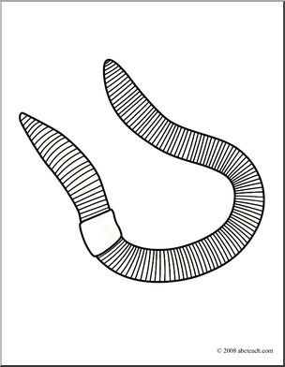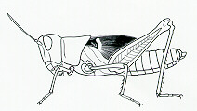
Organism B
Organism C
Organism A

 | 2.2.1  2.2.2  2.2.3 | Name the different phyla to which organisms A, B and C belong.  Identify organisms A and B.  Which diagram A, B or C has the following characteristics?  (a)Triploblastic  (b)Cephalisation  (c) Acoelomate |  | (3)  (2)  (5)  [10]

2.3 | The graph below shows the number of reported cases of malaria in different regions of South Africa in 2004.

Graph showing the number of reported cases of malaria in different regions of South Africa in 2004

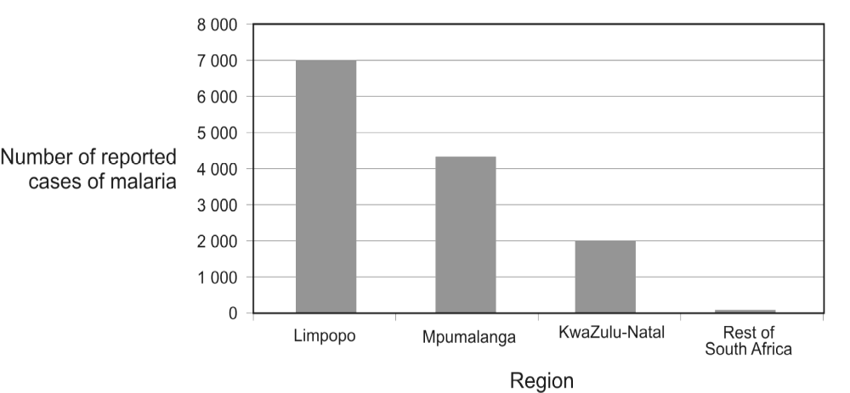

 | 2.3.1  2.3.2  2.3.3  2.3.4  2.3.5  2.3.6 | Which region has the greatest number of reported malaria cases in 2004?  Why is malaria found only in certain regions of South Africa?  Give the scientific name of the parasite that causes malaria.  List the THREE stages of a malaria attack.  Why is malaria referred to as a recurring disease?  State TWO hosts needed by the parasite to complete its life cycle. |  | (1)  (2)  (1)  (3)  (3)  (2)  [12]

QUESTION 3

3.1 | Study the following diagrams of differences between dentition of herbivores, carnivores and omnivores.

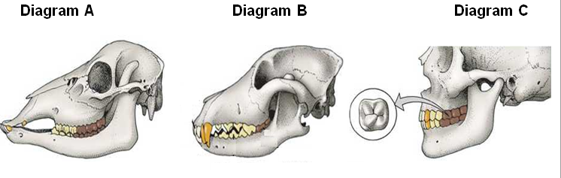

 | 3.1.1  3.1.2  3.1.3  3.1.4 | Which diagram (A, B or C) is representative of an herbivorous organism?  Give TWO reasons for your answer in QUESTION 3.1.1  Explain the kind of digestion that takes place in the mouth.  The pH in the mouth is slightly acidic (between 5.6 and 6.9).What is the reason for this degree of acidity? |  | (1)  (2)  (4)  (2)  [9]

3.2 | The flow diagram below shows two biochemical processes that are related to each other as the products of the one process is the raw materials in the other.

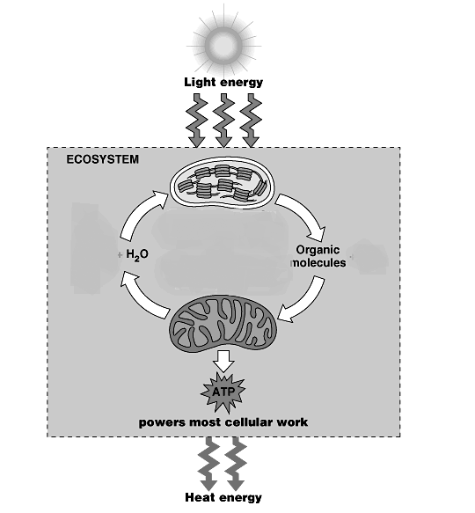
Gas A + H₂O
Organic molecule + Gas B
Organelle X
Organelle Y

 | 3.2.1  3.2.2  3.2.3  3.2.4  3.2.5  3.2.6 | Identify the processes associated with organelle X and organelleY.  Identify organelles X and Y respectively.  Name the gases labelled A and B.  Name the pigment found in the part labelled B.  State the function of the pigment named in QUESTION 3.2.4  Explain TWO structural adaptation of organelle Y to perform its function. |  | (2)  (2)  (2)  (1)  (1)  (4)  [12]

3.3 | In industrial brewing processes, yeast is added to a sugary solution and left at 25°C. The sugars are converted to glucose and then this undergoes fermentation.

 | 3.3.1  3.3.2  3.3.3 | What are the products of fermentation?  List FOUR ways that the above-mentioned process is economically important.  (a) This type of biochemical process also occurs in animals. What product is produced in animal tissue?  (b) What effect does this product have on the muscles? Explain what the body does to ease the symptoms. |  | (2)  (4)  (1)  (3)  [10]

3.4 | The diagram below illustrates an experiment in progress. The distance between the light source and the apparatus have been altered at regular intervals to record the number of bubbles released at various distances. The data gathered has been represented in a table below. Study the diagram and the table to answer the following questions.

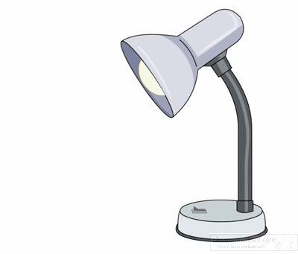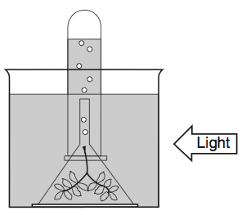
Gas bubble
Water with sodium bicarbonate
Water plant
Lamp

Number of air bubbles counted when the distance between the lamp and apparatus altered at regular intervals.

Distance between lamp and plant in mm | 40 | 80 | 120 | 160 | 200 | 240 | 280 | 320 | 360 | 400 | 440
Bubbles per minute | 30 | 30 | 30 | 25 | 15 | 10 | 5 | 3 | 2 | 0 | 0

 | 3.4.1  3.4.2  3.4.3  3.4.4  3.4.5  3.4.6  3.4.7 | What is the aim of the above experiment?  What is the function of sodium bicarbonate?  Name the gas released during the experiment.  Explain a simple test that can be done to confirm the presence of the gas mentioned in QUESTION 3.4.3  Name any TWO environmental factors, besides light intensity, that could affect the chemical process shown in the diagram above.  Plot a line graph to represent the data obtained during the experiment.  What conclusion can be drawn from the graph drawn in QUESTION 3.4.6 above? |  | (1)  (1)  (1)  (2)  (2)  (8)  (2)  [17]

TOTAL SECTION B: |  | 80

SECTION C

QUESTION 4

4.3 | In humans most absorption of digested food takes in the small intestines. Describe and explain how this region of the alimentary canal is suitable to perform this function. |  | (17)  (3)  (20)

 | NOTE: | NO marks will be awarded for answers in the form of flow charts or diagrams.

TOTAL SECTION C:  GRAND TOTAL: |  | 20  150

