JOHANNESBURG REGION

LIFE SCIENCES

JUNE EXAMINATION 2016

GRADE 11

MARKS: 150

TIME: 2½ HOURS

This question paper consists of 19 pages.

INSTRUCTIONS AND INFORMATION:

Read the following instructions carefully before answering the questions.

1. Answer ALL the questions in the ANSWER BOOK provided.

2. Start the answer to EACH question at the top of a NEW page.

3. Number the answers correctly according to the numbering system used in this question paper.

4. Present your answers according to the instructions of each question.

5. If answers are not presented according to the instructions of each question, candidates will lose marks.

6. ALL drawings should be done in pencil and labelled in blue or black ink.

7. Draw diagrams or flow charts only when requested to do so.

8. The diagrams in this question paper may NOT necessarily be drawn to scale.

9. The use of graph paper is NOT permitted.

10. Non-programmable calculators, protractors and compasses may be used.

11. Write neatly and legibly. Candidates will lose marks for slovenly and illegible work.

SECTION A
QUESTION 1
1.1 Various options are provided as possible answers to the following questions. Choose the most correct answer and write only the letter (A to D) next to the question number (1.1.1 – 1.1.10) in the ANSWER BOOK, for example
1.1.8 D.

1.1.1 Reproduces through binary fission:
A Virus B Fungi
C Bacteria D Moss
1.1.2 Which of the following produce antibodies?
A Blood plasma B Lymphocytes
C Macrophages D Red blood cells
1.1.3 The evolutionary history of an organism is known as its…
A taxonomy B philosophy

C phylogeny D morphology

1.1.4 Which of the following is a characteristic feature of mosses?
A Xylem B Phloem
C Seeds D Spores
1.1.5 In which of the following plant groups do male gametes depend on water/moisture to swim towards the ovum?
A Pteridophytes and Gymnosperms B Pteridophytes and Angiosperms
C Bryophytes and Pteridophytes D Bryophytes and Gymnosperms

1.1.6 Gymnosperms are more evolved for terrestrial life because:
A they reproduce by spores B they have true roots and leaves
C their sperm are motile D they produce seeds

1.1.7 The first animal phylum on the evolutionary tree with three tissue layers that developed from the embryo is…
A Cnidaria B Plathyelminthes
C Chordata D Porifera

1.1.8 In which pairs of phyla below do the animals have a through gut?
A Cnidaria and Porifera B Chordata and Porifera

C Platyhelminthes and Annelida D Arthropoda and Chordata

1.1.9 Which of the following will make up a balanced diet?
A Mineral salts, vitamins, carbohydrates, no fats, proteins, water,
roughage
B Mineral salts, vitamins, glucose, fats, water, roughage
C Mineral salts, vitamins, carbohydrates, fats, proteins, roughage, water
D Vitamins, carbohydrates, fats, proteins, water, fiber.

1.1.10 Diet for vegans include:
A fruits, vegetables, pulses B eggs, no dairy, no meat, pulses
C honey, pulses, eggs, fruit D dairy, no meat, no fish, fruits
(10 × 2) (20)

1.2 Give the correct biological term for each of the following descriptions.
Write only the term next to the question number (1.2.1 to 1.2.6) in the ANSWER BOOK.

1.2.1 Formation of ATP from ADP during the light phase of photosynthesis.

1.2.2 The rhythmical contraction of the muscles in the alimentary canal causing food
to move along the gut.

1.2.3 Plants that produce only one kind of spore.

1.2.4 In angiosperm plants, the walls of the ovary form this part.

1.2.5 A rod of cells along the dorsal side of chordate embryos.
1.2.6 The germ layer in animals that gives rise to reproductive organs

(6 × 1) (6)

1.3 Indicate whether each of the statements in COLUMN I applies to A ONLY, B ONLY, BOTH A AND B, or NONE of the items in COLUMN II. Write A only, B only, Both A and B, or none next to the question number (1.3.1 to 1.3.7) in the ANSWER BOOK.

COLUMN 1  STATEMENT OR DESCRIPTION |  | COLUMN II  ITEM
1.3.1 | All organisms in this phylum are  sessile | A | Porifera
 |  | B | Chordata
1.3.2 | Root-like structure in moss plants | A | Thallus
 |  | B | Rhizoids
1.3.3 | Management of malaria | A | Insect nets
 |  | B | DDT
1.3.4 | Role of antigens in the body’s defense | A | Trigger an immune response
 |  | B | Bind to the invading pathogen
1.3.5 | Digestive juice | A | Saliva
 |  | B | Bile
1.3.6 | Beneficial effect of certain bacteria | A | Nitrogen fixing
 |  | B | Making wine
1.3.7 | The dominant generation in flowering plants | A | Gametophyte
 |  | B | Sporophyte

(7 × 2) (14)

1. 4 Study the flow diagram and answer the questions that follow.

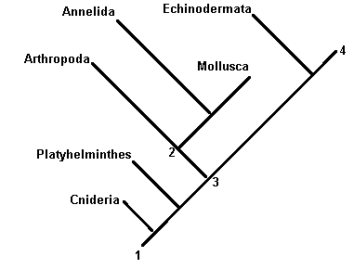

1.4.1 Give the scientific name for this diagram. (1)

1.4.2 Name one phylum in which the animals are mostly radial symmetrical. (1)

1.4.3 Which phylum was the first to evolve into bilateral symmetrical organisms? (1)

1.4.4 Is Annelida more related to Arthropoda or Platyhelminthes?
Give a reason for your answer. (2)

1.4.5 Name the phylum that evolved last. (1)

1.4.6 Which number on the diagram represents the following?
a) The common ancestor? (1)
b) The first point of diversion? (1)

1.4.7 Give one example of an organism that can be found in the following phyla:
a) Cnidarians (1)
b) Annelida. (1)
(10)

TOTAL QUESTION 1: 50

TOTAL SECTION A: 50

SECTION B

QUESTION 2

2.1 The following diagram indicates different shapes found in a specific type of
micro-organism. Study the diagram and answer the questions based on it.

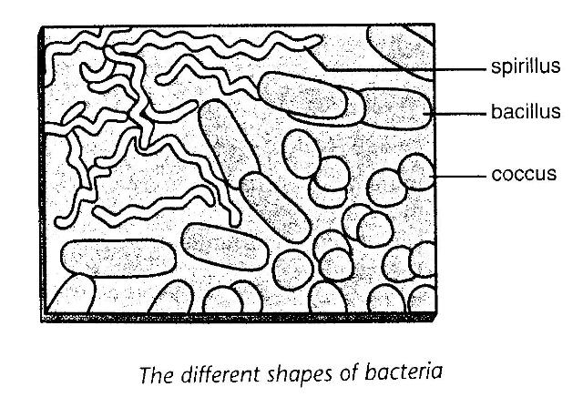

2.1.1. Identify the type of micro-organism. (1)

2.1.2. Draw a labelled diagram indicating the structure of a typical bacillus. (5)
(6)

2.2. The following flow chart shows the life cycle of the malaria parasite.

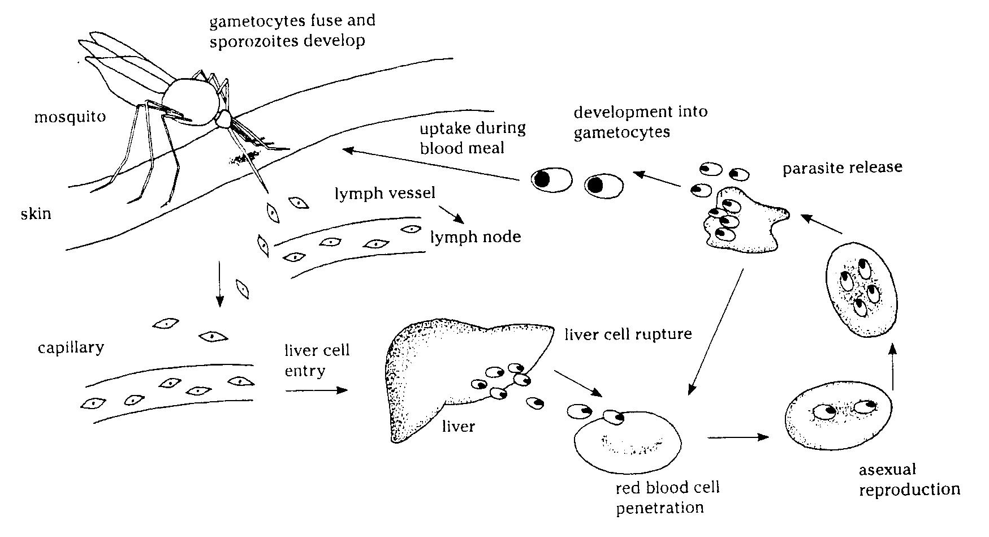

2.2.1. Name the species of mosquito that acts as the vector for the malaria parasite.
(1)
2.2.2. Name the two different types of body cells that the Plasmodium parasite
attacks. (2)

2.2.3. Why would people die if they contract malaria? (1)

2.2.4.
DDT to Control Malaria?
DDT is a pesticide that was used to control mosquito populations in malaria areas. In the early 1990’s, there was a worldwide ban on the use of DDT. The number of deaths due to malaria in South Africa rose from about 19 in 1991 to over 450 in the year 2000. The government decided to lift the ban and is using DDT again under controlled conditions.

a) Explain why DDT was banned in 1990. (2)

b) Do you think the South African Government made the right decision to
unban DDT? Give a valid reason for your answer. (1)
(7)

2.3. The graph below shows the growth of yeast in wine over a period of time.

Growth of yeast in wine over a period of 20 days

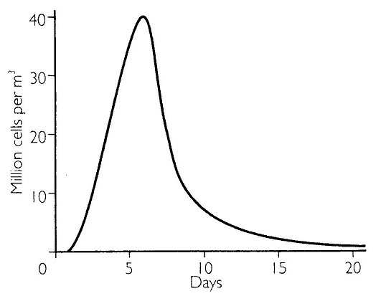

2.3.1. Explain the purpose of yeast in the production of wine. (3)

2.3.2. Explain the growth of the yeast from day 1 to day 5. (2)

2.3.3. Explain why the growth of the yeast slows down and stops completely after
20 days. (2)
(7)

2.4. Study the diagrams A to C, which show three different types of terrestrial plants.
All of these plants have lived on land for at least 360 million years. Study the
diagram and answer the questions based on it.

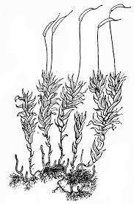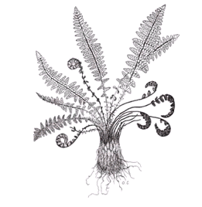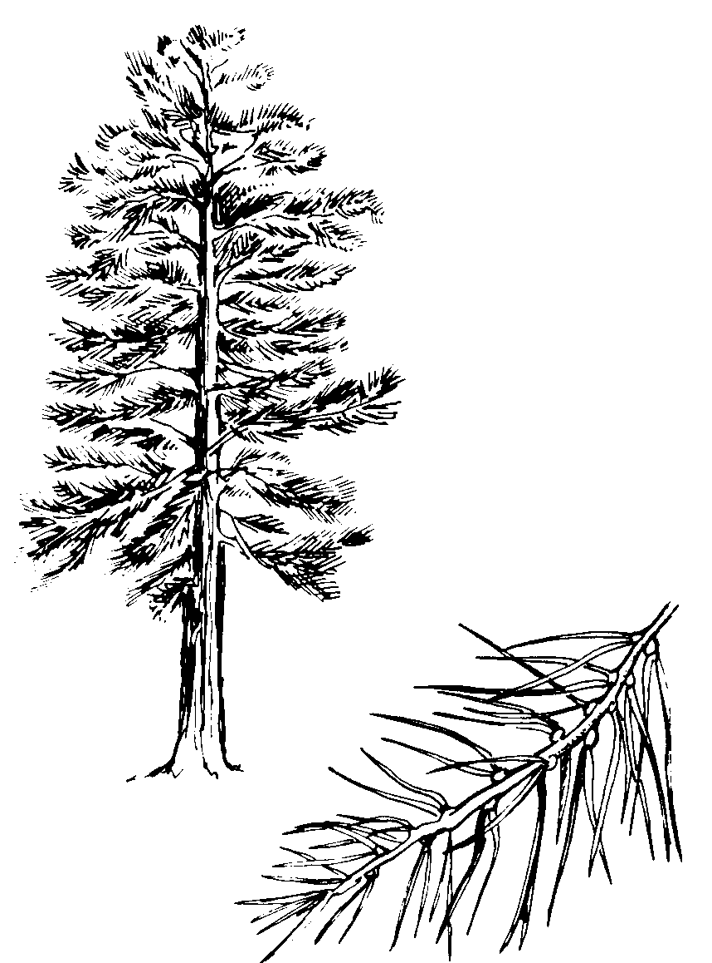
A B C

2.4.1. Discuss these plants A, B and C under the following headings:

a) Phylum. (3)

b) Apart from the vascular tissue, what other structural differences do the
leaves of these three plants exhibit? Discuss at least two different features
of each plant’s leaves. (6)

c) Reproductive structures. (3)
(12)

2.4.2. The following diagram indicates the structure of a hibiscus flower.

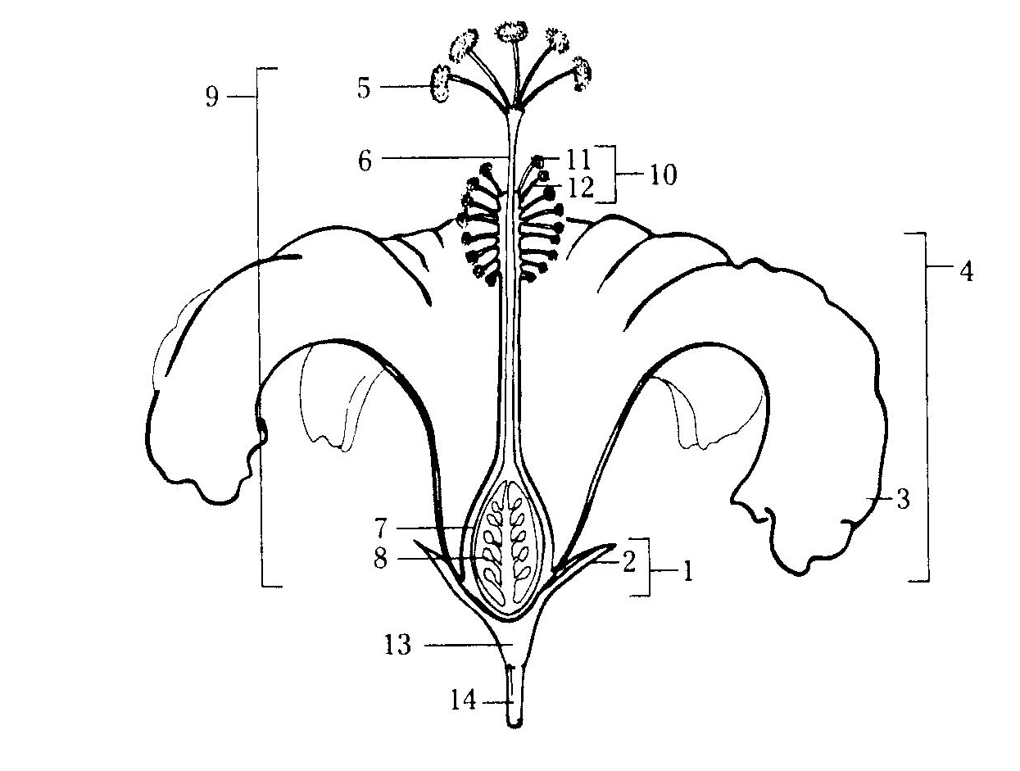

Match each of the following with one of the numbered parts of the diagram.
Write only the letter and applicable number down, e.g. F - 14
A – Attracts pollinators
B – Female organ
C – Produces pollen
D – Receives pollen
E – Protects flower while in bud (5)

2.4.3. What is meant by double fertilization of the flowers of angiosperms? (3)
(8)

TOTAL QUESTION 2: 40

QUESTION 3

3.1. The diagram below shows a model that has often been used to explain the process
of photosynthesis. Study the model carefully and then answer the following questions about it.

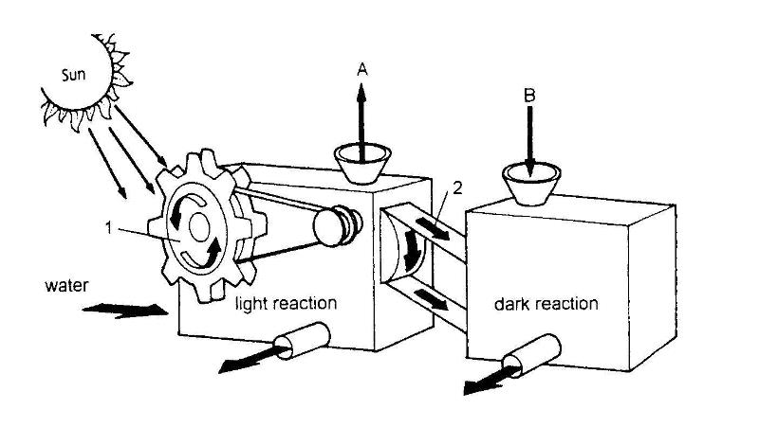

3.1.1. What organelle in a plant is represented by the structure labelled 1? (1)

3.1.2. In the model radiant energy is converted into kinetic energy. What form of
energy is it converted into in the real process? (1)

3.1.3. The belt is providing energy to the dark reaction box. What chemical compound
provides this energy in the real system? Shortly describe how this compound is formed. (3)

3.1.4. A co-enzyme is needed to transfer a certain element to the dark reaction box
as indicated by number 2. Identify this element. (1)

3.1.5. Identify the substance B, entering from the atmosphere. (1)

3.1.6. Name the byproduct A. (1)

3.1.7. Name the product that eventually results from the dark reaction box. (1)
(9)

3.2. The following diagram represents a potted plant with variegated leaves. The plant was destarched and then prepared for investigation as indicated by A and B respectively. After the plant has been exposed to sunlight for a period of six hours, the two leaves were tested for the presence of starch. Study this diagram and then answer the question that follow:

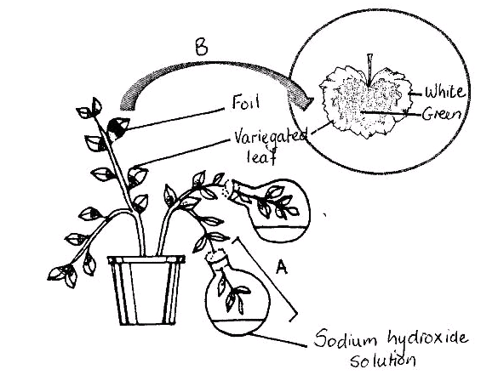

3.2.1. What is the aim of investigation A? (1)

3.2.2. List TWO factors being tested in B. (2)

3.2.3. Make THREE drawings of the leaf used in investigation B, shading the areas where starch will be present:

a) before the leaf was destarched
b) after the leaf was destarched
c) after the leaf was exposed to sunlight (3)
(6)

3.3. Study the graph below showing the optimal CO₂ concentration for different light intensities and answer the questions set.

Graph showing the optimal light intensities for photosynthesis
In a greenhouse at different CO₂ concentrations
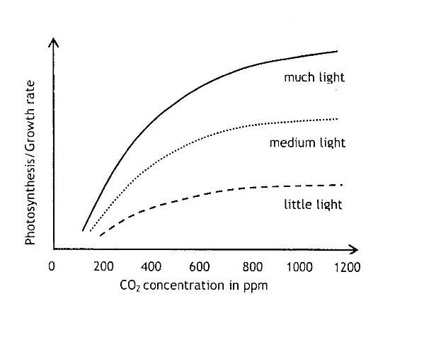

3.3.1. What effect did an initial increase in the CO₂ concentration have on the rate of photosynthesis? (2)

3.3.2. What other factor seemed to have influenced the maximum rate of
photosynthesis? (1)

3.3.3. Why did a continuous increase in CO₂ level lead to a stabilizing of the rate of photosynthesis at all three light intensities. (2)
(5)

3.4. The diagram represents part of the human digestive system. Answer the questions based on it.

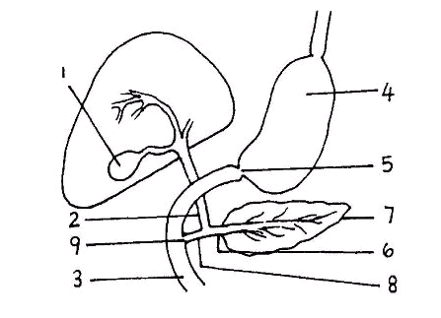

3.4.1. Name the organs labelled 3 and 4 (2)

3.4.2. Name the digestive juice secreted by part 4 and part 7 respectively. (2)

3.4.3. If the structure numbered 6 were cut through, it can be deduced that
digestion of food will be affected, but there would be no signs of
diabetes mellitis. Explain these two deductions. (5)

3.4.4. List THREE characteristics that an absorption surface must have. Next to each
characteristic write down how the structure of the small intestines complies to it.
(6)
(15)

3.5. Study the energy content of processed food as it appears on the labels
indicated in the following table.

FOOD | Amount of energy per 100 grams (kJ)
Brown bread | 1000
Mealiepap | 1274
Roast chicken | 950
Peanut butter | 2350
Carrots | 100
Bananas | 384
Milk | 153
Sugar | 1650

3.5.1. Which type of food in the table has the most energy per 100 g? (1)

3.5.2. How much energy will you get if you eat 50 g brown bread? (1)

3.5.3. Calculate how much energy Portia would get from the following meal:
- two slices of brown bread weighing 60 g,
- a spoon full of peanut butter weighing 10 g
- a glass of milk weighing 200 g
Show your working. (3)
(5)

TOTAL QUESTION 3: 40

TOTAL SECTION B: 80

SECTION C

QUESTION 4
Some invertebrates play an important role in agriculture and the environment.
Do you agree that the disappearance of invertebrates would lead to the
disappearance of humans? Discuss the statement and the role of arthropods in ecosystems and agriculture. (17)

Synthesis (3)
(20)

NOTE: NO marks will be awarded for answers in the form of flow charts or diagrams.

TOTAL QUESTION 4: 20

TOTAL SECTION C: 80

GRAND TOTAL 150

GRID COMMON JUNE EXAM GRADE11 2015
 | Cognitive Levels |  |  |  |  | SPECIFIC AIMS |  |  |  |  | Knowledge Strands
Question nr | A | B | C | D | SA1 |  | SA2 |  | SA3 |  | Molecular, Cellular, Tissues |  |  |  |  | Life Processes
 | Basic knowledge | Comprehension | Application | Analysis, Synthesis & Evaluation | Knowledge |  | Process skills |  | Science & Society |  | Biodiversity and classification of microorganisms | Biodiversity in plants and reproduction | Biodiversity of animals |  |  | Photosynthesis | Animal nutrition
1.1 | 20 |  |  |  | 20 |  |  |  |  |  | 4 | 6 | 6 |  |  |  | 4
1.2 | 6 |  |  |  | 6 |  |  |  |  |  |  | 2 | 2 |  |  | 1 | 1
1.3 |  | 14 |  |  |  |  | 14 |  |  |  | 6 | 4 | 2 |  |  |  | 2
1.4 | 3 |  | 1 | 6 | 3 |  | 7 |  |  |  |  |  | 10
Total Quest 1 | 29 | 14 | 1 | 6 | 29 |  | 21 |  |  |  | 10 | 12 | 20 |  |  | 1 | 7
2.1 | 6 |  |  |  | 1 |  | 5 |  |  |  | 6
2.2 | 4 | 2 |  | 1 | 6 |  |  |  | 1 |  | 7
2.3 |  | 3 | 4 |  | 3 |  | 4 |  |  |  | 7
2.4 | 6 | 6 | 8 |  | 20 |  |  |  |  |  |  | 20
Total Quest 2 | 16 | 11 | 12 | 1 | 30 |  | 9 |  | 1 |  | 20 | 20
3.1 | 4 | 3 | 2 |  |  |  | 9 |  |  |  |  |  |  |  |  | 9
3.2 | 2 | 1 | 3 |  | 3 |  | 3 |  |  |  |  |  |  |  |  | 6
3.3 |  | 5 |  |  |  |  | 5 |  |  |  |  |  |  |  |  | 5
3.4 | 4 | 6 | 5 |  | 15 |  |  |  |  |  |  |  |  |  |  |  | 15
3.5 |  |  |  | 5 |  |  | 5 |  |  |  |  |  |  |  |  |  | 5
Total Quest 3 | 10 | 15 | 10 | 5 | 18 |  | 22 |  |  |  |  |  |  |  |  | 20 | 20
4.1 |  |  | 20 |  |  |  | 20 |  |  |  |  |  | 20
Total Quest 4 |  |  | 20 |  |  |  | 20 |  |  |  |  |  | 20
Quest 1 | 29 | 14 | 1 | 6 | 29 |  | 21 |  |  |  | 10 | 12 | 20 |  |  | 1 | 7
Quest 2 | 16 | 11 | 12 | 1 | 30 |  | 9 | 1 |  |  | 20 | 20 |  |  |  | 20 | 20
Quest 3 | 10 | 15 | 10 | 5 | 18 |  | 22
Quest 4 |  |  | 20 |  |  |  | 20 |  |  |  |  |  | 20
Total | 55 | 40 | 43 | 12 | 27 |  | 72 | 1 |  |  | 30 | 32 | 40 |  |  | 21 | 27
Norm | 40% | 25% | 20% | 15% |  |  |  |  |  |  | 20% | 21% | 27% | % | % | 14% | 18% |  | %
Marks | 55 | 40 | 43 | 12 |  |  |  |  |  |  | 30 | 32 | 40 |  |  | 21 | 27
Total | 150 |  |  |  | 150 |  |  |  |  |  | 150

Date: 4 May 2015 Signature: Examiners. R. Ferreira and H. Germishuys
Date:………………………………… Signature: Moderator………………………………….

