BIODIVERSITY AND CLASSIFICATION (notes)

Biodiversity (biological diversity) is the totality of the variety of living organisms,the genetic differences among them, and the communities and ecosystems in which they occur.

It is the ‘natural wealth’ of the earth, which supplies all our food and much of our raw material.

Biodiversity is extremely valuable:

Our natural biodiversity cleans our water and air, prevents flooding

and holds our soil in place.

These services are amazingly effective and provided at no financial cost.

Biodiversity provides the complex genetic pool that provides us with

food and medicines.

Wild genes can improve crops by providing resistance to disease or changes in climate.

In addition, over 21 000 plants around the world have reported medicinal uses.

Endemic: only found in the particular area referred to, e.g. Cape Town Metro Area.

Red Data List: a national list, based on internationally recognised criteria, of species threatened with extinction.

South Africa has the second highest number of plant extinctions in the world.

70% of the Cape Floral Kingdom’s 9 600 plant species are found nowhere else on earth. About 20% of these are Red Data listed.

Cape Town itself is home to about 3 000 indigenous plant species, 190 are endemic, 318 are considered threatened and 13 are extinct or extinct in the wild.

The Cape Town Lowlands area supports more than 1 466 plant species in 1 874 km² of which 76 are endemic and 203 are considered threatened.

The Cape Town Lowlands area has the highest concentration of threatened plants per area of remaining vegetation in the world.

The Cape Peninsula Mountain Chain supports 2 285 plant species in 471 km², of which 158 are endemic.

83 mammal species remain in Cape Town, 24 Red Data listed and three recently extinct.

361 bird species live in Cape Town – ten are endangered, 22 are Red Data listed and at least three species have become extinct in recent years.

There are numerous invertebrate species in Cape Town,approximately 111 of them are endemic in the Cape Peninsula Mountain Chain alone.

There are 27 amphibian species in Cape Town of which ten are listed as Red Data species.

57 reptile species, of which five are Red Date species and three are locally extinct, are found in Cape Town.

24 fish species are dependent on Cape Town’s estuaries.

There are 18 different national terrestrial vegetation types found in Cape Town. 14 of these are threatened owing to habitat transformation.

Cape Town contains remnants of the nationally most-threatened vegetation types: Lourensford Alluvium Fynbos, Swartland Shale Renosterveld and Swartland Silcrete Renosterveld.

Many globally important horticultural plants originate in Cape Town and the Cape Floral Kingdom in general.

These include geraniums, gladioli, freesias, ixias, pincushions and gazanias. The Western Cape is also a world centre of bulb diversity.

 

 

Some of the greatest threats to our biodiversity include:

* Urban sprawl and development
* Human population growth
* Spread of invasive alien species
* Litter, dumping and pollution
* Over-frequent, human-induced wildfires
* Overprotection from fire in some areas

INDIGENOUS VERSUS EXOTIC BIODIVERSITY

The term ‘biodiversity’ alone does not distinguish between plants and animals that occur naturally in Cape Town and those that came to be here as a result of human actions and activities.

CLASSWORK ACTIVITY

**Study the graph below which shows the major extinction events answer the questions that follow**.

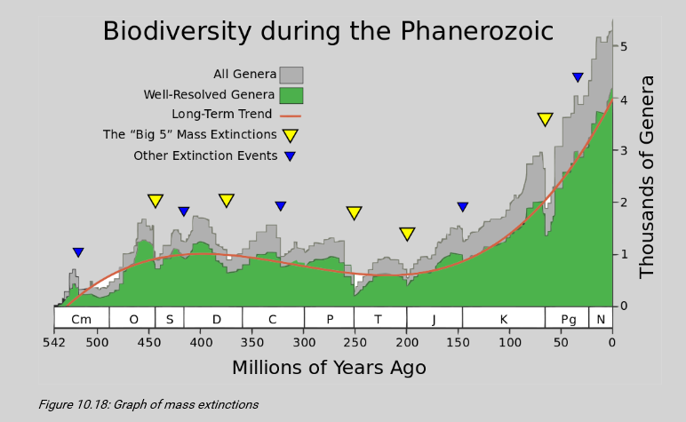

1. When did the Cenozoic era begin?
2. Which mass extinction took place towards the end of the Paleozoic era?
3. Approximately how many genera of species went extinct at the end of the Paleozoic era? Show ALL working.
4. Explain why the number of genera of organisms increased rapidly after each mass extinction.

**Answers:**

1. Around 65 mya, after the last major extinction.
2. The Permian extinction.
3. Learners are required to read-off of the number of genera present at the start of the extinction and the number of genera remaining at the end of the extinction. The difference between these two figures would be the number of genera lost during the extinction. Learners will have to estimate from the graph as the axes are not clear. A range of answers should therefore be accepted. The answer should be around 80% 80% .
4. The number of genera increased rapidly after each extinction event, because many genera were wiped out completely during the extinction, so their niches were left open. These niches were rapidly taken over by other genera, who diversified and formed new genera by natural selection.

Define the following terms :

1. Indigenous
2. Exotic
3. Endemic

ANSWERS

1.INDIGENOUS:

Naturally occurring plants and animals – those that belong in Cape Town

2.EXOTIC OR ALIEN BIODIVERSITY: Those plants and animals that have

been brought in by humans (on purpose or accidentally) .

3. INVASIVE : Alien species that grow vigorously and replace indigenous

species