LIFE SCIENCES GRADE 10 TOPIC : HISTORY OF LIFE
MARKS: 27

QUESTION 1
The diagram below shows a hypothetical rock profile from two locations separated by a distance of 67 km. Layers D and L are volcanic ash deposits and all the other layers are sedimentary rock.

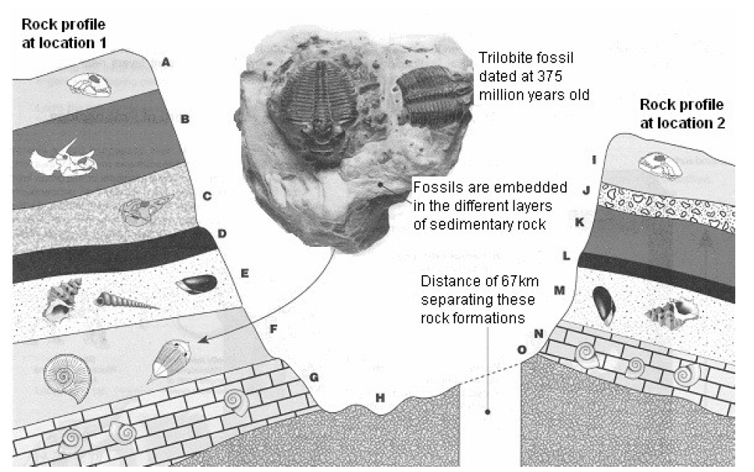

 | 1.1  1.2  1.3  1.4  1.5 | Using radiometric dating, the trilobite fossil was determined to be approximately 375 million years old. The volcanic layer (D) was dated at 270 million years old. Assuming there has been no geological activity (e.g. Folding) estimate the age of:  - The rock in layer B  - The rock in layer G  Which layer at location 1 is the same age as layer M at location 2?  Layers H and O are also sedimentary rocks. Give a possible explanation why there are no visible fossils in these layers.  Is it possible that a sea once covered these two locations?  Give evidence to back up your answer. | (1)  (1)  (1)  (2)  (1)  (1) (7)

1.1 | 1.1.1  1.1.2  1.1.3  1.1.4  1.1.5 | (a) Less than/< 270 mya  (b) more than/> 375 mya  Layer E  Organism eaten by predators or decomposition took place  Yes  The presence of sea shells in layer E and M | (1)  (1)  (1)  (2)  (1)  (1) | (7)

QUESTION 2 : ESSAY
Evidence of the history of life on Earth is largely based on fossils found in South Africa. Fossil tourism is becoming very popular because people across the world come to visit South Africa`s fossil sites. Describe what fossils are, and give a detailed description on how fossils are formed. Also describe to what extend fossil tourism can contribute to opportunities and economic development of the local people

 | Content:17  Synthesis:3 |  | (20)
POSSIBLE ANSWER : ESSAY

Fossils are the remains, imprints or traces of organisms that existed on earth million years ago and are preserved in rocks/ice/tar.

When organisms die, the sediment deposited over the remains form layers. The layers become compressed and hardens to form rocks.
Within these rocks the skeleton of the organisms fossilise.
Bones and teeth molecules are replaced by silica or carbonatesfrom the rocks.

Fossil tourism can generate employment opportunitiesfor tour guides, professional palaeontologists, anthropologists and archaeologists
Museums and fossil sitesattract tourists which contribute to the growth of the economy of the country

Tourism also improve growth and development of business in restaurants, guesthouses/hotels, garages and SA traditional goods.

ANY 17

ASSESSING THE PRESENTATION OF THE ESSAY

Criterion | Relevance (R) | Logical sequence (L) | Comprehensive (C)
Generally | All information provided is relevant to the topic | Ideas are arranged in a logical/ cause-effect sequence | All aspects required by the essay have been sufficiently addressed
In this essay | Only information relevant to fossilisation and contribution of fossil tourism to the economy of the country | Information regarding the description of fossils, formation of fossils and economic contribution of fossil tourism | Description of fossils:2/3  Fossilisation: 5/7  Fossil tourism: 5/7
Mark | 1 mark | 1 mark | 1 mark

Synthesis |  | (3)
TOTAL |  | (20)  27

