ANNEXURE A Grade 10 Life Sciences: History of Life on Earth

10.4 Mass extinctions
Learn about the five major mass extinctions that occurred in Earth's history.
Video: 2CY4
A mass extinction is a sharp decrease in the amount of plant and animal life. There have been five major mass extinction events in Earth's history. These are shown in the table given, along with the major events that characterised each.
Major mass extinction event | Date of occurrence | Major events
Cretaceous-Paleogene extinction event | 65 million years ago | Approximately 75% of all species became extinct. Mammals and birds emerged as the dominant land vertebrates.
Triassic-Jurassic event | 205 million years ago | Most non-dinosaur species were eliminated, leaving land dinosaurs with no competition.
Permian-Triassic event | 250 million years ago | This was Earth's largest extinction event. It resulted in the loss of 96% of marine species and 70% of land species. The event had great evolutionary significance because it allowed the vacant habitats and ecosystems to be filled by new species through natural selection.
Late Devonian extinction | 375–360 million years ago | This was a prolonged period of extinction lasting up to 20 million years. During this period up to 70% of living species were eliminated.
Ordovician-Silurian extinction event | 450–440 million years ago | Over 50% of all genera were eliminated during this period and is ranked as the second largest mass extinction in Earth's history

Causes of mass extinctions (ESGCW)
Watch a video about the debate about what really killed the dinosaurs.
Video: 2CY6
There is still a lot of debate among scientists as to what caused the mass extinctions. To be a valid theory to explain what caused mass extinctions, the theory must:
- explain all the losses of species at a particular mass extinction event (not just specific losses e.g. dinosaurs).
- explain why some organisms died and others survived.
- be based on natural events and processes that are shown to have occurred around the time of extinction.
Two of the hypotheses put forward are:
- the impact theory of extinction
- massive volcanic activity

Taken from Siyavula Grade 10 Life Sciences Textbook
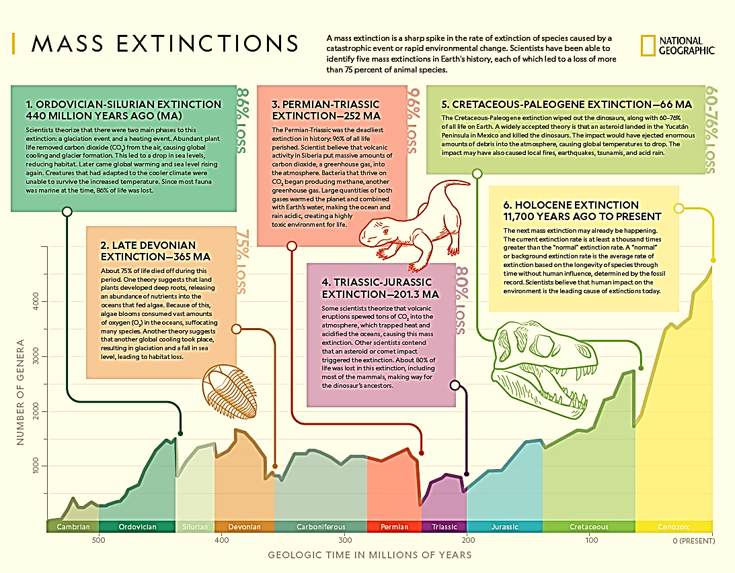

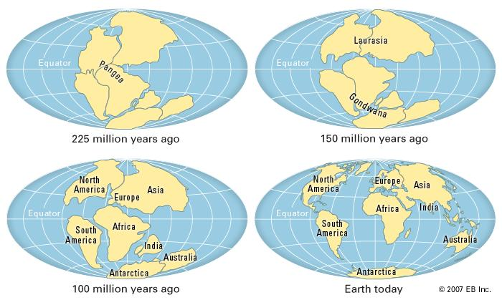

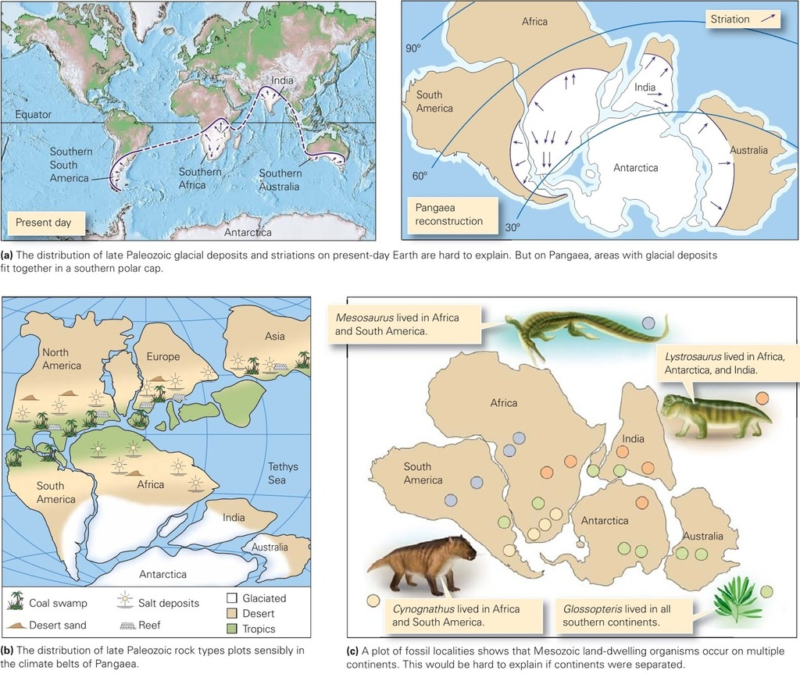
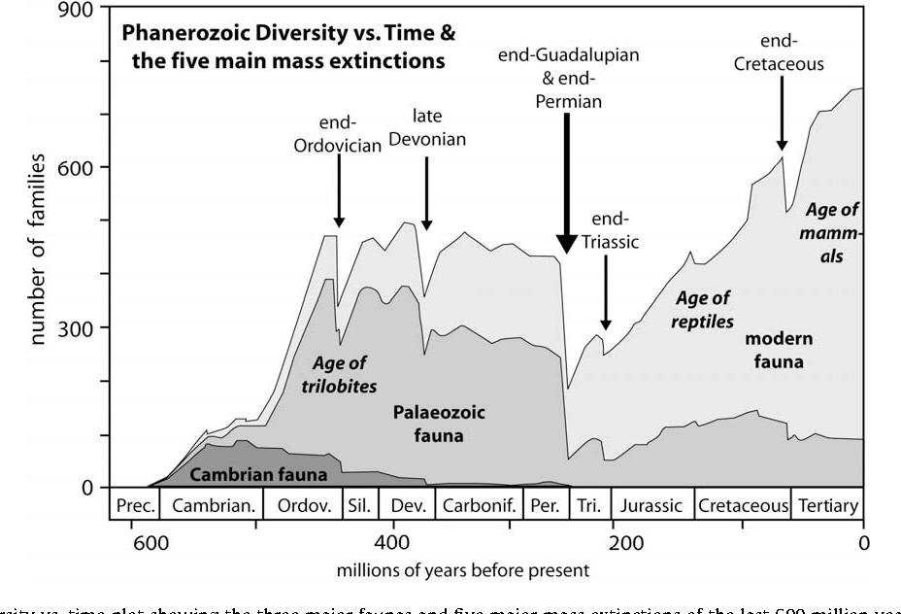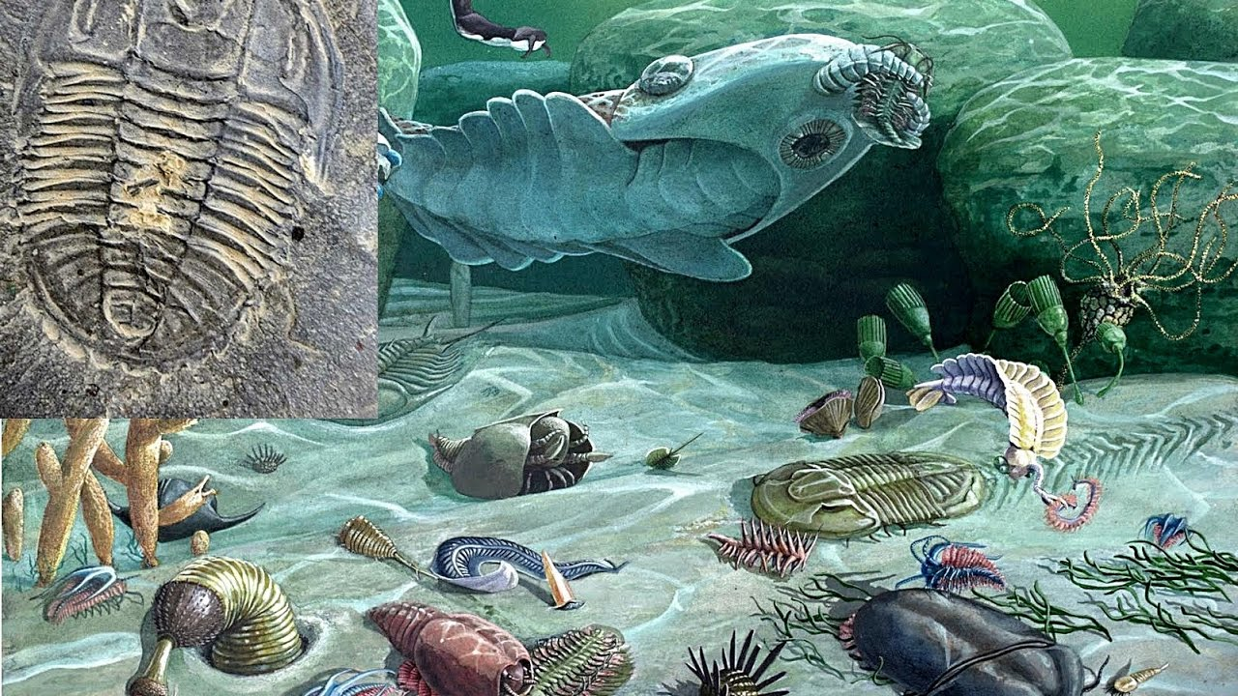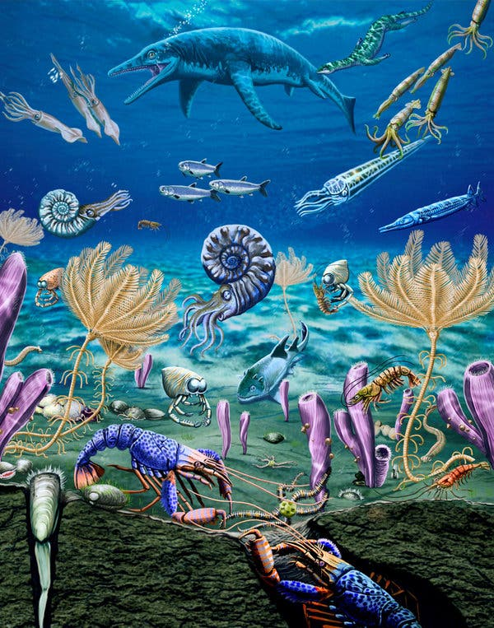
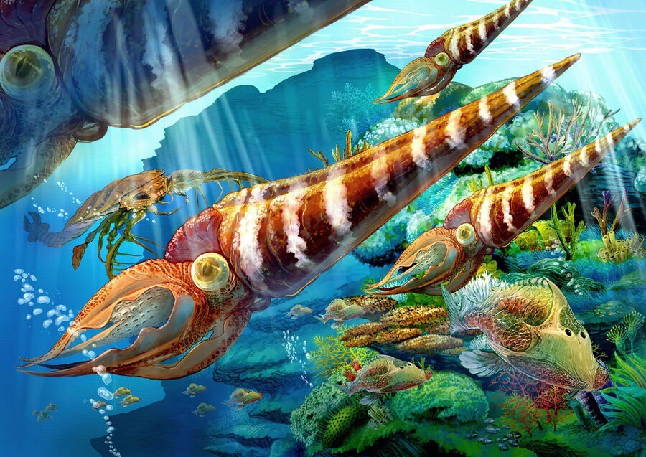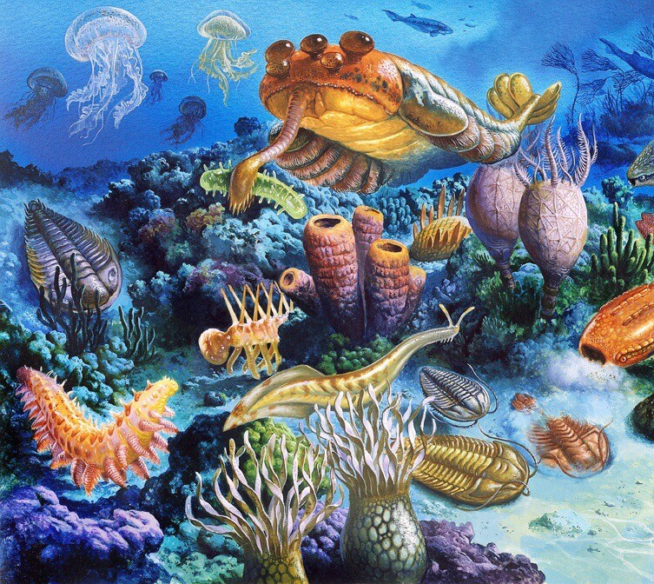
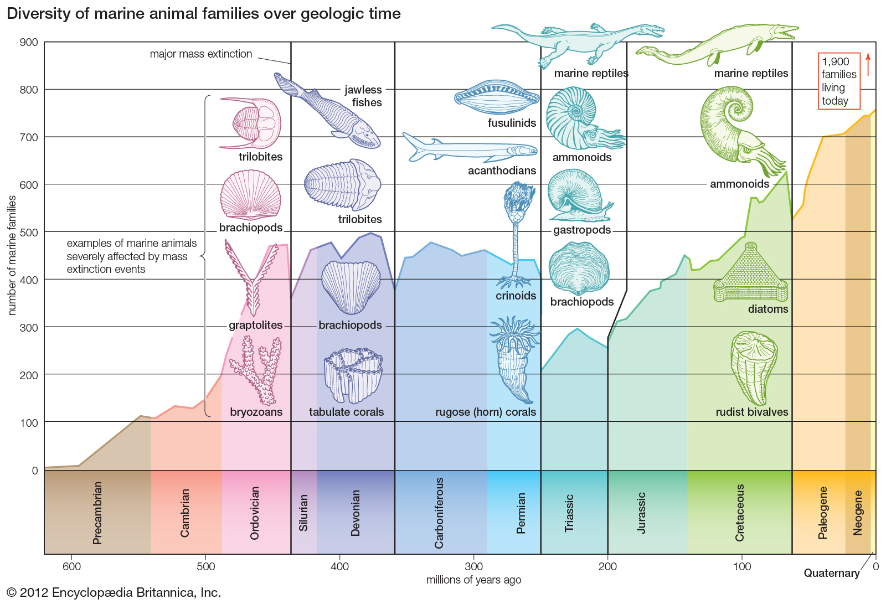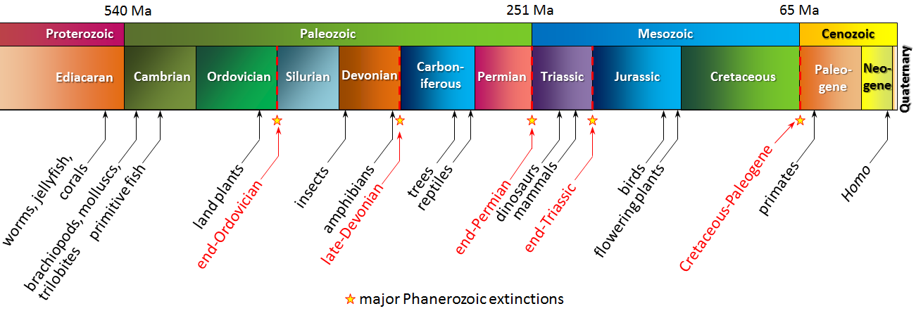
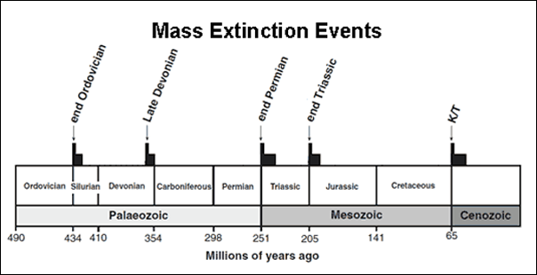
Other resources
https://www.dailymail.co.uk/sciencetech/article-5692167/Interactive-map-lets-travel-time-planet-600-million-years-history.html
https://www.amnh.org/learn-teach/curriculum-collections
https://www.siyavula.com/read/science/grade-10-lifesciences/history-of-life-on-earth/10-history-of-life-on-earth-04
https://www.nationalgeographic.com/science/prehistoric-world/mass-extinction/
https://phys.org/news/2015-11-elementary-theory-mass-extinctions-life.html
https://www.youtube.com/watch?v=bU1QPtOZQZU
http://youtube.com/watch?v=FlUes_NPa6M

